Puzzle fossil is the oldest animal in the world

Indeed before 558 million years lived the first multicellular animal in the primordial ocean
Spectacular find: The palaeontologists have discovered the oldest puzzle fossil in the world and they have solved the puzzle of one of the bizarre beings
in the history of the Earth. Because of the 558 million years the old genus of Dickinsonia looks so exotic, that insofar still remained unclear, whether it was a giant unicellular, a lichen or a multicellular organism. But now proves the organic remnant in the fossil, that it is actually in the past about the multicellular animal like the researchers report in the specialist magazine ‘’ science’’
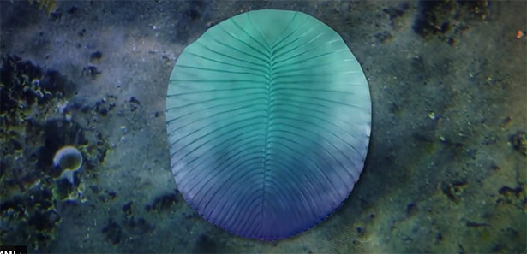
It was a confusing and strange world: in the primordial oceans of the Ediacaran period lived organisms from 571to 541 million years, which resemble aliens than current animals. Some of them resemble a lobate construct without head or bowel, other were tubular reefs and others resemble a half bloated airbed. Because of their weird shape, it is not clear to which kingdom of organisms they belong.

Puzzling Primordial times-creature
One of these puzzling creatures is Dickinsonia about 1,40 meter, giant, oval creature with acute ribs and floated body. A head, internal organs or limbs seem to be missing. Palaeontologists therefore suspect that Dickinsonia intake their nutrients directly from the environment or perhaps they practice an external digestion. But how was this rare creature being classified.
Scientists argue since more than 75 years about that, what was the Dickinsonia: a huge unicellular organism, a lichen, one of the first animals or only a failed experiment of the evolution. Ilya Bobrovskiy from the National University in Australia in Canberra explains that. The answer can be the organic biomarker and relic from fats and metabolic products which are exemplary for specific for kingdoms of organisms.
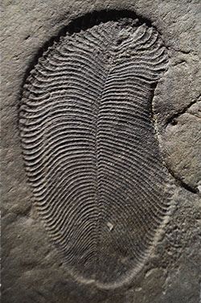

Find in the white sea

The problem was however, that we must firstly find Dickinsonia-Fossils which have organic materials inside them, explains that Bobrovskiy. The most of Earth layers with these fossils like for example the Ediacara-Formation in Australia exposed to heat, high pressure and weathering. Thereby were the organic relicts widely destroyed.
Now however have Bobrovskiy and her/his team first Dickinsonia-Fossills which have crucial biomarker discovered. They found them on a steep from 60 to 100 meter high cliffs on the coast of the White Sea in Arctic Russia. There found the scientists approximately more than 558 million years old Dickinsonia specimens. Inside their fossil imprints still remnants from organic material. The decisive analyses can take place with them.

It is only an animal
The result: Dickinsonia was a multicellular animal. As the analyses revealed, 93 percent of their biomarkers consist of cholesterol-similar molecules-compounds which are characteristic for animalistic lifestyles. Only 1,8 percent of the organic relicts on the other hand consist of Ergosteroids, fungi and characteristic compounds of lichens. Also the typical molecule mixtures was missing in the unicellular, as the researchers report.

Das Link vom echten Artikel : http://www.scinexx.de/wissen-aktuell-23181-2018-09-21.html

