Why Netflix has no competitors
The Netflix company was founded in 1997 to rent and sell DVDs by post. You just choose a DVD online and receive it by mail. Later, the company introduced a monthly subscription to an unlimited number of DVD rentals.
By 2006, the company had already 5 million regular customers. Moreover, in 2007 Netflix presented its streaming service, which was a great change in the movie industry.
Not so long ago, in 2016, the company entered the market in 190 countries. And according to the information at the end of 2019, the number of subscribers reached 167 million people. Netflix projects have several American Academy Awards and a huge number of Emmy Awards.
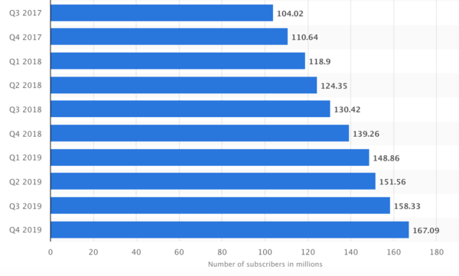
Service subscribers increase (in millions)
Of course, such a success could not fly under the radar. Large (and not so) companies began to create their services, and recently they pop up almost at the velocity of sound. The loudest in recent years was the launch of Apple TV+, Disney + and the announcement of HBO Max and Peacock from NBCUniversal. They are now called the main competitors of Netflix as well as the Amazon Prime Video. But are they in fact?
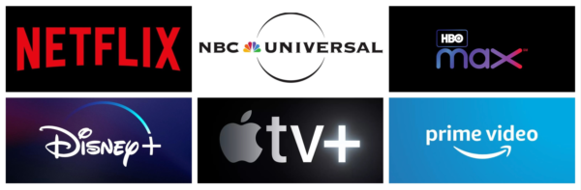
The main participants of the so-called Streaming Wars
Disney+ broke in with a$2.5 billion content budget and the entire Marvel, Lucas films and Disney movie library, attracting 28 million subscribers in three months. HBO max plans to start with a budget of $1.5-2 billion a year and an enormous library of already shown content. Amazon spent $ 6 billion in 2019 on exclusive content.
These figures seem tremendous until you realize that Netflix spent $15 billion on the content in 2019 and plans to spend17.5 billion in 2020.
However, not the immense investments make Netflix an unsurpassed player in the market of streaming services. Three main factors ensured this.

IT company
The head of Netflix Reed Hastings has repeatedly stated that they are primarily an IT company. What does this mean for the user? It means that everything will work as it should.
The company has come far ahead in terms of the quality of video, sound, stability, the convenience of the interface. And efforts are continuously underway in each direction: development of new compression algorithms, updating of sound codecs, improvement of the interface, and the introduction of new functions.
The main feature of Netflix is a recommendation system managed by artificial intelligence. It was outlined when the company was engaged in the rental of DWD's. Based on the viewing history, duration, impressions about the viewed (at the end you can click “like” or “dislike”) the service recommends the content and gives the percentage of a particular movie or series matching your preferences.
No reviews, no rates. No need to care about someone else’s opinion. Only the stuff you personally like, not someone else. From my experience: after two or three months of use, it works quite accurately.
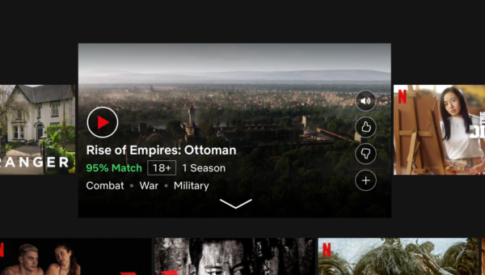
Recommendation: This series has a 95% match with my preferences
After frequent watching Netflix, it is quite ridiculous to use Russian streaming services. Usability, intuitiveness of the interface, stability –constant struggling. Services such as Okko, Amediateka, Wink, Premier are very weak in this regard. You cannot find the list of favorites, then the button "add to favorites" (even if you have already used it before), the service loses spot in the movie you stopped last time, does not save the episode number. And of course, downloaded content takes 1.5-2.5 times more space with less quality compared to Netflix.
From domestic services, ivi does well and “KinoPoisk” actively develops in the correct direction. It is evident that ivi is not new to the market and is taken care of by professionals. And “KinoPoisk” is still too young, but improvements are noted every month.
With respect to Western services, Disney+ and HBO MAX have another strong point – they are some of the best content creators in the world. As for the money for the development of good service, they have more than enough. But they do not share a philosophy of “user experience above all”. It is unlikely they can reach the Netflix level in this regard.
But there are also IT companies in this market. Apple TV and Amazon Prime Video are services that can provide the same level of user experience as Netflix. But strangely enough, they sell another product.

Main Product
Today Netflix has nothing but content. They don't make money from selling devices, goods or advertising. The customer pays for the content and receives the content. That's it.
Amazon, for example, has a different target. The main objective of Amazon Prime Video service is to keep you online for as long as possible and sell you the product using the target. Content is not what Amazon sells – the company uses content to buy your time and attention. And you pay for it.
That doesn't mean they have bad content. It's just not created as a final product, it is a bait. And this is how it can be different.
Apple creates an ecosystem with all its devices and services. And if you are attracted to the series on Apple TV+, then without Apple devices it will be almost impossible to watch it. When you get used to using the service, changing your iPhone, iPad or MacBook to a competitor's product becomes much harder. Just like, for example, when using an Apple Watch.
Apple's main task is to attract and keep you in the ecosystem. This, again, does not make content the end product.
As mentioned earlier, Disney+ and HBO Max are different. Their product is the content. But these are some of the largest media companies in the world (HBO belongs to WarnerMedia). This means that the streaming service will never be their main business.
This can lead to the fact that these services are only complementary to the core products. Like, for example, the expansion of the movie universes of “Star Wars” and Marvel using series on Disney+. It's more like drawing attention to the main projects of the franchise than to the original product.
In any case, Disney and HBO are much more experienced in content creation than Netflix. This can't be denied. With the correct direction, they can bypass Netflix in this field.
But they are in different directions.

World cinema
In 2020, the USA finally accepted the existence of foreign cinema, giving the main awards of the Academy of Motion Picture to the South Korean movie “Gisaengchung” (“Parasites”).
No wonder. In many countries, such as China, India, South Korea, and Japan, local films are increasingly in the lead. At the same time, income fromrental in such countries is growing every year.
US media corporations want a slice of that cake. And they start by making the Academy of Motion Picture international.
But Netflix management got that much earlier. In 2013, the first series of own Netflix production – “House of Cards” was launched, and in 2015 the first non-English-language content from Netflix appeared – the Mexican series “Club de Cuervos” (“Club of Crows”).
Next year, when the company entered the market of 190 countries, Netflix Original content of Brazilian, French and Spanish production is released. In 2018, one billion dollars was invested in European content, and by the end of 2020, it is planned to launch up to 100 new non-English-speaking projects.
Today Netflix produces and buys international rental rights in almost all countries of the world: China, Hong Kong, Japan, South Korea, India, Turkey, France, Germany, Belgia, South Africa, Brazil, Spain, Mexico, and others. Content from these countries is created by local people, Netflix hardly interferes with production.
Therefore, the projects do not lose their identity and are popular locally and on the international market. An excellent example is “La Casa De Papel” (“Money Heist”), the most popular foreign project of Netflix, 35 million accounts per week watched the third season.
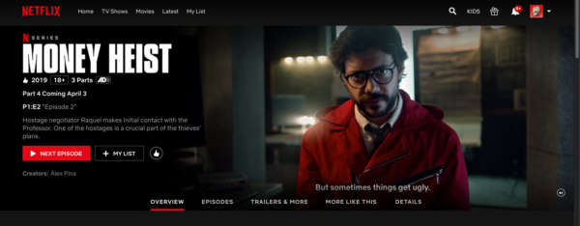
Page of the series “La Casa De Papel” (“Money Heist”)
Viewers outside the United States start getting annoyed with Hollywood products. They want something native and at the same time of good quality. And Americans began to learn little about the existence of foreign cinema, which is different from what they do in their country.
The general trend is clear. But Netflix picked up and developed it much earlier. Neither Disney, nor HBO, nor Apple plans foreign projects shortly. And when they plan, it may be too late.

Drawbacks of Netflix
Of course, everything cannot that fine. Netflix has many advantages, but there are some drawbacks. For the Russian people, the first and foremost is localization.
I saw with my own eyes vast Netflix installations in Istanbul's largest shopping malls, dedicated to the series “Umbrella Academy” and the movie “Irishman”. Netflix posters are on every bus stop in the center of Istanbul. All because Turkey is the world's largest exporter of television programs or rather series. This market is important and necessary for the development of the service.
But Russia for Netflix is a small and unclear market. Here people just begin to get used to paying for content, and streaming services are not very popular yet. Therefore, localization is minimal and for a person with zero knowledge of English, the site is completely incomprehensible.
The titles of movies and series are not translated, the search is in English. There is no separate category of films with translation or subtitles. You can only have the search request “Audio in Russian” – even in this case, not everything will be shown. Although recently, almost all new projects Netflix tries to release immediately with Russian translation and almost for everything Russian subtitles are added.
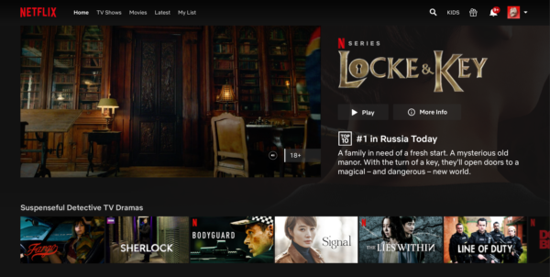
If there are no problems with English, then there is a second issue – the creation of streaming services by almost all major companies.
When streaming was first introduced it was enough to collect as many movies and series of different movie companies, now without exclusive content, streaming makes no sense. Russian services have started realizing that, trying to create own content for their platforms, but in the US market a streaming service without exclusive content will not survive a couple of months of competition.
When major TV and movie players like Disney, HBO, CBS create own service, they revoke the rights to broadcast their old content from other companies and create new exclusive content. For example, Disney withdrew the rights to show Marvel films from Netflix, and HBO to show the series “Friends” in the United States.
You won'tbe able to see everything you'd like to in one place. After all, a lot of classic and new content will be locked in the services of its rightsholders. This brings us to the third problem – price.
Netflix in Europe and Russia costs 10 euros per month for the FullHD subscription. These are peanuts for prosperous Western countries and not too expensive for the Russian audience.
I, for instance, have two subscriptions at the same time now: Netflix and Kinopoisk. The second for Russian content, as well as translated content – for children and family members who do not speak English. Most recently, I unsubscribed from “Amediateca” and Wink. If to add YouTube Premium, it turns out to be a pretty penny.
If we talk about the USA, you need to subscribe to CBS All Access, HBO Max, Amazon Prime Video, Peacock, Netflix, Apple Tv+ and Disney+ to watch all the greatest TV and movie hits. 70-75 dollars a month on subscriptions is quite a lot. You have to choose which content is more to your liking, and what you have to cut on.

Conclusion
Netflix had an advantage of time, and they made perfect use of it. They virtually created a streaming market and guide it for several years already.
For now, they have left competitors far behind, but large corporations will be able to catch up quickly with an active infusion of funds. There's no doubt that Disney and HBO can create content better than Netflix, they have more experience in this. Especially with such impressive exclusive content, as the sensational “Mandalorian” and a new episode of “Friends” with the classic cast. It remains only the question of strategy and implementation platform. If any of this goes wrong, they will not beat Netflix.
As for Russian services, they are still at the beginning of the road...
#netflix#disney#hbo
The material is published by the user.
Click the “Write” button to share your opinion or tell about your project.

