<https://rpkfavorit.com/catalog/vystavochnye-stendy/stojki-resepshn/>

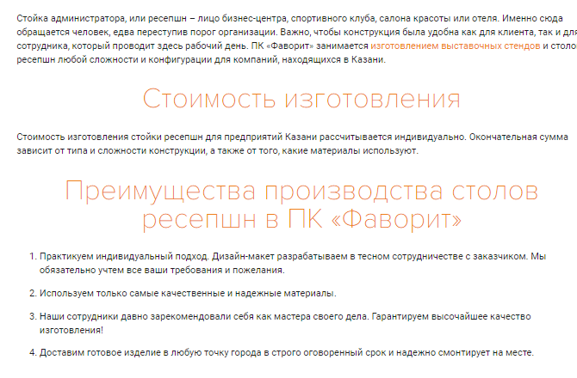

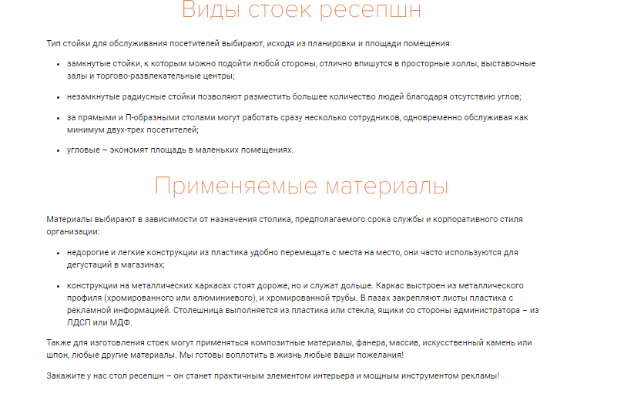

<https://rpkfavorit.com/catalog/vystavochnye-stendy/invidualnaya-zastrojka/>

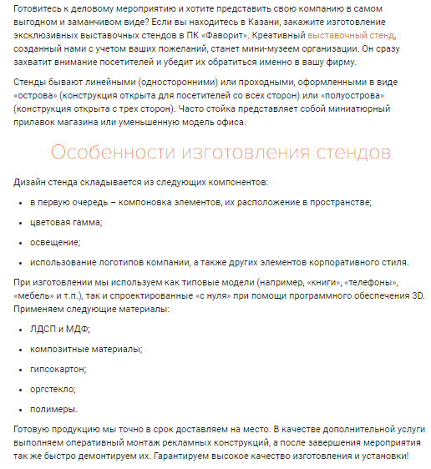

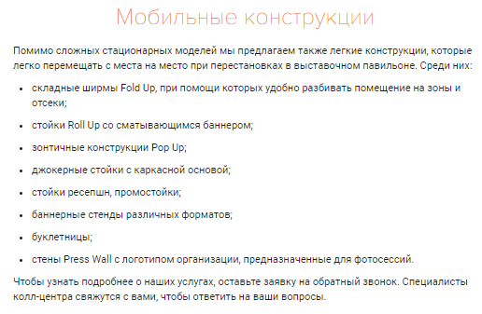

<https://rpkfavorit.com/catalog/informacionnye-stendy/pozharnye-stendy/>

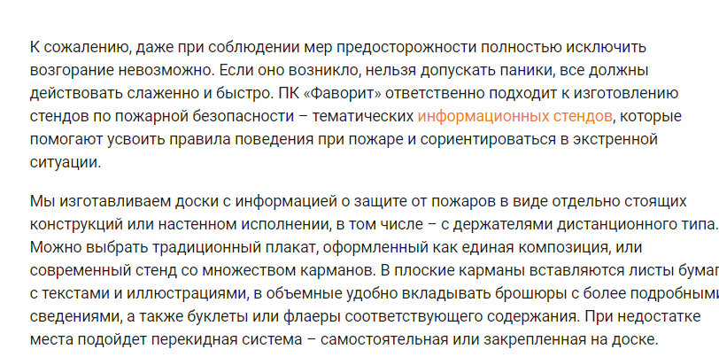

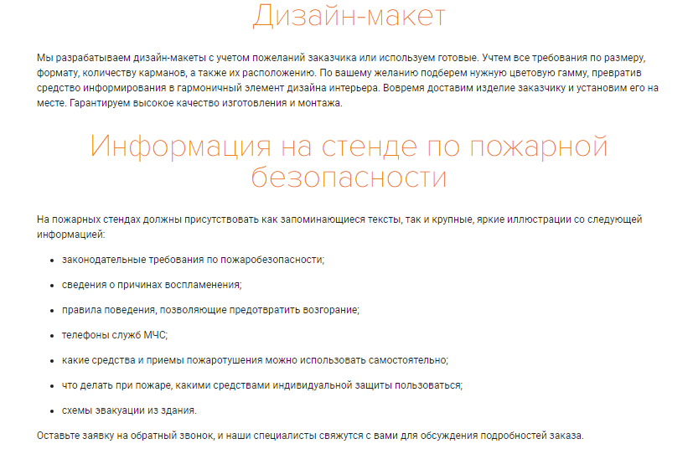

<https://samara.magmageo.ru/uslugi/geologiya/geologiya-dlya-stroitelstva/>

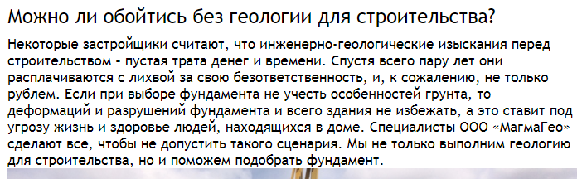

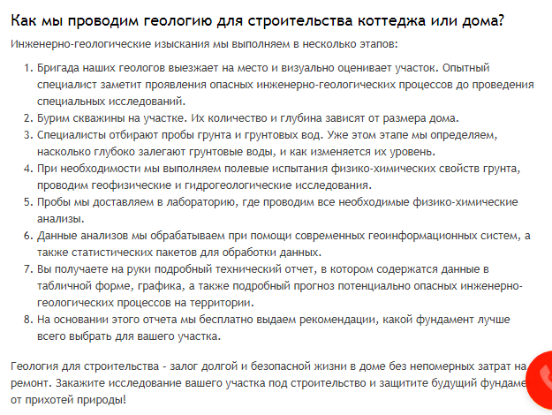

<http://www.kroyka.ru/stat146.php>

