1. YouTube to mp3 Converter – Best tools to Download Mp3 from Youtube
If you want to load the music from YouTube, just enter a video link to the converting website, and then click the button “To convert” youtube to mp3. Also, it is possible to cut down the track, to make tags correction, to select name of the file with its cover. For this, special websites are used.
Top Pick of Top Rated Tools to Download Mp3 from Youtube
There are many applications for converting the music from YouTube, there are various desktop programs, together with extensions. Just copy the necessary link, choose format of the audio and make quality settings. You will be able to save files to the smartphone or to the app gallery with youtube to mp3 converter.
Screen
3 services/methods to convert YouTube to mp3
When you insert a video link, it will be analyzed by YouTube and you will be offered to choose an available format youtube to mp3 download. You can choose classical mp3 format or mp4.
Screen
The Online Video Converter service is a simple to use application with the support of five audio formats, mp3 is one of them. You can choose the quality of sound, you can download the whole track or its part. For this, the option Download is used or a special QR code where there is a direct link to youtube to mp3 longer than 90 min.
YTSMP3.com is a really useful converting program, here you can load almost all music in mp3 format from videos and podcasts.
Screen
The main benefit of free youtube to mp3 converter is the highest quality of sound. You can download files very safely and quickly, and it is also possible to download the cover on the bases of image files from the videos. The converted mp3 file youtube to mp3 320 can be accessed freely anytime https://ytsmp3.com/youtube.
Youtube to mp3 FAQs
Why is the converter ytsmp3 useful? It is useful because it has the highest quality, and the speed of loading is really high.
How to choose the converting program for download youtube videos mp3? If you want just to load the music from YouTube, choose a simple and safe application, the example is ytsmp3.
What is YouTube to MP3 Converters?
In YouTube, you don’t have an opportunity to download the music, so this problem is solved by the third parties. For this, online converting programs are necessary. Just enter the website, then enter the video link, choose the option Convert and save the results. There are several popular services, such as https://ytmp3.cc/en15/.
Downloading from YouTube is legal or not?
Google prohibits downloading videos youtube to mp3 and audio from YouTube. Therefore, there are no download tools either in the Chrome extension store or in Google Play.
All Android apps will have to be installed via APK files. To protect your smartphone from viruses and other threats, take installation files only from developer sites or reliable repositories.
What Audio Quality Conversion is Supported by Convertors?
If you want to convert YouTube videos to audio files without compromising the sound quality, you'd better convert to a lossless format of youtube to mp3 converter such as WAV or FLAC. At least this way, the original YouTube video will not be compressed during transcoding.
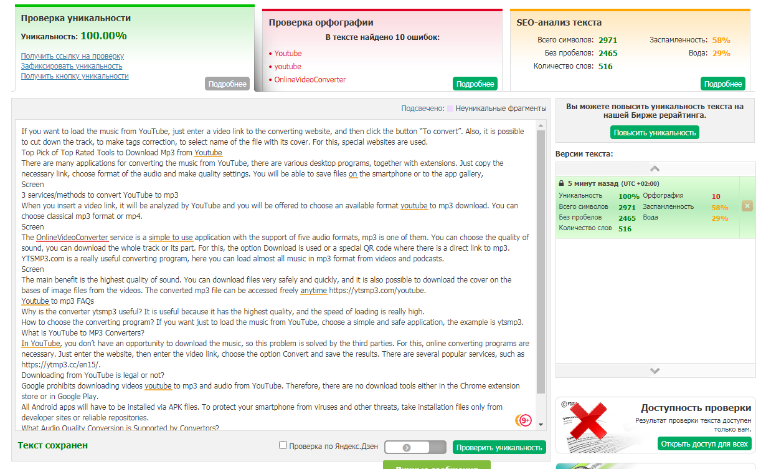
2. Choosing the best youtube to mp3 converter for you
If it is necessary to download the musical files from youtube to mp3, you must copy the video link, then choose any website for conversion and find the option Convert. Get the result and correct the track, if necessary. For example, you can cut it down by means of special online application or program convert youtube to mp3.

How to choose a good youtube to mp3 converter?

In the internet, there are many free apps that help you to download music from youtube in mp3format. All of them have different options, basic and additional ones. All apps have their benefits and disadvantages, for example, music can be converted slowly or with advertisement for convert youtube to mp3 that is really irritating.
While receiving mp3 music from youtube, choose a converter that is free, make the conversion and save the file to your mobile phone or to your personal computer, for this you can use https://ytmp3.cc/en15/.
Some converters don’t have any advertisement, that’s very convenient, and the download is fast. Choosing such a program will help you to succeed in conversion youtube to mp3 320.
What are the Standard Features of YouTube to MP3 Converters?
Video is very important for us, it is used both for education and entertainment. But sometimes it is necessary to take only audio from youtube, without the picture. Such a need can arise if you want to share a big file with many users or if you have a limited storage of files. Special programs of conversion are perfect because that can turn big videos into small and convenient to use mp3 files during download youtube videos mp3.

What are Some of the Best Free YouTube to MP3 Converters?
Converter from youtube to mp3 is a service for download youtube to mp3 that is very popular. Its design is simplified, no difficult to understand navigation is used. The interface is easy to use, and the website can be used by people without any special knowledge.
Such converters usually support almost all formats of sound, including standard and classical format of mp3. The interface of the best youtube to mp3 converter is usually clear and user-friendly, the safety of conversion and simplicity of navigation make such website popular.
YTSmp3 is a high-quality and popular converter, it has many supporters in different countries https://ytsmp3.com/youtube. The service youtube to mp3 online is free, it is provided online and compatible with different operation systems,
Screen
The Process of Converting YouTube Videos to MP4
Screen
It is the best converter from Youtube to mp3 music, the algorithm of use youtube to mp3 high quality is simple, in order to load the files one needs to:
- Find the video, copy its link;
- Open the converter, insert the link in order to analyze it, it will take a few seconds;
- Choose the option Download and wait until download is over. Then just save the result, and that’s all.
Screen
The downloaded files youtube to mp3 320 are available directly from the program - just click the Find button next to the selected video. By default, the program saves files in MP3 format, but it also supports AAC and OGG. You can change the format in the settings dialog.
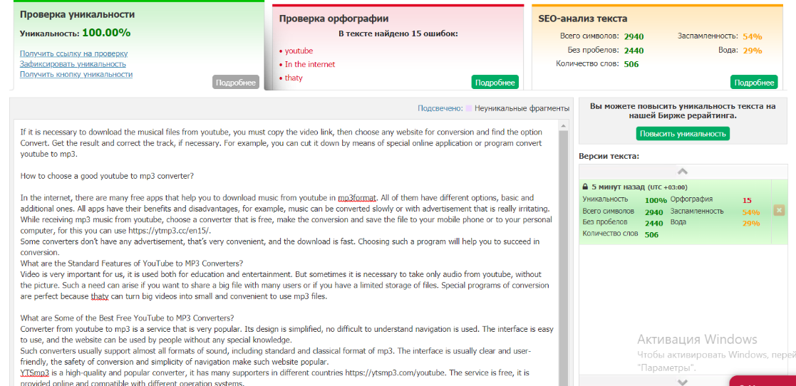
3. Free YouTube To MP3 Converters — The Ultimate Guide
All people enjoy watching youtube videos, but very often it is necessary to make conversion of youtube files into mp3 files, youtube to mp3. The legality of this action is doubtful, but many people are still doing it because sometimes it is necessary to listen audio without internet. Moreover, sometimes people use youtube to mp3 tracks for ringtones. So, it is really good to make such conversion for personal use.
How do YouTube-to-MP3 sites work?
The experts know many ways of conversion youtube to mp3. It is possible to load the video on the desktop and make conversion by means of special software. Also, extensions of the browser can be used and special websites for conversion. If people often make such an operation, special conversion sites for convert youtube to mp3 can be useful. Audiophiles, without doubt, will appreciate a special conversion website https://ytsmp3.com/youtube.
Screen
Benefits of YouTube to Mp3 Conversion tools
Conversion sites work like browser extensions, they help to load the files and make the necessary conversion. Also, it is not necessary to use a special browser extension, that’s a big advantage. It is a perfect option if you have a public computer where VLC can’t be loaded and browser extensions can’t be installed.
Features that YouTube to Mp3 Converter can provide
Mp3 is a well-known audio format, it’s a so-called classical format. It can be used with any devices. If mp3 file is converted from youtube, files youtube to mp3 320 can be converted from video to audio on all operation systems, including operation systems of your smartphone, such as Android and iOS.
Just make a connection to the internet and choose any web browser, for example, Opera or Firefox. Then, it’s time to listen to your favorite music converted from youtube!
Online Converter Vs Desktop Converter
If you use a free converter of the files from youtube to mp3 audio, it is not necessary to register, to create your profile or to install some extra programs for download youtube videos mp3. Conversion process is very simple, just make a few operations and enjoy your favorite music!
What is the best way to convert a Youtube video to mp3? – Our top pick
Screen
If your aim is to save the favorite music with the best youtube to mp3 converter, just choose the site ytsmp3.com, this site is really easy to use:
- Choose your favorite video and copy the link;
- Open the conversion site, if you haven’t opened it yet;
- Paste the link into a special field and wait until it is analyzed for youtube to mp3 online;
- Download the result by using a special option Download.
In addition to YouTube videos https://ytmp3.cc/en15/., this service also allows you to convert content from various social networks, as well as many other sites. Here are just some of the advantages of this service convert youtube to mp3:
- High quality sound;
- The service is easy to use download youtube videos mp3;
- No need to install anything on the PC;
- No need to register;
- Ads are not inserted into downloaded files of youtube to mp3 high quality.
Screen
The videos are not always successfully converted. But, in general, this website is perfect for everyday use.
