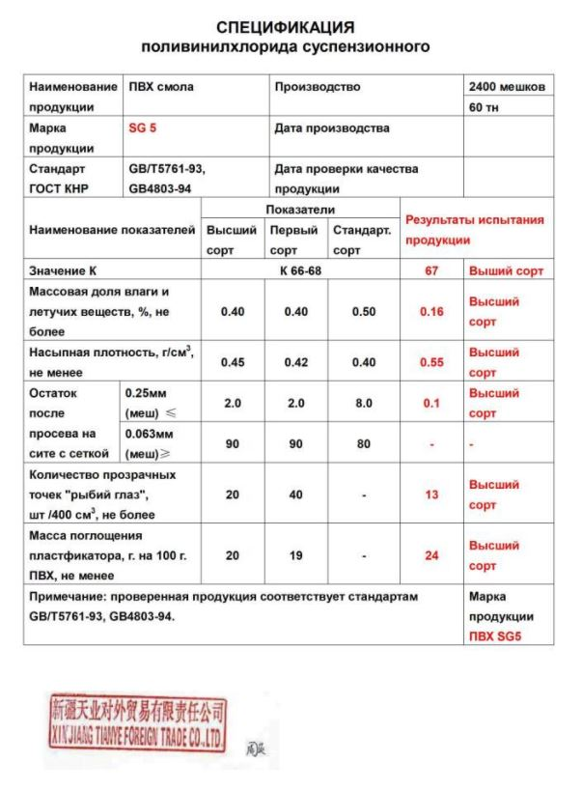

SPECIFICATION
PVC suspension

Product |  | PVC Resin |  |  | Manufacturing |  |  | 2400 bags
Grade |  | SG 5 |  |  |  |  |  | 60t
Standard  GOST PRC |  | GB/T5761-93,  GB4803-94 |  |  | Manufacturing date
 |  |  |  |  | Quality Assurance date
Parameter |  |  | Grades |  |  |  | Test results
 |  |  | Premium Grade | Grade 1 |  | Standard Grade
K-Value |  |  | K 66 - 68 |  |  |  | 67 |  | Premium Grade
Moisture and volatile matters (%wt) ≤ |  |  | 0,40 | 0,40 |  | 0,50 | 0,16 |  | Premium Grade
Bulk density (g/cm3) ≥ |  |  | 0,45 | 0,42 |  | 0,40 | 0,55 |  | Premium Grade
Residue after sieve analysis | 0,25 mm (mesh) ≤ |  | 2,0 | 2,0 |  | 8,0 | 0,1 |  | Premium Grade
 | 0,063 mm (mesh) ≥ |  | 90 | 90 |  | 80 | - |  | -
Fish eyes (counts/400cm3), ≤ |  |  | 20 | 40 |  | - | 13 |  | Premium Grade
Plasticizer absorbency (g/100 g) ≥ |  |  | 20 | 19 |  | - | 24 |  | Premium Grade
Note: tested product is compliant to requirements of standards GB/T5761-93 and GB4803-94 |  |  |  |  |  |  |  |  | Grade  PVC SG5

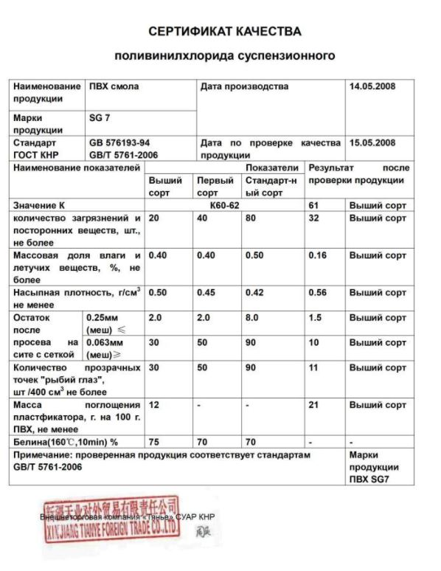

QUALITY CERTIFICATE
PVC suspension

Product |  | PVC Resin |  |  | Manufacturing date |  |  | 14.05.2008
Grade |  | SG 7
Standard  GOST PRC |  | GB 576193-94  GB/T 5761-2006
 |  |  |  |  | Quality Assurance date |  |  | 15.05.2008
Parameter |  |  | Grades |  |  |  | Test results
 |  |  | Premium Grade | Grade 1 |  | Standard Grade
K-Value |  |  | K60-62 |  |  |  | 61 |  | Premium Grade
Number of impurity particles, ≤ |  |  | 20 | 40 |  | 80 | 32 |  | Premium Grade
Moisture and volatile matters (%wt) ≤ |  |  | 0,40 | 0,40 |  | 0,50 | 0,16 |  | Premium Grade
Bulk density (g/cm3) ≥ |  |  | 0,50 | 0,45 |  | 0,42 | 0,56 |  | Premium Grade
Residue after sieve analysis | 0,25 mm (mesh) ≤ |  | 2,0 | 2,0 |  | 8,0 | 1,5 |  | Premium Grade
 | 0,063 mm (mesh) ≥ |  | 30 | 50 |  | 90 | 10 |  | Premium Grade
Fish eyes (counts/400cm³), ≤ |  |  | 30 | 50 |  | 90 | 11 |  | Premium Grade
Plasticizer absorbency (g/100 g) ≥ |  |  | 12 | - |  | - | 21 |  | Premium Grade
Whiteness (160ºC, 10min) % |  |  | 75 | 70 |  | 70 | - |  | -
Note: tested product is compliant to requirements of standard GB/T 5761-2006 |  |  |  |  |  |  |  |  | Grade  PVC SG7

