**About the Esperio broker**

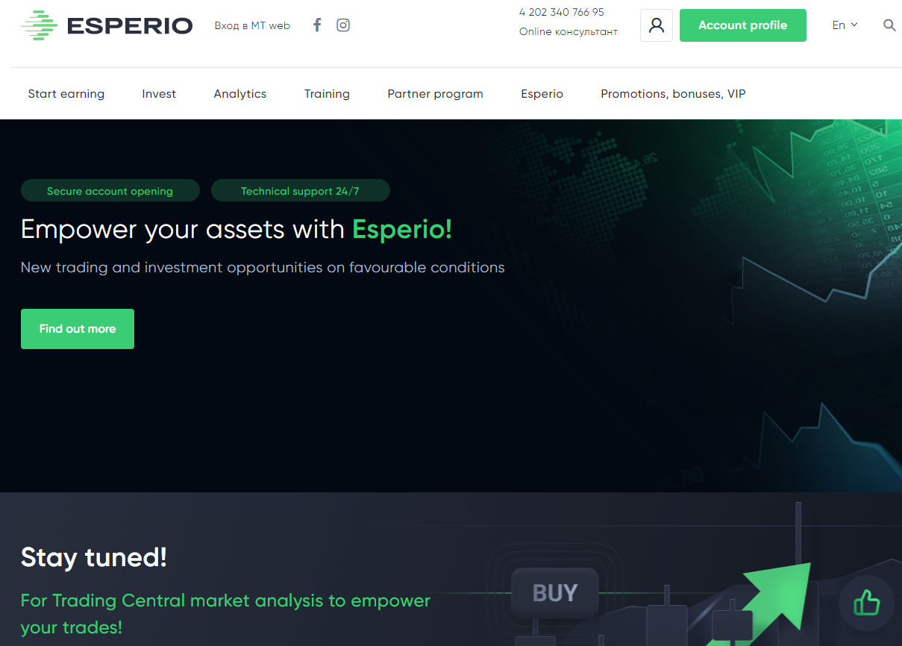The CIS countries are traditionally an interesting region for international forex brokers, but not everyone manages to attract attention to themselves. Almost every month a new company appears, but we don't find out about many of them, they just can't get promoted. Now the competition is very high, we need to offer something really interesting, unique. The easiest way is to give good trading conditions, but this doesn’t guarantee an influx of customers, you need to develop something new, expand areas of activity. **The Esperio broker** has been working in this market for a long time. The company can be described as the most customer-oriented with excellent working conditions and a large number of different services. Let's look at the main aspects of the work and talk about trading with Esperio.

**General information about Esperio**

**Esperio** started its activity in 2012. The company is registered under the name OFG Cap.Ltd, place of registration – Saint Vincent and the Grenadines. By type of activity, it belongs to international business companies, the Esperio trademark belongs to the OFG Cap. The license for financial transactions with securities and derivatives was obtained from the regulator at the place of registration. We should note that this is a fairly popular jurisdiction. It is often chosen by forex brokers who conduct international activities. Over the past 10 years, **Esperio** has achieved impressive results; the trade turnover of customers exceeded the $1 billion mark within a month and continues to grow. The broker is expanding the geography of its presence, and now it is actively working to attract clients from CIS countries.

**A brief description of the broker:**

● The registration date – 2012.

● Jurisdiction – Saint Vincent and the Grenadines.

● The broker's official website – **esperio.org**

● Trading platform – MetaTrader.

● Types of trading instruments – currency pairs, metals, stocks, indexes, cryptocurrencies, energy carriers.

● Leverage – from 1:1 to 1:1000.

● Depositing and withdrawal – bank payments, cards, EPS and cryptocurrency.

● Training programs – 4 courses.

● A system for copying transactions – check.

● Investment instruments – check.

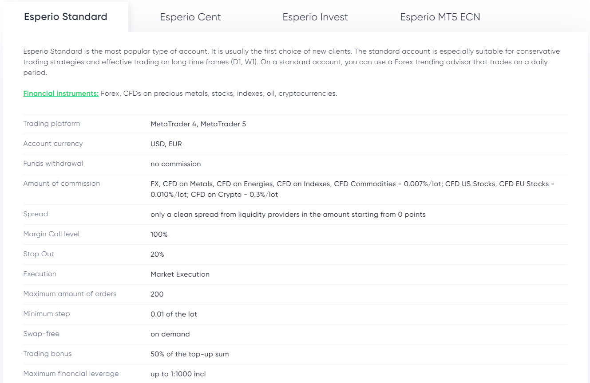● Affiliate program – check (2 types).

**Trading conditions and instruments**

The spread and commission rates at the **Esperio** broker correspond to the best in the industry – with a commission of up to 0.013%, the broker makes it possible to trade with spreads from liquidity providers. This approach significantly reduces the costs of active traders who trade within the framework of short-term movements and make a large number of trades. Traders are offered the following categories of trading instruments:

1. *Currency pairs*, in total, more than 50. We should note the presence of rare crosses and pairs with exotic currencies.

2. *Metals* – gold, silver, platinum and palladium. **Esperio** offers pairs not only with the US dollar, but also with other currencies.

3. *Stocks and stock indexes* in the amount of more than 500. The markets of the USA and Europe are represented.

4. *Energy carriers* – oil of two grades and natural gas.

5. *Cryptocurrency*. All major coins and in addition pairs with other currencies besides the US dollar, as in the case of metals.

The overall list is quite impressive, it allows you not only to trade within the framework of speculative strategies, but also to form investment portfolios. All instruments except currency pairs are offered in the form of contracts for difference in value (CFDs).

**Copy trading system and investment products**

**The Esperio brokerage company** is not limited to just providing access to trading. The broker has a well-developed platform for copying trades of the most successful traders. The broker's client does not have to be a trader himself to earn money, you can use the signals of others. This system operates on a simple principle – we register, open a trading account, then deposit it.

The next step is choosing a trader and subscribing to his signals. The list of signal providers can be found on the **Esperio** website. Everyone has their own selection criteria, profitability is important for someone, others prefer to minimize risks and choose conservative traders. If desired, you can create several accounts and subscribe to different traders with different systems and principles of operation, thus diversifying your investments.

The second great opportunity to invest is in investment portfolios presented on the **Esperio** website. These are ready-made solutions, the investor is only required to follow the instructions of analysts. These portfolios are formed by professional traders with extensive experience who monitor the situation on the markets and look for the most profitable areas for investments. There are a variety of instruments from assets such as gold to stocks (dividend and growth stocks). The expected indicators and parameters, as well as the composition of the investment portfolio, can be found in the description of the portfolios before making a decision on investments. The number will increase, now investment areas are represented by two portfolios and one fund.

**Training by Esperio**

**The Esperio brokerage company** has a training sector where traders can get useful information. The site provides a list of basic terms for free, as well as the first of 4 course options, within which you can learn the principles of working in financial markets, better understand trading processes and get acquainted with the profession of a trader. 3 more courses are designed for deeper study of analysis, strategies and trading systems, and also individual classes with professionals who have been working in the market for a long time. **Esperio** conducts training online, groups are formed depending on the course. The cost is in the range of $250-500 for group classes and $50 for each individual lesson.

**Esperio affiliate program**

The broker offers cooperation to everyone, for this you need to register on the website. There are 2 main options in total, which involve substantial payments and partner rewards:

1. Introducing broker. It’s suitable for those who have experience in this field, well versed in the structure of markets and the functioning of brokers. It assumes good payouts – up to 30% of the spread of attracted customers.

2. CPA and CPL payout system, in addition there is 10% of the spread. The work is carried out using a referral link, the conditions are simple – verification and deposit from $50.

A big advantage is the absence of restrictions on the amount of payments from each referral. Detailed information and the payment procedure are provided by **the official Esperio website**, the «Partner program» section.

**Conclusions**

**Esperio** can be called one of the leaders in a whole list of parameters, ranging from trading conditions to additional services. The broker is constantly developing and closely monitors the interests, requests and conjuncture of the trading community, trying to optimize its services for them. **Esperio** in Russia is gaining momentum; the number of customers exceeds 10 thousand already and is constantly growing. At this rate, in 1-2 years, the broker can become an industry leader, and this will be quite a natural result.

***Esperio – forex broker for all traders:***

<https://www.youtube.com/watch?v=2a3zFumEDUc&t=3s>