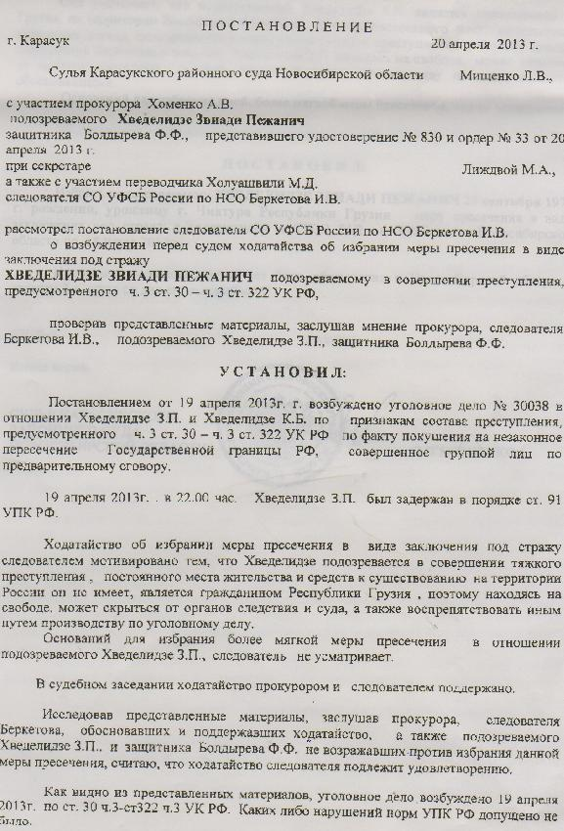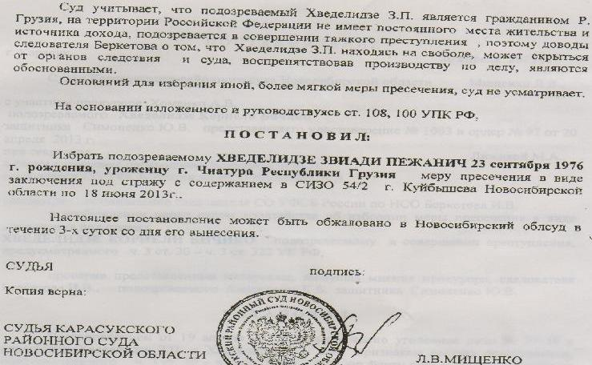

dadgenileba
q. karasuki 20 aprili 2013 weli

novosibirskis olqis raionuli sasamarTlos mosamarTle l. v. miSenko

TandaswrebiT: prokurori a. v. xomenko

eWvmitanili: zviadi beJanis-Ze xvedeliZe
damcveli: f. f. boldirevi, romelmac waradgina 2013 wlis 20 aprilis orderi #33 da mowmoba #830

mdivni: m. a. liJdvoi

agreTve:
Tarjimani m. d. xoluaSvili

ruseTis federaluri usafrTxoebis samsaxuris sammarTvelos sagamamZieblo ganyofilebis novosibirskis olqis gamomZiebeli i.v.berketovi

ganixila ra gamomZieblis fuss sg nso – is i.v berketovis mier dayenebuli Suamdgomloba, zviad beJanis-Ze xvedeliZis patimrobaSi ayvanis Taobaze, romelic eWvmitanilia ruseTis federaciis sisxlis samarTlis kodeqsis 30-e muxlis nawili III da 322-e muxlis nawili III Sesabamisad.

sasamarTlom wardgenil masalebze dayrdnobiT, aseve moismina ra prouroris - a. v. xomenkos, gamomZieblis - i.v.berketovisa da braldebul z. b. xvedeliZis dacvis - f. f. boldirevi mosazrebebi mimdinare sakiTxTan dakavSirebT

daadgina
2013 wlis 19 aprilis dadgenilebiT aRZruli sisxlis samarTlis saqme #30038, ruseTis federaciis sisxlis samarTlis kodeqsis 30-e muxli, III nawili da aseve 322-e muxli III nawiliebis Tanaxmad – (ruseTis federaciis saxelmwifo sazRvris ukanono gadakveTa) z. b. xvedeliZisa da k. b. xvedeliZis mxridan ikveTeba danaSaulebrivi qmedebebi.

z. b. xvedeliZe dakavebul iqna 2013 wlis 19 aprils 22:00 saaTze, ruseTis federaciis sisxlis samarTlis processualuri kodeqsis 91 muxlis Sesabamisad.

gamomZieblis mier sasamarTlos winaSe dayenebuli Suamdgomloba eWvmitanilis mimarT aRkveTis RonisZiebis gatarebis Sesaxeb motivirebulia imiT, rom xvedeliZem Caidina mZime danaSauli, radgan mas ar gaaCnia ruseTis federaciis teritoriaze arc mudmivi sacxovrebeli adgili da arc raime saarsebo wyaro. eWvmitanili aris saqarTvelos moqalaqe da Tavisublebaze yofnis periodSi, is SesaZlebelia miemalos sasamarTlosa da sagamoZiebo orgamoZiebs da aseve xeli SeuSalos da SeewinaaRdegos sisxlis samarTlis saqmis warmoebas.
gamomZiebeli z. b. xvedeliZisTvis mimarT garda aRkveTis RonisZiebisa, sxva msubuqi RonisZiebebis Catarebis safuZvels ver xedavs.

sasamarTlo sxdomaze dayenebul Suamdgomlobas mxari prokurorma da gamomZiebelma dauWira.

G prokurorisa da gamomZiebel berketovis mier Seswavlil masalebze dayrdnobiT dayenebuli da mxardaWerili Suamdgomloba, ar gauprotestebiaT arc braldebul z. b. xvedeliZes da arc mis damcvel
f. f. boldirevs.

rogorc wardgenili sabuTebidan irkveva, sisxlis samarTlis saqme aRZrulia 2013 wlis 19 aprils yovelgvari procesualuri normebis darRvevis gareSe, ruseTis federaciis sisxlis samarTlis kodeqsis 30 muxlis III nawili da 322 muxlis III nawili Sesabamisad.
sasamarTlo iTvaliswinebs ra, rom eWvmitanili z. b. xvedeliZe aris saqarTvelos moqalaqe da mas ruseTis federaciis teritoriaze ar gaaCnia arc sacxovrebeli adgili da arc saarsebo wyaro, aris eWvmitanili mZime danaSaulis Cadenaze. aqedan gamomdinare, gamomZiebeli berketovi samarTlianad miiCnevs eWvmitanilis mimarT aRkveTis RonisZiebis Catarebas, radgan TavisuflebaSi myof xvedeliZes SesaZlebloba ar mieces aaridos Tavi sasamarTlos da xeli ar SeuSalos sagamoZiebo organoebs.

sasamarTlo eWvmitanilis mimarT SedarebiT msubuqi RonisZiebebis gatarebis safuZvels ver xedavs. warmoTqmuli mosazrebebidan da ruseTis federaciis sisxlis samarTlis kodeqsis 108 da 110 muxlebze dayrdnobiT,

daadgina^

eWvmitanil zviadi beJanis-Ze xvedeliZes, dabadebuls 1976 wlis 23 seqtembers saqarTveloSi, qalaq WiaturaSi, Seefardos Tavisuflebis aRkveTa patimrobaSi ayvaniT. novosibirskis olqis qalaq kuibiSevis 54/2 sagamoZiebo izolatorSi 2013 wlis 18 ivnisamde.

arsebuli dadgenileba misi gamoqveynebidan 3 dReRamis ganmavlobaSi.
SesaZloa gasaCivrebul iqnas novosibirskis saolqo sasamarTloSi.

xels awers novosibirskis olqis karasukskis raionuli sasamarTlos mosamarTle l. v. miSenko

