Main Chapter
Speaking about accordion performance culture in WEC, its establishment and development, it should be stressed that accordion originally developed as an instrument of mass culture aimed at execution of simple melodies. Ease and availability of their reproduction in a variety of conditions of peoples’ life defined a great popularity of the instrument in Western Europe in the latter half of the nineteenth and early XX centuries.
Accordion has become an instrument responsive to the needs of mass artistic perception. In a certain way accordion played a role of mediator between the world of classical music and popular song-and-dance music.
This instrument is being actively developed as an area of professional academic performance, as well as pop-jazz art. Largely this was promoted by creative activity of a number of prominent artists, educators and artists. One of the important factors in this case, was the interest of professional composers shown to accordion and chromatic accordion. Western European countries presented us with a whole galaxy of bright, interesting, talented performers.
Accordion performance culture of WEC
Phil Bouffier, France. Artist, composer, author of solo projects. He has been studying music since he was seven. He participated in various international competitions, on his account of victories are Copa Mondial and reward in Castelfidardo. At present time, Bouffier plays many concerts in France and around the world: USA, China, Fiji, New Zealand, Germany, Italy, Serbia, and Bolivia... The French musician collaborates with many actors, singers, and participates with his band "Jazz-funk-fusion" in many jazz festivals. He has his own professional recording studio. On Phil’s account is also participation in TV programs and four solo audio CD.
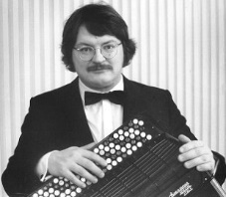
Alain Muzikini (1962, Avignon, Italy) – one of the most successful Italian accordionists. All styles and genres from classical music and gypsy jazz to bebop are subject to him. Chosen a career of musician at age 15, he won the prestigious World Cup in Kansas (USA) four years later, where he brilliantly played Bach’s famous D-minor Toccata and Fugue. Winning the competition discovered for Alan prestigious television studio CARRERE. The musician performs on tour in Europe and America with solo concerts of classical and jazz music, master classes, playing with famous singers (Reggiani, Guichard)... He organized his own quartet in 1986 with whom he plays the most famous dance evenings in France. He never repeats itself, making each of their concerts an unforgettable spectacular show.
Matti Rantanen (1952, Helsinki, Finland) – one of the leading classical accordionists. He has started playing accordion at age five. He graduated from Helsinki University with a degree in musicology, pedagogy and aesthetics in 1974. He also studied in the Royal Danish Academy under the guidance Mognesa Ellegard the spring of 1974. He is the laureate of the numerous national and international competitions. He performs as lead singer and a chamber musician at many international festivals around the world, including Amsterdam, Moscow, Toronto, Reykjavik, Paris, Budapest, and Helsinki. When it was decided that accordion will be taught in the Sibelius Academy (Helsinki), Matti Rantanen was approved as a head of the Department of the accordion in the Sibelius Academy. His school has earned excellent reputation at the international level; his students took first place in many international competitions. Sibelius Academy bestowed him with the title of Teacher of the Year in 1996. Matti Rantanen held master classes in Germany, Spain, Norway, Poland, Serbia, Russia, the Netherlands, France, Austria, Lithuania and Estonia, and was a visiting professor at the Academy of Music in Trossingen (Germany), at the Royal Academy of Music in Copenhagen (Denmark) and the Royal Academy of Music in London (UK).

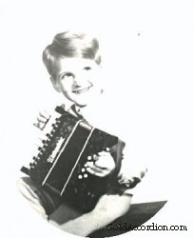
Zoltan Oros (1966, Hungary). Zoltan Oros inherited love for the instrument from his father, who felt early musical abilities of the son and presented Zoltan his first accordion when the child was only four years old.
In 1977, 11-year old Zoltan entered the Budapest Special Music School named Bela Bartok, where he studied playing the accordion along with organ class. After that, he enters the Higher School of Music in 1984. In 13 years, Zoltan Oros took part in the prestigious international competition of accordionists in the German city Klingenthal where he won the audience with his perfect game.
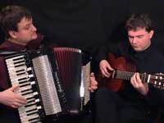
In 1992, along with guitarist Gabor Urshu Zoltan creates ensemble “Duet Podium”. Selection of popular, so-called "evergreen" tunes on the accordion in virtuoso performance contains its repertoire. The purpose of the musicians is to show the sound of accordion in various musical genres. The ensemble performs French Musette, German, Italian, Russian, Spanish popular melodies. “Duet Podium” tours with concerts in many countries around the world from Singapore to Paris, but always with distinct pleasure musicians perform at home in Hungary.
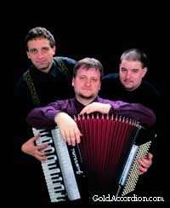
In 1993, with the mediation of Zoltan Accordion Trio Budapest was created (two accordions and one bass accordion). This is actually the only ensemble of such kind in Europe, which has a huge success both at home and abroad. Artists also perform French music. A couple of years ago they were the only foreign participants invited to the National Accordion Festival in France.

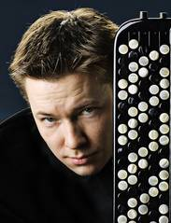
Janne Rättyä (Finland) considered one of the leading classical accordionists. In 2002 he debuted in the Chamber Hall of the Berlin Philharmonic (with the debut series Deutschland Radio Berlin), performing the first classical accordion solo concert of ever presented there. He performs as a solo artist and a chamber musician throughout Europe, the U.S. and Asia. Janne performed with such artists as Jorma Hynninen, Pekka Kuusisto, Martyn Brabbins and Patrick Galois. He was awarded with numerous prizes in various international competitions of classical accordion, primarily in the Arrasate Hiria in Spain in 1996. He works closely with contemporary composers, such as Aldo Clementi, Dieter Schnebel, Brave Pulkkis and Iris Ter Schiphorst, creating new music for his instrument.
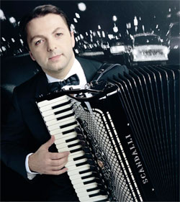Mirko Patarini (1966, Spoleto, Italy) is an outstanding Italian accordionist. In 1978, he began to study music at one of the offices of the Italian musical didactic center. At that time course of study of accordion playing was not included in the overall course of the Italian conservatory. In October of the same year, he began to take part in various national music competitions, where he received various awards and distinctions in Ancona, Pescara, Retsanate and other Italian cities. In 1980, he began to study playing on a bass accordion, and in 1981 has become one of the winners of preliminary competition-selection in Castelfidardo (Italy), which gave him the right to participate in the 30th World Cup Accordion, where he was the youngest performer. He started working with company "Fartisa-Bontempi" in 1988 as a music expert and here he began to develop his skills in a new direction and namely in electronic music. During those years, the concert activity of Mirko Patarini moves from classical repertoire to contemporary one, from acoustic to electronic accordion, from solo performances to concerts where both accordion and computer are involved. He now plays in Italy, as well as in Germany, Switzerland, Spain, Holland, Great Britain, Egypt, Brazil, USA, Russia, Norway, Sweden, Luxembourg, Japan, China, the Netherlands, etc. Nowadays he is co-owner of the company "Menghini SRL" together with Mirko Patarini brothers Leonardo and Luciano Menino, which develops, manufactures and distributes well-known brands of accordions "Scandalli", "Paolo Soprani" and "Menghini".
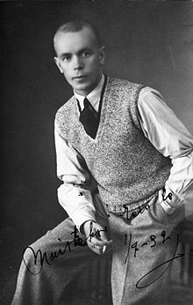
Viljo Vesterinen (1907-1961, Helsinki, Finland) is a Finnish accordionist and composer, four-time winner of competitions Bayan Scandinavia (1934, 1936, 1938 and 1939). He played in the Suomi Jazz orchestra from 1929 to 1931, then Dallapé-orchestra; also, he performed as solo artist and in duet; he did about 700 records totally. His records sold successfully not only in Finland and Scandinavia, but throughout Europe. He is especially known for his "Syakkiyarven Polka" which was recorded in 1939 and used for military purposes during the Russo-Finnish War of 1939-1940: it could create radio interference that did not allow a radio signal to explode mines laid by Soviet troops during their retreat from Vyborg.
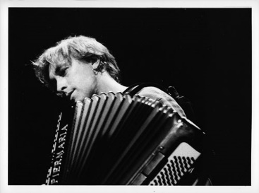
Yann Tiersen (1970, France) is a French multi-instrumentalist, composer and conductor minimalist. He plays various instruments among which are violin, piano, accordion, acoustic and electric guitar, cello, carillon, harpsichord, melodic harmonica, vibraphone, mandolin, banjo, etc. As main instruments in his works, he often uses piano or accordion. He gained a tremendous popularity due to the soundtrack to “Amelie”.
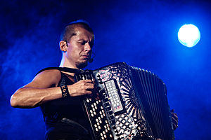
Kimmo Pohjonen (1964, Finland) is a Finnish musician and accordionist. He performs with improvisations over twenty years, plays rock music, avant-garde, Finnish folk music as well as the classics. He modernized traditional sound of Finnish accordion with the help of modern technology of sound design.
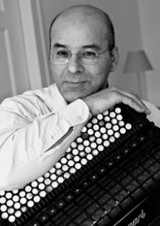
Teodoro Anzellotti is an Italian accordionist. He studied in Karlsruhe and Trossingen and hold classes in Bern (1987), Darmstadt (1992) and Freiburg (2002). The repertoire of Anzellotti are Baroque composers (Bach, Buxtehude, Haydn, Froberger, Frescobaldi, Domenico Scarlatti, and Rameau), now he performs the works of contemporary composers.

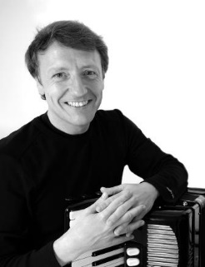
Stefan Hussong (1962, Hollerbach, Germany) is a German accordionist. He studied at the Hochschule für Musik Trossingen then in Toronto and Tokyo. Hussong is the first performer of more than 80 works, which are dedicated to him. Repertoire of the plays and transcriptions he performs is huge: Bach, Handel, Haydn, Mozart, Frescobaldi, Rameau, Domenico Scarlatti, Bartok, Stravinsky, Hindemith, Shostakovich, Berio, Gubaidulin, Nergord, Piazzolla and others. He teaches at the Musikhochschule Würzburg.
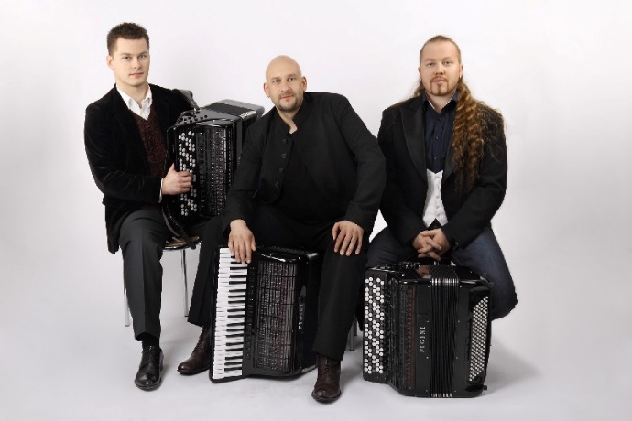
“Motion Trio” is a Polish trio founded in 1996 by Janusz Voytarovich – the leader of the group and the author of most of the compositions. Today it has become a real discovery in European and world music market. Music performed by the team changes our view of the possibilities of the accordion. Music whose authors are members of the band themselves, riddled with elements of different musical genres – from rock and jazz to classical music. Group members:
Janusz Voytarovich is an accordionist, composer, arranger, music producer, theatrical music author, accordion ensemble founder and a publisher of Motion Trio Akordeonus, which records CDs for Motion Trio and scores for accordion. He graduated from Musical Lyceum Frederic Chopin in Krakow. Then he became a student at the Academy of Music in Krakow in the class of the accordion and organ (private lessons) of Professor Andrew Byalko. He is the composer of most of the scores for ensemble Motion Trio.
Paul Baranek. He began his musical education at the age of ten years as a student of the State Music School in Mechow in class of the accordion of Master Wieslaw Kusena, with whom he then continued his musical education at the State Music Lyceum Ignatius Jan Padarevsky in Tarnow. He graduated Academy of Music in Krakow magna cum laude in class of accordion associated by Janusz Pater. He is the author of many compositions executed by ensemble “Motion Trio” and the winner of national and international competitions among accordionists.
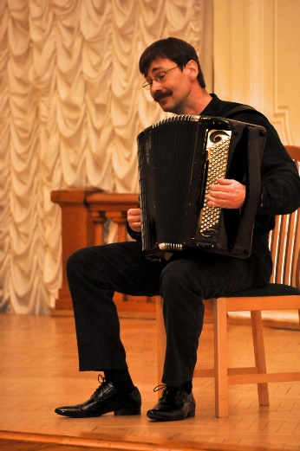
Petri Makkonen (1967, Finland) is a composer and performer. Petri Makkonen began his accordion apprenticeships at the age of 14 years at Heidi Velam who was the teacher of Sibelius Musical Academy. Nowadays he is a faculty member of the Finnish city Kuoppio conservatory. His musical performing art was highly appreciated both in the most of Finland and beyond.
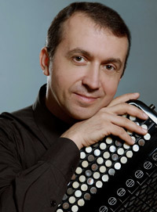
Franck Angelis (1962, France) is a composer and performer. He received his musical education as an accordion player in the French city of Melun near Paris. Big success comes to Frank Angelis in 1979, when he won the Grand Prix at the International Competition of accordionists, organized by the French teacher and musical philanthropist Fernand Lacroix. After that, he became the winner of a number of other prestigious national and international competitions among accordionists. In the 90s, he often involved in the jury of various competitions, both in France and abroad. The same time he is engaged in an intensive educational work accordion and chromatic accordion, plays many concerts in France and abroad (China, Czech Republic, Yugoslavia, Austria, Italy, Switzerland, Belgium, etc.).
Bogdan Precu (1960-1996, Poland) is a composer and performer. He was born in a small Polish town Myslowice, near Katowice. As an accordionist, he graduated from the conservatory in Katowice where he gave lessons with outstanding Polish artist and teacher Joachim Pihury. He taught at the same school from 1984 to 1987, and then up to the end of his life he lived in Spain in Madrid. Over the years, he has actively toured, recorded a lot on radio and TV across Europe. He was a member of the jury of many accordion international competitions. He was a member of Slaski accordion quintet from 1980 to 1987 and as a member of the group was awarded at two international competitions - in St. Etienne (France) and Castelfidardo (Italy). He toured in many countries around the world as a solo artist and in ensemble, performed with leading Polish orchestras – Warsaw and Katowice Philharmonic. However, he had to play a lot in the various jazz ensembles and rock bands. It came out from here – fiery, sharp syncopated rhythms coming from the jazz and pop music took place in his performance.
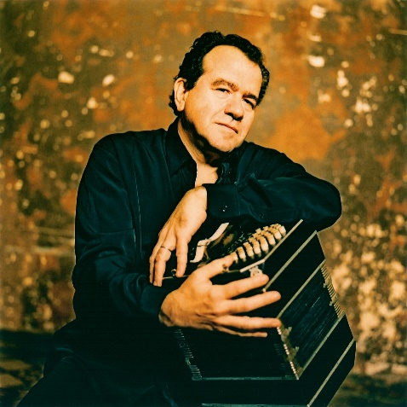
Richard Galliano (1950, Cannes) is a world-famous jazz accordionist. In France, he is called a “sacred monster of jazz”. The musician owns the game on all flavors of the accordion. Galliano was born in Cannes and his first lessons in piano and accordion he received from his father. He graduated Magana cum laude from the Conservatory in Nice. In his youth, he participated in international competitions for accordionists and became famous as an interpreter of the Bach, Tchaikovsky and Gershwin music. Already then, he won the Trophée Mondial in Valencia and the first prize of the President of the French Republic (1968). In 1973, Galliano moved to Paris, where he worked with such stars of French songs, as Jacques Brel, Barbara, Serge Reggiani Serge Gainsbourg, Charles Aznavour, Juliette Greco, Georges Moustaki, Yves Montand, and Claude Nougaro. In 1983, he met Astor Piazzolla who invited the young musician in the theater Comédie Française as a bandoneonist for the first performance of Shakespeare’s “Midsummer Night's Dream”, to which the maestro wrote the original music. His friendship with the great musician lasted until his death in 1992. This meeting was a landmark for Galliano’s career. Since 1980, Richard Galliano plays with such musicians as Chet Baker, Joe Zawinul, Al Foster, Pierre Michel, Jenn Clark, Jan Garbarek, Paquito D'Rivera, Philip Catherine, Toots Thielemans, Michel Portal, Ron Carter, Michel Petrucciani, Enrico Rava, and many others. In 1993, he won a prize at the Academy of Django Reinhardt in French jazz Academy and was named musician of the year. At the same time, he signed an exclusive recording contract with Dreyfus Jazz. From 1993 to 2003 he recorded 12 CDs. Richard Galliano played in many cities around the world – in Paris, Rome, Berlin, Moscow, London, New York, San Francisco, Montreal, Buenos Aires, Tokyo. Among the most prestigious stages in which the speaker Richard Galliano and his colleagues played are Lincoln Center in New York, La Scala in Milan, Concertgebouw in Amsterdam, Théâtre des Champs Elysées in Paris. Richard Galliano is also known as a teacher: he taught video courses for accordionists around the world.
List of wizards of Western European art of the accordion can be further continued - Bogdan Dovlash, Kshanovsky Andrzej, Krzysztof Olchak, Martin Vyrostek (Poland), Mika Vyayurenen (Finland), Alain Abbot Louis Beyer, Mark Bertume Emile Vache, Azole Marseille (France), Francesco Petrodarki (Italy), Albert Vossen and Rudolph Vyurtner (Germany), etc.

Accordion and chromatic accordion Weltmeister
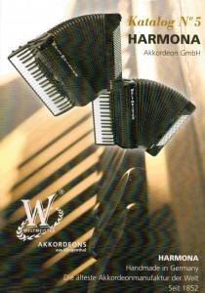
Weltmeister (Harmona Akkordeon GmbH), Klingenthal, Germany, foundation date – 1852.
Address: Reichsstrasse 17
D-08468 Reichenbach / Vogtland
http://www.akkordeon-klingenthal.de/
Due to modern technologies, high-quality assembly of instruments, constant creative search, great sound and reliability accordion and chromatic accordion Weltmeister rightfully enjoys a well-deserved love and recognition of accordionists from many countries, including Russia.
Due to the division of Germany after the Second World War two main German factories, producing Weltmeister and Hohner accordions were in different conditions of development, which affected the production Weltmeister. It lagged in quality, though continued to be a leader in sales in the socialist camp markets. After German unification, there became more freedom and opportunity in the choice of materials, and quality of instruments has grown and reached the level of the best world manufacturers. By the way, prices of instruments are rather democratic.
For more than 160 years (since 1852), there is an accordion factory in Klingenthal, and due to it this small German town became known throughout the world not only as the largest manufacturer of accordions, but also as a center of musical culture with a musical competition which is very well-known and respected by all popular accordionists, the victory in which makes you are well-known immediately and opens the door to all major halls of the world.
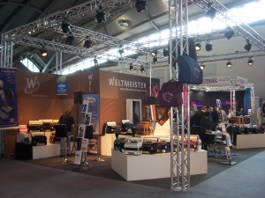
Weltmeister stand on music fair in Frankfurt am Main (2012)
Cheap Weltmeister accordions and chromatic accordions for children for study consists the main range of the factory.
Want to buy an accordion or chromatic accordion Cavagnolo? 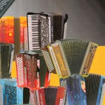
This means that you will belong to a privileged circle of owners of this tool. Of fusion of traditions and innovation accordions, chromatic accordions and digital tools are born every day in the factory that are highly appreciated by famous musicians. Pay attention to the harmony of lines, the famous lattice of right treble parts: chrome-plated with two flying swallows and two dragons. And beautiful sound?
Now let me tell you a few lines from the story of the founder of the family factory. Domenico Cavagnolo founded the factory in 1904 in the Italian city Vercelli halfway between Turin and Mailand, and in 1923 moved to the French Villeurbanne, today’s part of the Lyon. In 1937, both of his sons have adopted the family business. Pietro, a brilliant technician, actively started to implement their idea of ​​creating the world famous tool with a unique sound. And he managed to create such accordion. The second brother Ermano, a trueborn manager succeeded in factory’s building-up and its tools not only in France but also far beyond its borders.
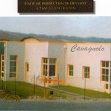
Cavagnolo, factory building
Cavagnolo production expanded and in 1956, the factory moved to new modern premises. In 1969 the third generation of Cavagnolo: Paule, Claude and Francoise Rive Cavagnolo took over the factory's management and continued large family traditions on. French Cavagnolo was the first one who made ​​a breakthrough in the world of modern digital accordions. In 1994 a new page in the history of the factory began, the new model Odissey – digital accordion of the future was created and presented to the public. The tool was developed with the direct participation of Jean-Louis Noton – French accordionist and accordion-specialist in the field of computer technology (Jean-Louis Noton plays chromatic accordion like the overwhelming majority of French musicians). By the way, he is a regular participant of all musical fairs in Frankfurt and always dressed extravagantly, plays a lot and presents the opportunities of digital accordion Odyssey.
Moreover, the tool is really good: light, beautiful, with lots of voices, including all kinds of tools and harmonic timbres, its body have an elective system, besides the dynamics the same as a normal accordion depending on pressure and force of conducting fur.
No one any longer denies that science and electronics are playing nowadays an increasingly important role in all sectors. Almost all musical instruments, including accordion and chromatic accordion do not stand apart from this processes and develop actively.
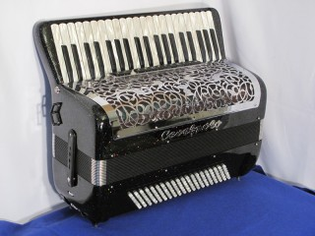
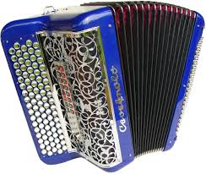
Cavagnolo was the first company and since 1965, revolutionary technologies have emerged and developed and later became available to other firms producing accordions.
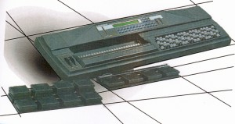
Cavagnolo, MIDY 20, Keyboard / synthesizer with chromatic keyboard
Here's an example:
- 1965: MAJORVOX, the first electronic accordion with transistors;
- 1967: MAJORVOX ts, the first electronic accordion with built-in switch;
- 1974: MOSS, the first organ with accordion keyboard;
- 1983: PROLOG, the first digital organ with accordion/chromatic keyboard;
- 1984: MIDY 5, first located MIDI keyboard for accordionists.
- 1986: DMX 123, the first dynamic M.I.D.I. / MIDI system for the accordion;
- 1991: CS20 first Expander with 128 accordion timbres;
- 1992: Odissey 1, the first digital accordion with 128 voices;
- 1996: Odissey 2 with Liberty 4, the first digital accordion without cable with integrated HF transmitter;
- 2001: Odissey 3 with Modell ORCHESTRA, first standard digital accordion “All in one”;
- 2006: ZykboX.
Paolo Soprani factory
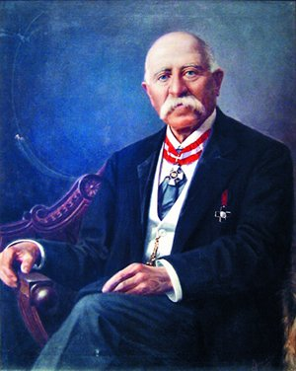
Over 70% of Italy's GDP accounts for a small business, and many economists believe that it will not allow the country to eventually solve the problem of the debt burden of $ 2.6 trillion because small business is really small one. However, there are examples in Italy showing that the size of manufacture does not always matter. Town Castelfidardo located on the east side of the Italy for 150 years lives by the principle of “quality over quantity”, while maintaining the reputation of the world capital of accordion business. Musicians come from all over the world for production of famous masters of Castelfidardo and sometimes pay ten thousands of euros for one tool.
The history of conversion of two millennial brass instrument into a modern accordion passes through Europe. His prototype is the first known instrument with reed principle of sound called ancient eastern “sheng”. In the middle of the XVIII century, a German musician and a traveler brought sheng home from China, and in the beginning of XIX century, the instrument became the prototype for the invention of accordion. In 1822 organ and piano tuner, Christian Buschmann from Berlin was inspired by design of the tongue Chinese sheng and invented a little harmonica by attaching leather fur to a tuning fork to tune bodies. Seven years later in Vienna Cyril Demian with his sons Karl and Guido created and patented harmonic chord with accompaniment in the left hand. Since then all the harmonics, which had chordal accompaniment, were called accordions. Emerging of this instrument in Italy in the middle of the XIX century coincided with the struggle for the unification of disparate territories into a single state.
The instrument sounded in a folk-simple manner but optimistic that was in the spirit of the time: in search of a new national identity, famous Italian zest for life was born, and import of accordion played not the last role in it.
Soprani’s Clan
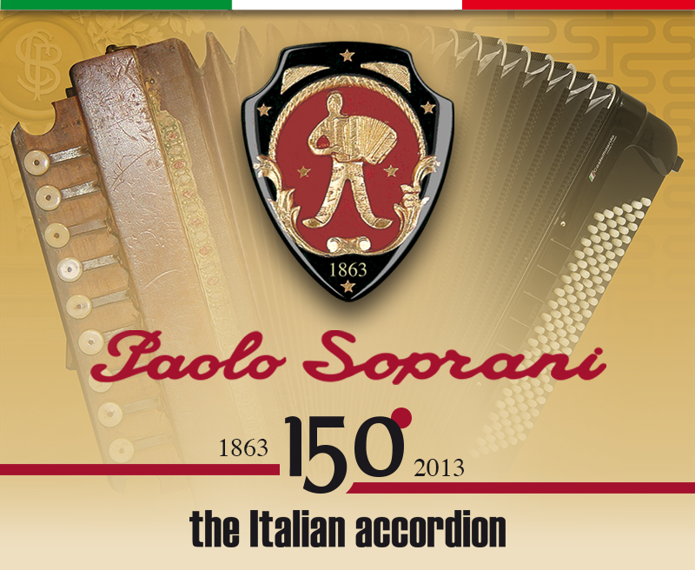
One of those who caught the recent developments was a young farmer from Castelfidardo Paolo Soprani. One wandered Austrian monk who stayed at Soprani’s home, brought copy of the Demian accordion and whether left tool in gratitude for the hospitality, whether sold his to the master. Third version says that a talented young man disassembled instrument, studied, restored it and returned it to the guest. Anyway, Paolo learned a new craft, which a few years later spread throughout the county. In 19 years, the young man refused to be a peasant and started right in his parents' house a small workshop in 1864, and later opened a new bigger shop, where he brought together several local craftsmen who knew and understand the issues of carpentry and mechanics. Soprani sold his first accordions at the fairs in neighborhood town Loreto, where a monastery that gathered many pilgrims was. Besides that Paolo made ​​quality tools, he also learned to play them, which boosted the popularity of new items to Soprani accordions and almost immediately relished the local public. It was easy to accompany folk songs and dances.
Classical musicians, however, also recognized accordion. Giuseppe Verdi in 1870 made ​​a proposal to introduce playing accordion (formerly considered exclusively “national” tool) as an official subject in Italian conservatories. In 1883 for the first time in classical music, Tchaikovsky wrote an accordion party for his Second Suite.
Soprani expanded its manufacturing but lagged behind the increasing demand, and in 1872 Paolo opened in Castelfidardo a whole factory. A few years later, he invested the profits in construction of a huge building of his company in those days at the center of Castelfidardo. It was the first factory of harmonics in Italy. Paolo has already produced 1,200 accordions per month when nobody thought about mass production. Rumors about his instruments spread quickly and orders were already from Sardinia and abroad – from European countries and the USA. At the World Exhibition in Paris in 1900, Soprani accordions received the highest award, and he became a member of the Brussels Academy of Inventors and was adopted by French President Emile Loubet on the Champs Elysees.
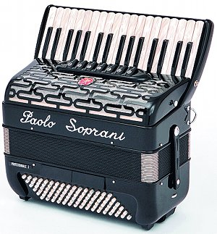
Small workshops of other accordionists began to appear not only in Castelfidardo but also based all over the country. Initially, the most part of the production was sold on the Italian market. According to official figures, in 1907 only 690 accordions were exported, but already in 1913 this figure reached 14,365 units. Of course, Italian immigrants did their job, who overwhelmed the U.S. Coming to the United States, immigrants from the Apennines quenched sounds of nostalgia and poignancy with accordion and opened in their new locations small shops selling tools, and even music schools, where children can learn play them.
As for Paolo Soprani, he continued his work until 70 years old and in 1914 conveyed his business in hands of the son Luigi Soprani.

Shine. Poverty. And shine once again.
Cruel XX century was not the most favorable for the accordion business. After all, musical instruments in general, and especially accordion are the goods of mostly emotional value, the popularity of which depends on the mood of customers and of society itself. The first sign of decline of the rapid growth in production of Italian accordions fell on the market crash on Wall Street in 1929. Export of accordions from Italy to only in the United States fell from 26 000 units in 1926 to 17 000 in 1932. Naturally, this event had big consequences for the region, where the craft was promoted and considered profitable for accordionists: people remained without orders and work.
Assistance came from where it was not expected. The dictatorship of Fascist Party of Italy came to power in the country in 1922, considered these musical instruments worthy of public support. Propagandists of the fascist regime called accordion the invention of “pride diligence and grace of the Italian people”. To protect the industry in 1937 Consortium of manufacturers of accordions and accessories for them, with headquarters in Ancona was created by the branch Association. The president of the consortium was a member of the pro-fascist parliament - charismatic Angelo Manarezi and the vice president was the nephew and namesake of his famous uncle Paolo Soprani. Consortium coordinated the government contracts and volumes of supplies. Only in 1941, Benito Mussolini ordered for the army 1 000 accordions.
Yet The Second World War had a negative effect on the development of industry in Italy. Total production decreased from 51,000 instruments in 1938 to a mere 500 items in 1944. As a result of Allied air forces bombardments Soprani's factory suffered greatly. But after the liberation of Italy from Nazi troops and the establishment there of republican government in 1945 the sector began to rise again. Only in Castelfidardo, a city with 9000 inhabitants, 19 new firms producing accordions were founded from 1946 to 1948.
Unprecedented boom of production came in the early 1950s. In the U.S., there were accordion orchestras, who performed at the celebrations of the Italian diaspora. Castelfidardo started receiving dividends from tens of thousands sold musical instruments. In 1953, about 10,000 craftsmen did here 200 000 accordions per year.
This was also a time of major mergers. Soprani, for example, has teamed up with Scandalli from neighboring Camerano under the brand name “Farfisa” and became the largest factory of musical instruments in the world that produced 180 accordions per day. New York Excelsior opened a factory in Castelfidardo, whose products almost entirely returned on sale in the United States. In the town companies with pretentious titles appeared: Paramount Accordions, Universal Accordions, United Artists, Metropolitan and MGM. The street where the owners of accordion villas have built their companies then called Dollar Street.

Blame it on the Elvis
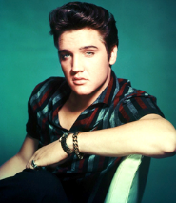
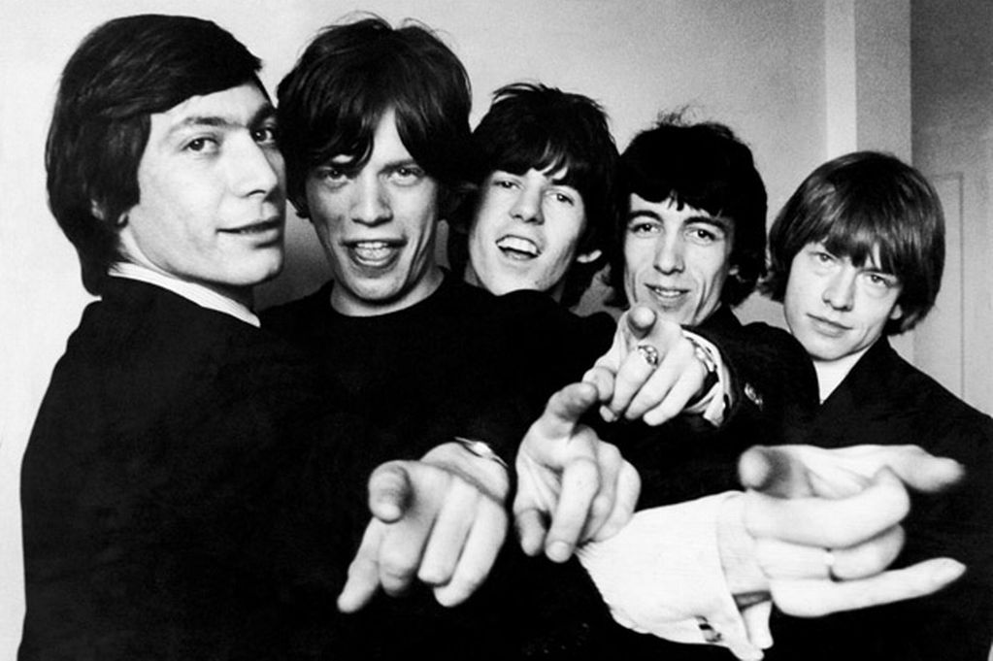
However, in late 1950s the next crisis appeared on the horizon. And this time the reason was not in the economic situation or war, but in a simple change of musical trends - energetic rock 'n' roll rhythms were in fashion. Compared with Elvis Presley, “The Rolling Stones” and even “The Beatles” whom Castelfidardo still consider the culprits of sunset of the golden age, melodic accordions seemed irrelevant to young people. Accordionists in those days lost to rock musicians in charisma.
Representatives of the accordion industry paid no attention to TV, which would be an excellent channel for promoting their products. Besides the urbanization process began in Italy; people moved from their homes to apartment buildings, and accordion, anyway, is very loud musical instrument. Some companies in Castelfidardo region were able adjust to the new market conditions and started to produce electric guitars and synthesizers. Farfisa achieved a breakthrough by creating the first electric accordion Cordovox in 1962.
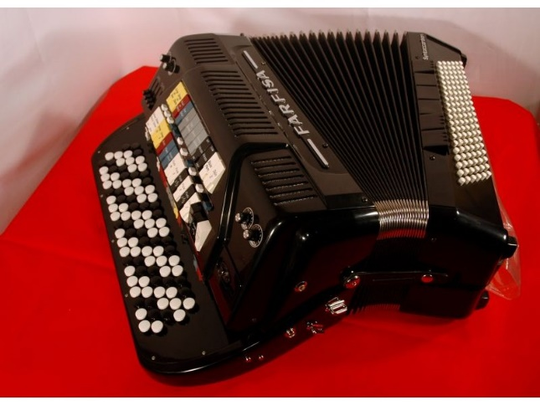
However, many manufacturers have not gone through reduction of demand. Now Castelfidardo produce only 20 000 accordions a year - 90% less than during the boom years.
Nevertheless, people have not stopped to play accordion, remaining firms, among which are Soprani/Scandalli change its accents. If in the 1900s inexpensive accordion could be purchased for $ 5, tools worth up to 50,000 euros are now produced in Castelfidardo. Focus on quality, rather than quantity still supports accordion industry of the country. Italy remains a country of “many small items of excellent quality”, as Deputy Minister of Labor and Social Policy Michele Martone mentioned.

