

APPENDIX 1
to VTM 038 OG

ULTRASONIC FLAW DETECTOR
UD4–T

Operator's Workbench

USER GIUDE
VTM 038 UG

2007

Contents
1 General description 3
1.1 What is a Workbench UD4-T 3
1.2 Workbench UD4-T purpose 3
1.3 Software and Hardware Requirements 3
2 Preparation to Use 3
2.1 Before Installation 3
2.2 Program Installation 3
2.3 Removing the Program 5
3 Work with Program 5
3.1 Program algorithm summary 5
3.2 Program Start 5
3.3 Program Adjustment 7
3.4 Data synchronization 7
3.5 Work with Reports 8
3.6 GUI language 8
3.7 Changing of Main Window View 8
3.8 Use the reference 8
3.9 Information about Program 8
4 Program Modules 9
4.1 Manager Link Module 9
4.1.1 Choice of Interaction Interface 9
4.1.2 Device information 9
4.1.3 Device Connection State 10
4.1.4 Device File System Information 10
4.1.5 File record in device 10
4.1.6 Reading file from device 11
4.1.7 Delete file from device 11
4.1.8 Generation and Printout of Reports 11
4.2 RS-232 interface module 11
4.2.1 Connection parameters settings 12
4.3 General purpose flaw detector module 12
4.3.1 Data view 12
4.3.2 Data edit 13
4.3.3 Generation and Printout of Reports 13

1 General description

1.1 What is a Workbench UD4-T
Workbench UD4-T is a software complex, intended for computer processing and storing of test data, got with use of Ultrasonic flaw detector UD4-T HU-01 device. In addition, Workbench UD4-T allows the UD4-T device software version updating, provides easy viewing and navigation of stored data and generates the test results reports.

1.2 Workbench UD4-T purpose
Workbench UD4-T allows to storage the data got by UD4-T device in database, provides easy viewing and navigation of stored data with required details. Workbench UD4-T accepts the UD4-T device software version updating that allows using UD4-T not only as flaw detector but as thickness gauge and tensometer as well. Workbench UD4-T provides to archive test data, that is useful both for technical purposes (history of defect progress, defect statistics and so on) and organization aims, because result report is saved as electronic document and may be used in any ways. Workbench UD4-T provides easy-to-use facility for creating final reports of different objects inspection.

1.3 Software and Hardware Requirements
Workbench UD4-T may be installed on computers with OS: Windows 95/ 98/ NT4.0/ 2000/ XP.
Minimal configuration of PC:
- CPU Pentium 200 MHz or higher;
- 32 Mb of RAM;
- 20 Mb of free hard disk space;
- standard keyboard;
- standard mouse;
- one free serial port (RS-232) for connection UD4-T to computer.

2 Preparation to Use

2.1 Before Installation
First of all, before of Workbench UD4-T software installation check if the computer hardware/software resources correspond to the ones mentioned in section 1.3.

2.2 Program Installation
Workbench UD4-T is distributed as an executive file SETUP.EXE. The file is installation program.
To install Workbench UD4-T on computer:
- Run the SETUP.EXE file for executing.
- Follow the program's instructions enter necessary information for installing. By default software Workbench UD4-T is installed in directory C:\PROGRAM FILES\NDTSW. User may change this parameter.
- By default all available program modules («General purpose flaw detector», «Specialty application-dependent software for railway (СПО ЖД)» etc) are installed.
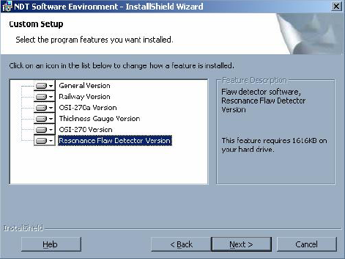
- If the results processing is assumed only for several modules, for example «General purpose flaw detector», «Specialty application-dependent software for railway (СПО ЖД РД 07.09.97)», then other modules are not to be installed.
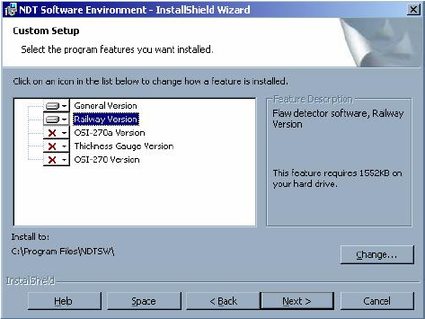
- Wait while Workbench UD4-T is being installed.
- After installation the folder NDTSW appears in START menu. The folder contains shortcut to main module DT Software Environment.

2.3 Removing the Program
Removing of installed program is carried out by standard Windows operation Add and Remove Programs (see Control Panel).

3 Work with Program

3.1 Program algorithm summary
Workbench UD4-T software is built on the base of component technology. It means that the base module (kernel) works conjointly with additional modules (components).
At start, the base module downloads additional modules, and an application package is created. This application package could be modified by some additional modules adding or changing. Changing or adding of additional modules is carried out by copying of appropriate files in the directory, where the program was installed.

3.2 Program Start
ATTENTION! Before device connection to computer through connector of the communication port RS-232 with use of cable (included in deliverу set), make sure that the device de-energized!
Use the START –> Programs –> NDTSW –> NDT Software Environment menu command to start the program. Searching and activation of the program modules is performed after the program start.
The main program window with selected program module Link manager is represented on Fig. 1.
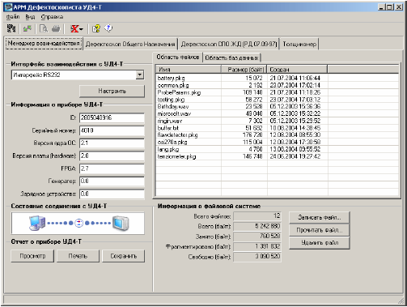
Fig. 1
Main program window contains:
- Main menu, intended for tasks launch (for example, Program adjustment, Help) and for settings of main window parameters.
- Toolbar with the frequently used tasks buttons.
- Field of program modules. Note, that all loaded program modules are represented as separate pages. Moving between the pages is carried out by tab selection.
- Status line, containing reference help on the interface elements.

3.3 Program Adjustment
Select the File\Settings menu command to adjust the program.
Select the following parameters in on the General tab of the Settings window (see Fig. 2):
- GUI language. By now Russian and English languages are available.
- Path to directory, where database files are located.
- Method of synchronization of data with UD4-T device.
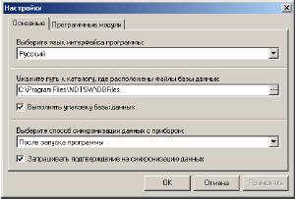
Fig. 2
In the Program modules tab (see Fig. 3) you can see the list of active program modules (with information on file location and size).
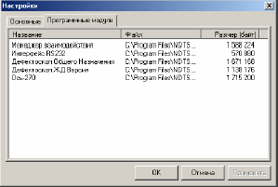
Fig. 3

3.4 Data synchronization
While data synchronization with UD4-T device database files are transferred from the device to computer. Synchronization may be performed by two ways:
- Automatic. Depend on selected method either after program start or before program module opening.
- Manually. Select the File\Data synchronization menu command.

3.5 Work with Reports
There is a possibility to get the checking result report depending on program module that is active in the time.
Select File\View report (Ctrl+V) menu command to view the report.
Select File\Print report (Ctrl+P) menu command to print the report.

3.6 GUI language
There is multilanguage support in the program. By now Russian and English languages are available. Select proper View\GUI language command for switching between languages.

3.7 Changing of Main Window View
Select menu View command and set necessity parameters to get proper main window view:
- View\Hide Toolbar
- View\Hide Status Line

3.8 Use the reference
Select Help\Contents and Index (F1) command to get reference.

3.9 Information about Program
Select menu Help\About Program command to view information about the program.
Following information is accumulated in the Information window (see Fig. 4):
- The program. Information about program version and copyright.
- Software Company. Company details, e-mail, Web address.
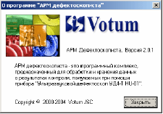
Fig. 4

4 Program Modules

4.1 Manager Link Module
Manager Link module provides the following functions for interaction with device:
- Device state data getting.
- Importation and storage the test data (device archive) in the form of files on computer’s hard disc.
- Device software updating.
- Generation of report about device UD4-T and report printout.
All this functions become accessible due to physical interface realization, for example RS-232 (see description in the section 4.2) etc.
Manager Link module window (see Fig. 1) contains:
- Window of the choice of interaction with device interface.
- Field displaying information about device.
- Field displaying device connection state information.
- Generation of report about device UD4-T field.
- Pages with list of files, recording in device.
- Field displaying information about device file system.
- Field containing device file system control elements.

4.1.1 Choice of Interaction Interface
Select from pop-up list interface to interact with device. Press on the Set button for the interface options set. RS-232 interface settings window is described in the section 4.2.1.

4.1.2 Device information
Device information contains:
- Device ID
- Serial number
- OS kernel version
- Board version
- FPGA version
- Generator version
- Charger version

4.1.3 Device Connection State
The field that represents device current connection state is shown on Fig. 5. Left picture corresponds to connection presence and right – to connection absent.
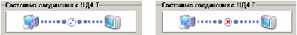
Fig. 5
In case of device connection fault the following should be checked:
- Device connection parameters (see section 4.2.1)
- The correct connection of coupling cable between the device and the computer
- Device active operation mode

4.1.4 Device File System Information
Information about device file system contains:
- Files number
- Total memory size
- Used memory size
- Fragmented memory size
- Free memory size

4.1.5 File record in device
Press Record File button to record file in device. Window with a files list will be opened (see Fig. 6). Select required file(s) from the list and press Open button to begin the files copying on device. Some time is required, depending on file size. If file is bigger than free memory size the device memory defragmentation is performed. In case the free memory size is still less than file size the record is impossible.

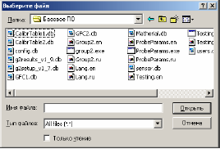
Fig. 6

4.1.6 Reading file from device
To read file from device find it in the file list and press Read file button. Window with a directory list will be opened (see Fig. 7). Select directory in the window where file is to be saved. Press OK.
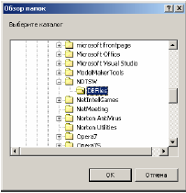
Fig. 7
Reading file from device will be start. It may take some time, depending on file size.

4.1.7 Delete file from device
To delete file from device find it in the file list and press Delete file button. Warning message will appear (see Fig. 8).

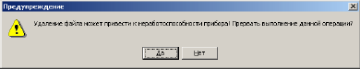
Fig. 8
Click on Yes button to interrupt deletion. Click on No button to delete file.

4.1.8 Generation and Printout of Reports
The program module has function of UD4-T device report generation. To view the report press View button, that placed in generation report field. To print the report press Print. To save report as a text file press Save button.

4.2 RS-232 interface module
RS-232 interface module realizes physical interface interaction with device UD4-T via serial port RS-232.

4.2.1 Connection parameters settings
Connection parameters settings are carried out in COM-port parameters window (see Fig. 9).
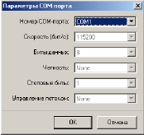
Fig. 9
Note, UD4-T device uses predetermined settings of connection port (115200 8N1), thus in the window only COM-port number is allowed to be changed.
Press OK to save changes.
Press Cancel to cancel the changes.

4.3 General purpose flaw detector module
General purpose flaw detector module is intended to display the data, to generate and printout test reports.

4.3.1 Data view
The Main Window of module looks like this:
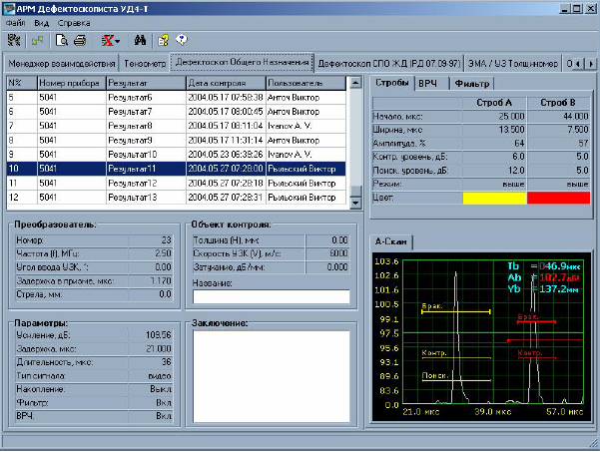
Fig. 10
List of test results is situated in the left upper field of the window. The list looks like a table.
The table columns contain following information:
- Record ordinal number
- Device serial number
- Test result name
- Date and time of test
- Data about the user which executed test.
Information represented in other fields (general test parameters, transformer parameters, test object parameters, strobe and signal parameters, A-scan, B-scan, D-scan) is related to the selected entry.
There are parameters represented in the right upper field of the window: strobe parameters or ARD-diagram parameters (when results are saved, the work is going in ARD-mode); VRC-parameters (when VRC is switch on); filter parameters (when filter is switch on).
In the right bottom field of the window A-scan image is represented. The B-scan or D-scan window will be displayed on a separate tab if it was received (Fig. 11).
Attention! A-scan accumulated curve will be saved if accumulation was included in program «General purpose flaw detector module». When working with B- and D-scan in the capacity of A-scan curve will be saved curve, which was received at passing of the sensor through point 0.

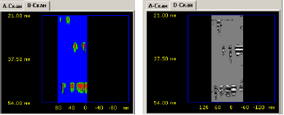
Fig. 11

4.3.2 Data edit
Only record fields Test object name and Conclusion can be edited. To edit these fields enter new value in them. When moving to other record, new values are automatically saved in database.

4.3.3 Generation and Printout of Reports
To generate and print the test report, select the necessary record at first.
Select File\View report (Ctrl+V) menu command to view the report.
Select File\Print report (Ctrl+P) menu command to print the report.

