**Cream cheese cake**

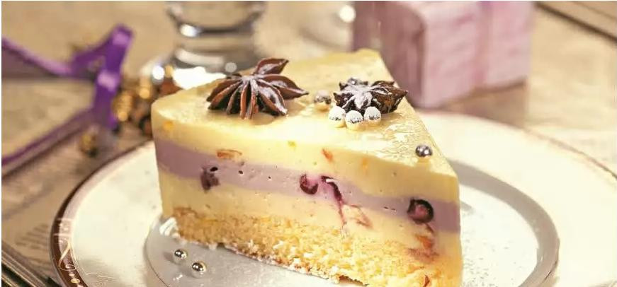

**Ingredients:**

* Icing sugar
* Butter 40 g
* Baking flour 100 g
* Salt
* Cream 20% fat 250 ml
* Baking soda
* 2 eggs
* 1 tbsp lemon peel
* 1 tbsp lemon juice
* 1 orange
* Vanilla sugar
* Philadelphia cream cheese 500 g
* Orange jam 100 g
* Black-currant jam 100 g

**Directions:**

1. At first, bake a sponge cake. Separate yolks from whites and beat whites with salt and lemon juice into feathery froth, then beat yolks with sugar, add melted butter, sifted flour, baking soda and finely ground lemon peel. Blend with a mixer.
2. Preheat oven to 180°С. Cover a springform pan with a baking paper and splash it with water. Slowly blend the yolk mix into beaten whites. Mix with a spatula from the bottom up. Pour into a springform pan and bake for 15 minutes, then let it cool.
3. Whip cream cheese with 50 g of icing sugar and 200 ml of cream. Divide the mix into three parts. Peel an orange, remove membranes and seeds, and cut into cubes. Add black-currant jam into one part of the mix, and then mix it with a spatula.
4. Add orange jam and orange cubes into two other parts of the mix and mix with a spatula. Dissolve gelatin in the remaining cream. Heat up the cream, but do not boil it. Blend 1/3 of the gelatin into black-currant mix, them blend the remaining gelatin into orange mix.
5. Cover a springform pan with a clean sheep of baking paper. Put the sponge cake on it, and then pour half of the orange mix. Put into the fridge for 30 minutes.
6. Pour the back-currant mix and put into a fridge again for 30 minutes. At last, pour the remaining orange mix and put the cake into the fridge for an hour.

Оригинал: http://www.gastronom.ru/recipe/4582/tort-iz-slivochnogo-syra