Contents
Description of project 1
Interface 2
Form with the reports selected by the condition (i.e. Ret) and by the selected period 3
Setting up the period 4
Choosing the type of the report in combobox 5
Code MS SQL 6
Code MS Access 9
Reports 11
Report in MS Access 11
Report in MS Excel 11
Report in PDF 12

Description of project

This project describes some activities of the company selling stationary products.
Most of the sale is done by the sales representatives and each sales representative has its unique number. Performance of the sales representative is controlled by the sales manager and every manager has a number of the reports. These reports could be executed both in Access, and Excel or PDF to be sent to the clients.
The project is executed on MS SQL (data and stored procedures) and MS Access (forms and reports).
Artem Karetnikov 03-22-2015

Interface

A list of reports with the option to find the requested, to set up the period of time (at the bottom) and to provide the results in MS Access, MS Excel or PDF.

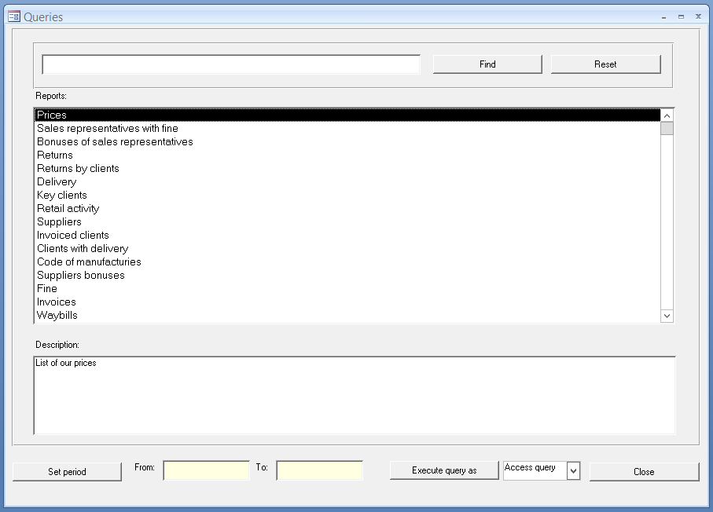

Form with the reports selected by the condition (i.e. Ret) and by the selected period
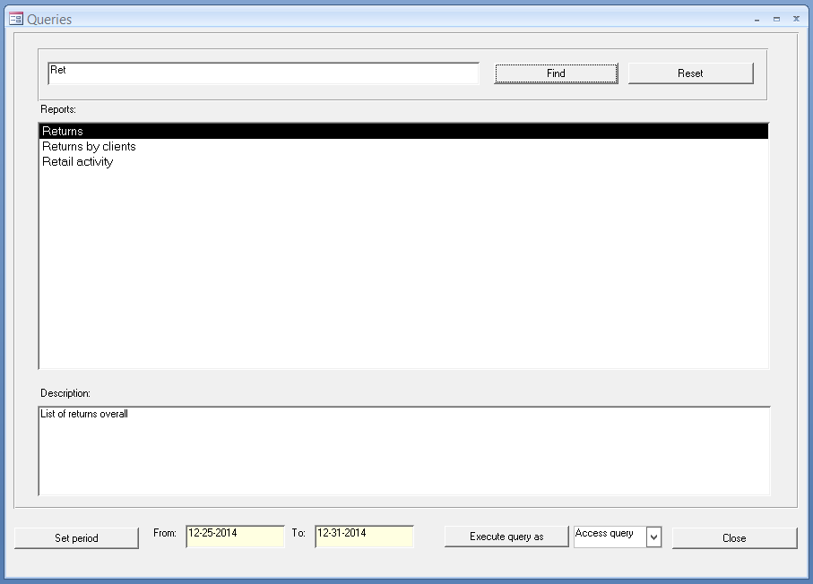

Setting up the period

‘Yellow fields’ - from and to – are setting the period of report. These fields are not-editable fields for users, these values are set by the form, automatically.
Available periods are set as a day, a week, a month etc. The form saves a choosen priod and keeps as defualt value for the next time it is opened (f.e., if a user sets up the period as a week, next time form will suggest it as default value for the period). Also, there is an option to set up a ramdom date at the bottom. However, this date won’t be saved for the next opening.
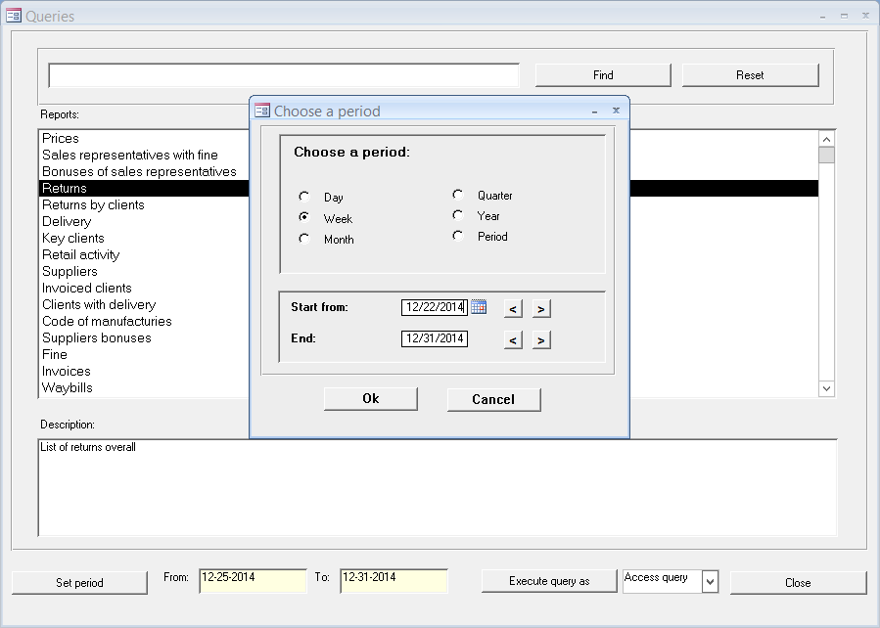

Choosing the type of the report in combobox

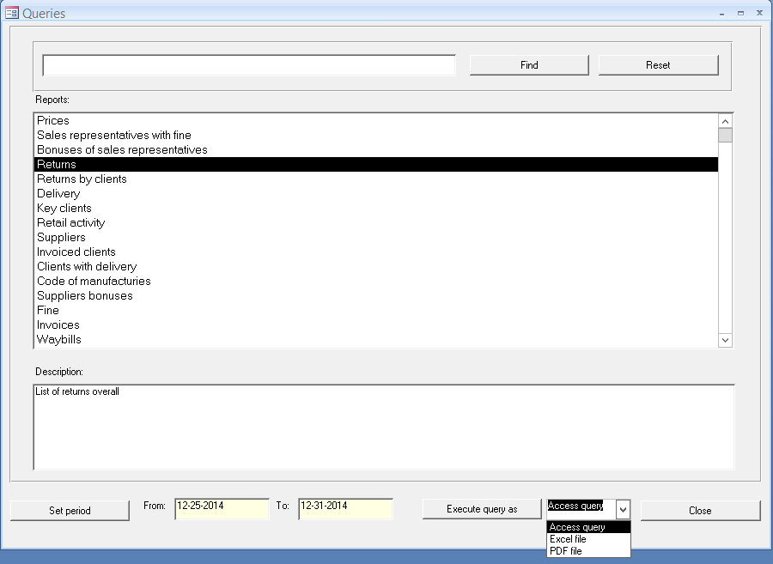

Code MS SQL

Database TRADE is used for the data storage.
Table dbo.tbl_UserQuery is used for the storage of users’ queries and stored procedures, getting the data for the reports. Table dbo.tbl_UserQueryParam is used for the storage of parameters’ names.
Stored procedure p_tbl_UserQuery_Select with parameter @QueryName is used to get filtered list of queries mathcing to the parameter. If this parameter is not set, the procedure will show the full list of queries.

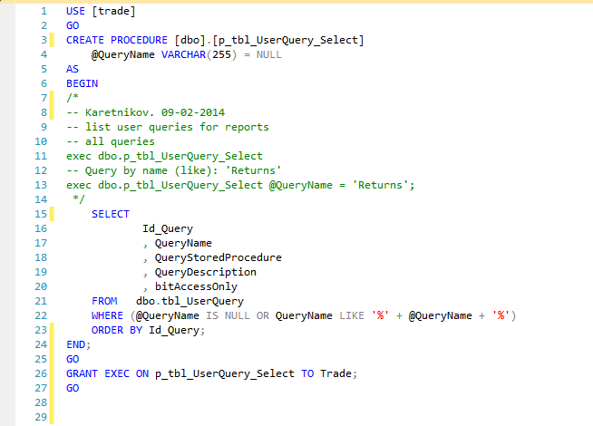

Stored procedure p_tbl_UserQueryParam_Select returns recordset by parameter @Id_Query. This parameter is required.

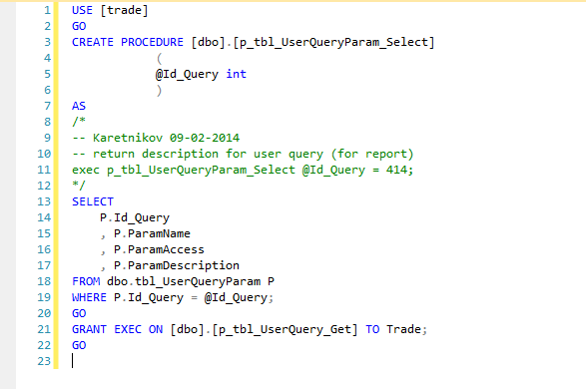

As illustaration the request ‘Returns’ was executed, with @Id_Query as 414 and period set as the last week of 2014. Procedure, returning this recordset, is called p_tbl_Return_Select.
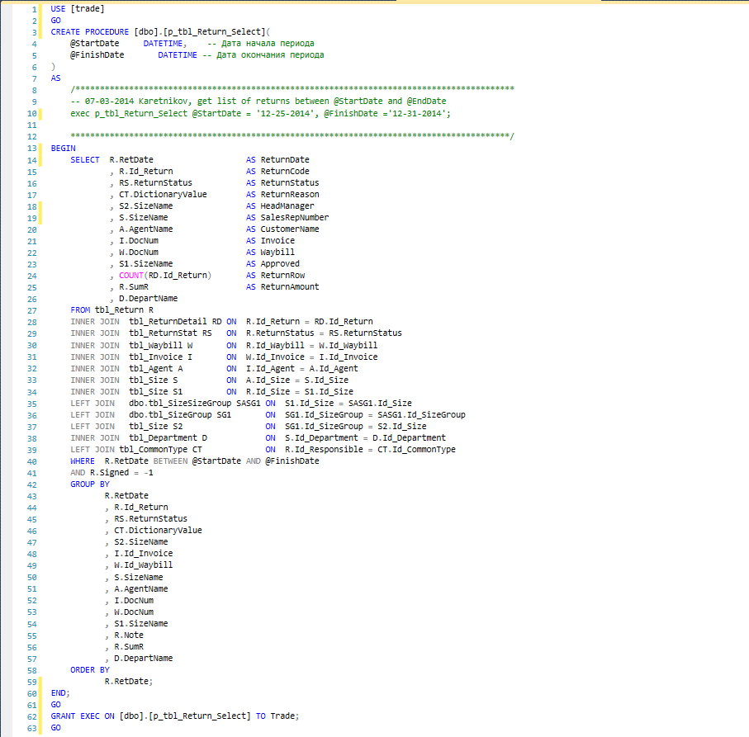

Code MS Access

The procedure btnFind_Click is used to filter the data.
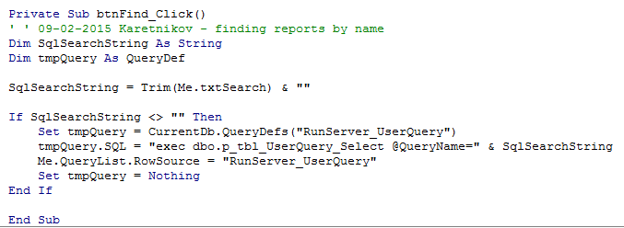
The procedure btnReset_Click is used to drop the filter.
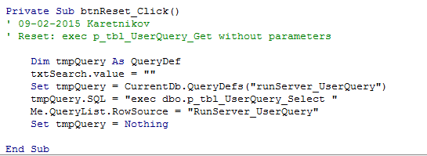
The procedure btnSetPeriod_Click is used to set up the date.
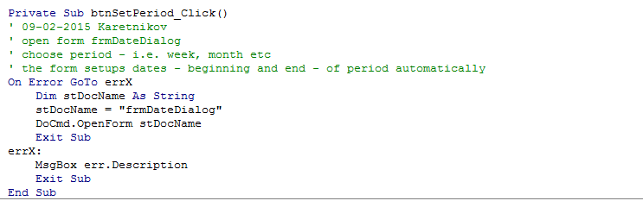
The procedure RunQuery is used to execute the query.
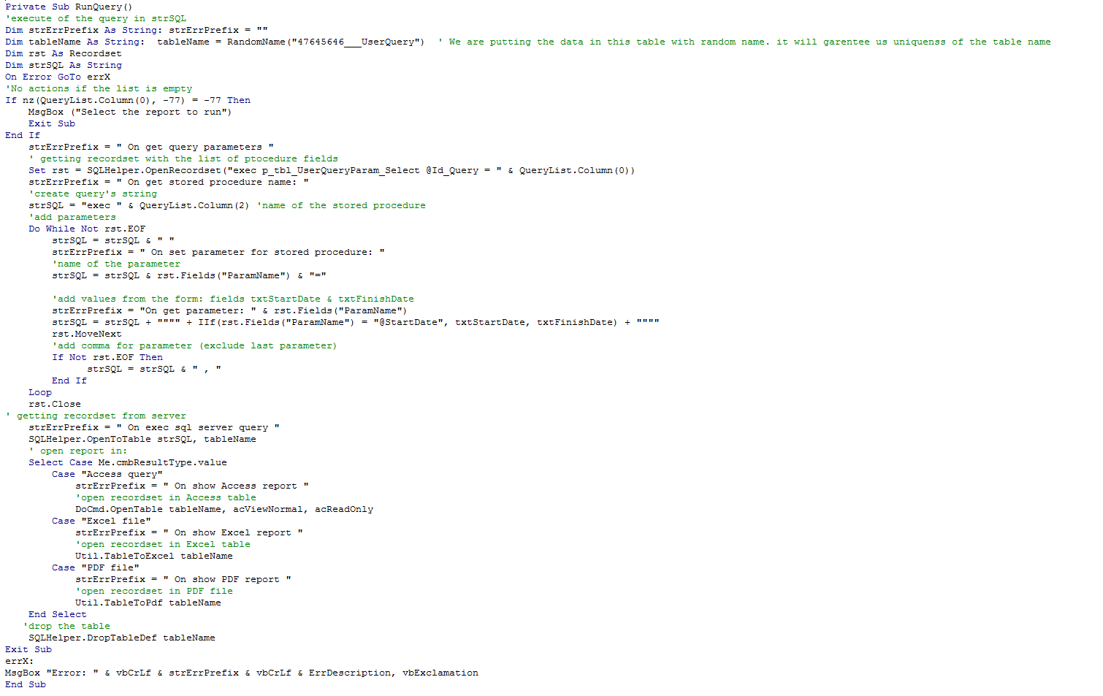

Reports

Report in MS Access

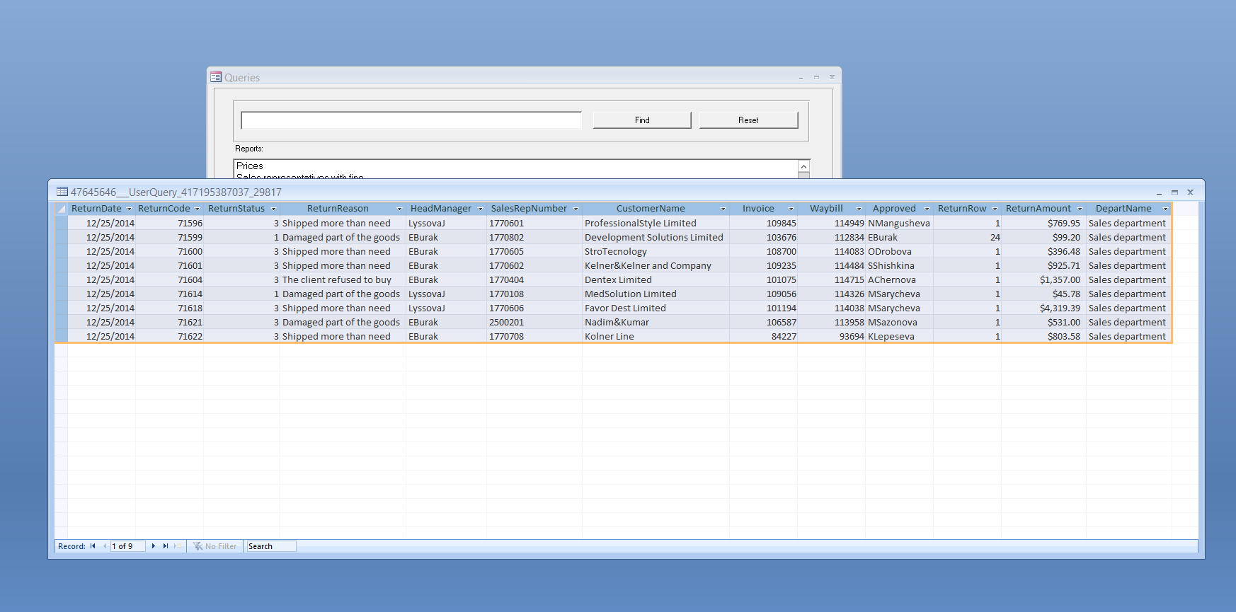

Report in MS Excel

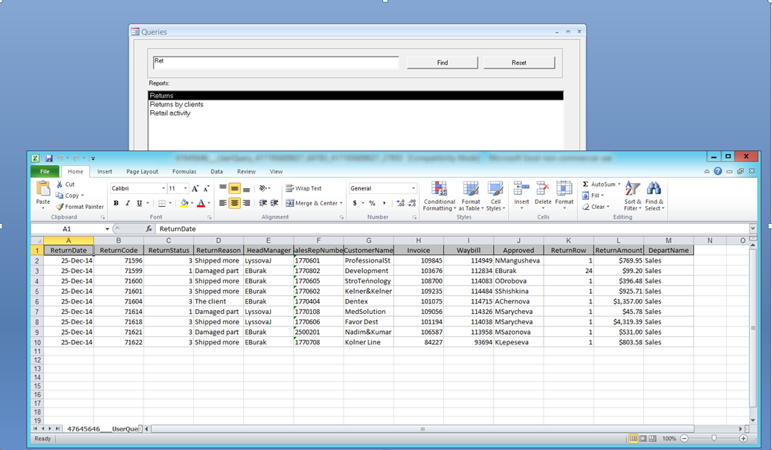

Report in PDF

