Simulating a process of dielectric substrate surface cleaning in
high-voltage gas discharge plasma

N.L. Kazanskiyª, V.A. Kolpakov∗^{b}, S.V. Kritchevskiy^{b}
ªImage Processing Systems Institute, Russian Academy of Science,
151 Molodogvardejskaya st., Samara, 443001, Russia;
^{b}Samara State Aerospace University named after academician S.P. Korolyov,
34 Moskovskoye Shosse, Samara, 443086, Russia

ABSTRACT

The mechanism of dielectric substrate surface cleaning in low-temperature high-voltage gas discharge plasma is theoretically and experimentally investigated. It is shown that the main technological factors that affect surface purity are the time of exposure, discharge current, accelerating voltage. A unique relationship is obtained that relates the value of impurity surface concentration variation to the speed of removing the impurities and exposure duration. It is shown that experimental data agree well with this relationship. It is established that minimal values of impurity surface concentration are achieved at the exposure time no less than 10 seconds, discharge current no less than 3 mA and accelerating voltage of 2-3 kV. An actual example of etching silicon dioxide grooves in high-voltage gas discharge plasma in the mixture of CF₄ and O₂ is taken to show how substrate surface purity affects geometric parameters of microstructures formed. The results of the investigation made it possible to develop a method of cleaning dielectric substrate surface in high-voltage gas discharge plasma. The method is characterized by low cost and energy consumption. It makes it possible to clean a surface up to the level of 10⁻⁹ g/cm².

Keywords: simulating, cleaning mechanism, high-voltage gas discharge plasma, organic impurities

- INTRODUCTION

The quality of micro- and nanostructures formed is determined by the degree of substrate surface purity and its uniformity over the area of the plate. The main contamination source of plates underwent the chemical purification and placed into the processing chamber of the vacuum unit are exhaust materials which operation involves the evaporation of the vacuum oils and its concretion on the substrate surface [1]. Therefore, each time after the substrate was placed in the processing chamber of vacuum unit, its surface should be cleaned from the organic impurity before etching. Nowadays plasma technologies of surface cleaning have gained wide acceptance. They use high-frequency and very high-frequency sources of structural complexity, high cost and power consumption to generate uniform plasma. Nevertheless, in the process of plate treatment in plasma formed by such sources the surface becomes contaminated with particles that have no or little activity as the substrate is placed between the electrodes of a gas-discharge device. Plasma parameters in this case are determined by the properties of the surface being treated (loading effect) to a considerable extent. In [2,3, and 4] advantages of high-voltage gas discharge plasma are discussed: ion-plasma flow is generated outside the electrodes of the gas discharge device; only negatively charged particles (ions, electrons) move towards the surface in such plasma, which makes impossible its contamination with plasma particles. That is why theoretical and experimental investigation of the process of surface cleaning in high-voltage gas discharge plasma appears now to be urgent for the purpose of improving the quality of micro- and nanostructures produced.

- METHODS OF EXPERIMENT
For the investigation, the ceramized substrate and silicon dioxide substrate of the size 30x20x1 mm³ were used [3]. The identity of initial properties of substrate surfaces was secured by the procedure of controllable contamination [5]. The substrate surfaces were cleaned from the organic impurities by means of exposure of structures under investigation to the plasma flux generated by high-voltage gas-discharge device [4]. The values of the accelerating voltage, discharge current and exposure duration were changed within the ranges of 0 to 5 kV, 0 to 3 mA, and 5 to 180 seconds, respectively. The range of the discharge current variation was selected so as to secure the minimal heating of substrate and to exclude the formation of flaws on its surface. The air was used as a working gas. To ensure the reliability and reproducibility of experiment results, ten identical samples were employed for each mode. The dispersion of the values of surface impurity concentration measured was no more than 10 percent.
After exposure, a degree of substrate surface purity was measured by the tribometric method based upon the dependence of probe sliding velocity over the surface on the concentration of organic impurities adsorbed on the surface [6]. The sliding velocity was expressed in relative units — from zero to one — and was an integral estimation. With the sliding velocity V_{sl} =0, the contamination concentration C_{d} was taken to be equal to the minimal detectable concentration, that is, C_{d} =C_{d min}, and with V_{sl} =1 we have C_{d} =C_{d max}, where C_{d max} = ph (p being the density of organic impurities, h being the width of impurities layer) is the concentration of contaminants corresponding to the presence of impurities monolayer on the surface. To determine the true values of C_{d max} and C_{d min,} corresponding to the limiting values V_{sl} =0 and V_{sl} =1, the measurements of the sample substrates were taken, one of which was contaminated by the monolayer of organic impurities (vacuum oil), and the other was to the maximum cleaned from them. The width of impurities monomolecular layer was checked by the scanning probe microscope P4-SPM-MDT, the value of C_{d min} was taken to be equal to 10⁻⁹ g/cm² [6,7]. As the surface contamination has a uniform character, the probe sliding velocity is proportional to the impurity concentration. With due regard to the statements made, the relative values of sliding velocity may be brought to the values of surface concentration of organic impurities (which are measured in g/cm²) by the relationship:
$C_{d}=C_{d\text{min}}+C_{d\text{max}}V_{\text{sl}}$, (1)
where C_{d} is the concentration of organic impurity, expressed through g/cm².

- MECHANISM OF CLEANING
The cleaning of the surface of dielectric substrates was implemented in the plasma of an air of high-voltage gas discharge. According to [3] and [4], in such a plasma, the negative particles will move in the direction of the surface. In the case when the air is a working gas, consisting of 78 percent of nitrogen and 21 percent of oxygen, these particles are the negative ions of oxygen and the electrons. The positive ions of nitrogen and oxygen will move in the direction of the cathode of gas-discharge device. At high values of pressure in the processing chamber, that is, at low values of accelerating voltage 0,5 ≤ U ≤ 1 kV, the surface substrate has always a layer of the neutral molecules NO, N₂O, NO₂ adsorbed on it, generated due to recombination of the oxygen ions with the nitrogen ions and molecules N₂ and O_{2.} [2]. The chemical reactions of these compounds with the molecules of organic impurities, the latter being the hydrocarbons (- C_{x}H_{y} – C_{m}H_{n} -), do not proceed or proceed weakly without an additional activation. With the ion bombardment, the impurities are removed by the process of plasma-chemical etching (PCE) which has found a detailed description in [3, 4]. Under the influence of the ion bombardment, the neutral molecules NO, N₂O, NO₂, N₂, O₂ dissociate on the surface, thus forming the positive ions of nitrogen and oxygen which commence a movement along the electric field lines towards the cathode, and the radicals of oxygen which interact actively with the free surface bonds of carbohydrates. The oxidation of organic impurities is a chain reaction proceeding, apparently, by the following scheme [8]:
$\text{RH}+O→\overset{}{R}+\overset{}{\text{OH}}$; $\text{RO}\overset{}{O}+\text{RH}→\text{ROO}\overset{}{H}+\overset{}{R}$;
$\text{RH}+O→\overset{}{R^{'}}+\overset{}{R^{''}O}$; $\text{ROOH}→\overset{}{\text{RO}}+\overset{}{\text{OH}}$;
$\text{RH}+\overset{}{\text{OH}}→\overset{}{R}+H_{2}O$; $\overset{}{R_{n}O}→R_{n−1}O^{'}+\text{RO}$;
${\overset{}{R}+O_{2}→\text{RO \{}O}^{'}$; $2\overset{}{R}→R_{2}$,
where R and $\overset{}{R}−$ are the fragments and radicals of the organic impurities molecules, $R^{'}$ and $R^{''}−$ are the radicals derivative from R and generated in the process of decomposition of contaminant molecules. As a result of reactions of this kind, the layer of organic impurities is decomposed into separate fragments of small molecular weight with subsequent oxidizing these fragments and generating the gaseous compositions CO and CO₂ and vapors of water H₂O as well.
With the accelerating voltages U being more than 1 kV, organic impurities removal will proceed by the mechanism of the ion-chemical etching (ICE), described in detail in [3], and [4]. It should be noted, however, that at the exposure duration being less 50 seconds, the discharge current up to 10 mA, and the accelerating voltages up to 3 kV the substrate temperature, as it follows from the observed dependence represented in Fig. 1, do not exceed 360 K. Consequently, the adsorption of neutral molecules on the surface is possible and the mechanism of ion-chemical etching of impurities differs from the aforesaid one by the presence of neutral molecules NO, N₂O, NO₂, N₂, O₂ which are the source of forming the reactive radicals of oxygen. Thus, except the procedure of the ICT, described in [3], and [4], the impurities will be removed due to the mechanism of the ion-stimulated etching (ISE) and electron-stimulated radical etching (ESE). The main removing processes are as follows:
- Physical dispersion by the negative ions of oxygen;
- Chemical etching by the negative ions of oxygen;
- Chemical etching by the oxygen radicals generated at the dissociation of neutral molecules owing to the ion bombardment on them by the negative ions of oxygen;
- Chemical etching by the oxygen radicals generated at the dissociation of neutral molecules owing to the electron impact on them.

Figure 1. Observed dependence of substrate temperature on the accelerating voltage:
- I = 1mA; 2) I = 2 mA; 3) I = 3 mA; 4) I = 4 mA; 5) I = 5 mA; 6) I = 6 mA; 7) I = 7 mA; 8) I = 8 mA; 9) I = 9 mA; 10) I = 10 mA; exposure time t = 50 s.

The physical dispersion of the particles of organic impurities leads to a forming of unsaturated valence bonds featured by high chemical activity, which still more intensifies the chemical reactions.
It is known from [8], and [9] that hydrocarbons are capable of polymerization at the exposure to the plasma flux. Besides, the polymerization rate is proportional to the process temperature [10]. Due to polymerization, the molecules of organic impurities are combined into long chains and these chains are sewed with each other. Strengthening of the intermolecular bonds impedes the removal of organic impurity particles from the substrate surface and slows down the process of its purification. According to [10], the polymerization is especially effective at the temperatures of 400 K and higher. Whereas at the temperatures of 360 K and lower, the polymerization rate will not be greater than 0, 96 percent/hour and, consequently, the polymerization processes may be neglected in the investigation under question. Than the total rate of impurity removal is defined by the rates of the aforesaid processes.

- MAIN RELATIONS AND EXPERIMENATL RESULTS
Let the surface purity be defined as a dependence of the variation rate of surface impurity concentration on the impurity removal rate (V_{et}) and exposure duration (t):
C_{d} = C_{(0)d} - V_{et} ρ t, (2)
where C_{(0)d} = h⋅ρ is the initial impurity concentration on the surface, h is the thickness of the impurities layer, ρ is the impurities density. The value V_{et} may be represented as a sum of rates:
V_{et} = V_{iht} + V_{ist} +V_{est} , (3)
Where V_{iht} is the rate of ion-chemical etching of the impurities, V_{ist} is the rate of ion-stimulated radical etching, V_{est} is the rate of electron-stimulated radical etching of impurities. According to [3], the rate of ion-chemical etching with due regard to the presence of neutral molecules on the surface will be defined by
$V_{\text{iht}}=\left(\frac{B\left(k_{1}+k_{3}\right)M}{{ρN}_{A}}\right)\left|\text{exp}\left(\frac{U−U_{\text{gr}}}{U}\right)−1\right|×J_{i}^{−}θ ,(4)$ (4)
where B is the value of penalty function derived from the real experiment and being a constant; k₁, k₃ are the coefficients of plasmo-chemical etching and physical dispersion; M is the molar mass of organic impurities; U_{gr} is the voltage at the electrodes of gas-discharge device, at which the electron energy value lies at the boundary of the energies of plasmo-chemical and ion-chemical etching at the moment when it approaches to the surface under treatment; $J_{i}^{−}$ is the ion flux upon the substrate; θ is the degree of surface fill by the reactive particles. The value $J_{i}^{−}$ may be computated by the formula [3]:
$J_{i}^{−}=\left(1−\frac{d}{d_{\text{max}}}\right)\frac{I}{{\text{qeS}}_{K}}\left(1−\frac{γ_{е}η}{\left(1+γ_{е}\right)}\text{exp}\left[\left(α−α_{n}\right)d_{\text{max}}\right]\right)$, (5)
where (1-d/d_{max}) is the multiplier, numerically characterizing the part of ions in the aggregate flux, having reached the sample surface and participating in its etching, provided that d_{max}>d, where d_{max} is the maximal propagation distance of the ion-plasma flux; d is the distance to the substrate; S_{k} is the cathod square; q is the geometric transparency of the gauze anode; γ_{e}, α, α_{n} are the coefficients of secondary emission, ionization and adhesion. Reactive radicals of the oxygen arise on the surface due to dissociation of four types of molecules: NO, N₂O, NO₂, O₂. Consequently, the total degree of surface fill by the reactive particles amounts to:
$θ=θ_{\text{NO}}+θ_{N_{2}O}+θ_{{\text{NO}}_{2}}+θ_{O_{2}}$. (6)
At the absence of passivating particles [3] in plasma, the values $θ_{\text{NO}},θ_{N_{2}O},θ_{{\text{NO}}_{2}},θ_{O_{2}}$ may be recast in the following form:
$θ_{\text{NO}}=1/{\left[1+\frac{\left(k_{1}+k_{2}^{\text{NO}}\right)J_{i}^{−}}{s_{a}J_{n}^{\text{NO}}}\right]}$, $θ_{{\text{NO}}_{2}}=1/{\left[1+\frac{\left(k_{1}+k_{2}^{{\text{NO}}_{2}}\right)J_{i}^{−}}{s_{a}J_{n}^{{\text{NO}}_{2}}}\right]}$, (7)
where $k_{2}^{\text{NO}},k_{2}^{N_{2}O},k_{2}^{{\text{NO}}_{2}},k_{2}^{O_{2}}$ are the desorption coefficients of NO, N₂O, NO₂, O₂ molecules, calculated by the method [9]:
$k_{2}^{i}=\frac{3}{4π^{2}}β_{i}\frac{4{\text{mM}}_{i}}{{\left(m+M_{i}\right)}^{2}}\frac{E_{n}}{E_{\text{sv}}}$, (8)
where β_{i} is the non-dimensional parameter depending on the mass ratio of the incident ion (m) and the target particle of the i- type of molecules (M_{i}); E_{n} is the ion energy when it approaches to the surface; $J_{n}^{\text{NO}},J_{n}^{N_{2}O},J_{n}^{{\text{NO}}_{2}},J_{n}^{O_{2}}$ are the fluxes of neutral molecules incident on the substrate surface, designed by the methods [8], and [11]. The combined coefficient of physical dispersion is calculated by the formula:
$k_{3}=k_{3}^{C}+k_{3}^{H}$, (9)
where $k_{e}^{}$ are the coefficients of physical dispersion of the oxygen and hydrogen atoms calculated by the formula (8).
Taking into account all the computations made, the rate of ion-stimulated etching is defined by formula [12]:
$V_{\text{ist}}=\frac{{\text{Bk}}_{i}^{}k_{1}M}{{ρN}_{A}}J_{i}^{−}θ$, (10)
where $k_{i}^{}$ is the non- dimensional coefficient of ion-stimulated etching. Analogous to Eq. 10, we may rewrite the rate of electron-stimulated etching in the following form [13]:
$V_{\text{est}}=\frac{{\text{Bk}}_{e}^{}k_{1}M}{{ρN}_{A}}J_{e}θ$, (11)
where $k_{e}^{}$ is the non- dimensional coefficient of electron-stimulated etching; J_{e} is the electron flux on the substrate surface designed by formula [3]:
$J_{e}=\frac{{Iγ}_{e}η}{{\text{eqS}}_{K}\left(1+γ_{e}\right)}\text{exp}\left[\left(α−α_{n}\right)d_{\text{max}}\right]$. (12)
Substituting Eq. (9) into Eq. (4), Eqs. (4, 10, and 11) into Eq. (3) and transforming, we obtain the resultant expression for determining the aggregate rate of organic impurities removal:
$V_{\text{et}}=\frac{\text{BM}}{{ρN}_{A}}\left[\left(k_{1}+k_{3}^{C}+k_{3}^{H}\right)\left|\text{exp}\left(\frac{U−U_{\text{gr}}}{U}\right)−1\right|J_{i}^{−}+k_{i}^{}k_{1}J_{i}^{−}+k_{e}^{}k_{1}J_{e}\right]θ$ . (13)
Thus, the expression for computating the surface concentration variation of the organic impurities with due regard to Eq. (3) and Eq. (13) takes the form:
$C_{d}=ρh−\frac{\text{BM}}{N_{A}}\left[\left(k_{1}+k_{3}^{C}+k_{3}^{H}\right)\left|\text{exp}\left(\frac{U−U_{\text{gr}}}{U}\right)−1\right|J_{i}^{−}+k_{i}^{}k_{1}J_{i}^{−}+k_{e}^{}k_{1}J_{e}\right]θt$. (14)
In Fig. 2, 3, and 4 are plotted the observed dependencies of surface concentration of the organic impurities on technological factors such as accelerating voltage, exposure duration, discharge current after the substrate having been cleaned in plasma. Analyzing the loops sketched in Fig. 2 one can see that two kinds of processes are possible in the treatment area, depending on the value of discharge current on the surface. Within the range of small values of discharge current (0,5 ≤ I ≤ 1 mA, loops 1 and 2), the plasma has a deficiency of the negative ions of oxygen owing to a low concentration of neutral molecules of the working gas. At 0,5 ≤ I ≤ 1 mA, all over the range of accelerating voltages, the free path length of the charged particles reaches the substrate surface [2]. The negative ions О⁻ interact with the layer of organic impurities with the energy values practically equal to eU. High-energy ions О⁻ cause the intense physical dissipation of the surface. Alongside with it, this flux upon the surface and the flux of neutral molecules as well are not sufficient to generate an ample quantity of reactive radicals of oxygen capable of intensifying the chemical reactions. The rate of physical dispersion considerably exceeds the rate of chemical reactions. The atomized modified atom-molecular complexes of organic impurities adsorb back on the surface thus contaminating it. With the increase of accelerating voltages, the energy of particles bombing on the surface also increases, and the number of the dispersed atoms rises which, due to deficiency of the reactive radicals О*, do not react in the main, thus increasing the surface impurities concentration. That is what provides an explanation for the identical behavior of the loops 1 and 2 and rise of C_{d} all over the range of accelerating voltages. But the loop 2 lies below the loop 2. The reason is a large quantity (at I=1 mA) of the negative ions of oxygen, the presence of neutral molecules of the working gas in the plasma, decrease of energy of the particles bombing on the surface, resulting in the increase of reactive particles (RP) on the surface. The RP react with atom-molecular complexes of impurities thus impeding the process of their physical dispersion and decreasing C_{d}.
Loops 3 and 4 testify for the statements made. With gas-discharge current I≥2 mA the quantity of reactive particles on the surface is sufficient to start the processes of ion-chemical, ion-stimulated, and electron-stimulated etching of the organic impurities. The rate of chemical reactions is commensurable or exceeds the rate of physical dispersion of organic impurities. This provides an explanation for the minimal values of C_{d} within the voltage ranges 0,5 ≤ U ≤ 1,5 kV (loop 3) and 0,5 ≤ U ≤ 2,5 kV (loop 4). At the voltages 1,5 ≤ U ≤ 2,5 kV (loop 3) and 2,5 ≤ U ≤ 3 kV (loop 4) the energy of particles reaches the value at which the processes of physical dispersion begin to intensify and, as a result, a surface impurities concentration rises steeply. The saturation areas of the loops 1, 2, 3, and 4 represent the total dispersion of organic impurities from the substrate surface. With the increase of discharge current, the accelerating voltages applied to the electrodes of gas-discharge device must be so great as to secure conveying of the charged particles to a surface with the energies sufficient for total dispersion of impurities molecules. Due to it, the saturation of the loops 1, 2, 3, and 4 begins at different values of accelerating voltage. Different levels of loop saturation show that with the increase of discharge current, a part of atom-molecular complexes of impurities is removed from the substrates surface by the evacuation systems as a light-end product, due to the mechanism of ion-chemical, ion-stimulated and electron-stimulated etching.
To choose the optimal conditions of substrate surface cleaning with the purpose of their investigation with respect to time, in the research under consideration, observed dependencies C_{d}=f (t) are derived shown in Fig. 3. Different sharpness of the loops is caused by the different quantity of the RP reacting with the atoms of impurities. The low discharge current corresponds to the weak fluxes of negative ions and oxygen radicals upon the surface. Consequently, the greater exposure duration is necessary to remove the impurities. Note that is primarily in the case of the RP deficiency that the oxygen radicals react with the reactive hydrogen atoms. Removal of chemical inert carbon atoms to the value C_{d}=10⁻⁹ g/cm² is possible by removal of the RP deficiency on the surface. The latter, in its part, is possible at the discharge current I=2,6 mA and I= 3 mA. In the latter case the exposure time necessary to attain C_{d} = 10⁻⁹ g/cm² amounts to only 10 seconds. The long exposure periods at the accelerating voltages over 1 kV lead to a heating of substrate surface up to a temperature, at which the adsorption of neutral molecules of working gas on it and, consequently, generation of the RP becomes difficult [3]. To each value of the discharge current corresponds its own critical time of exposure (t_{lim}), at which the surface is heated up to a temperature of desorption of neutral molecules from it. The value θ tends to zero at the interval t ≥ t_{lim}, thus decreasing to zero the rate of organic impurities removal. That provides an explanation for the parts of the loops 1, 2, 3, and 4 (Fig. 3) where the value C_{d} is no more dependent on the time of plasma treatment. Moreover, the reason of it may be the presence of hard-to-remove modified layer of the carbonic compounds on the surface, which removal requires great values of the discharge current. The value t_{lim} for each value of the discharge current is determined at the point of intersection of tangents to the corresponding loop (Fig. 3).

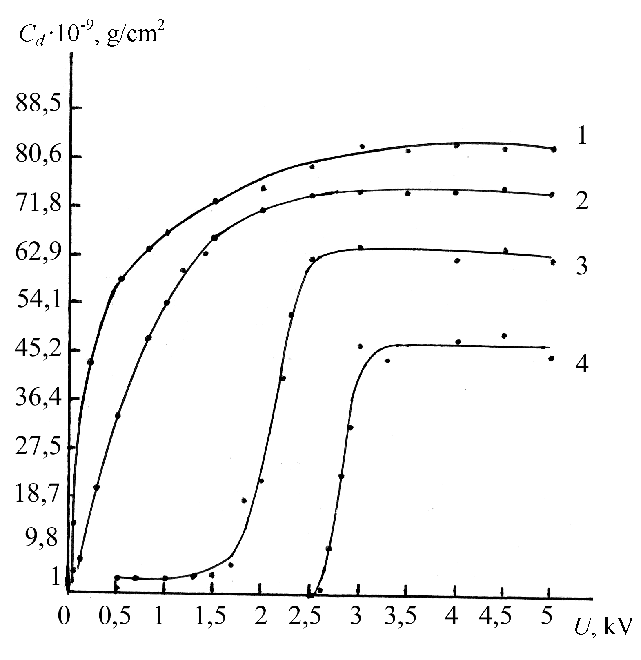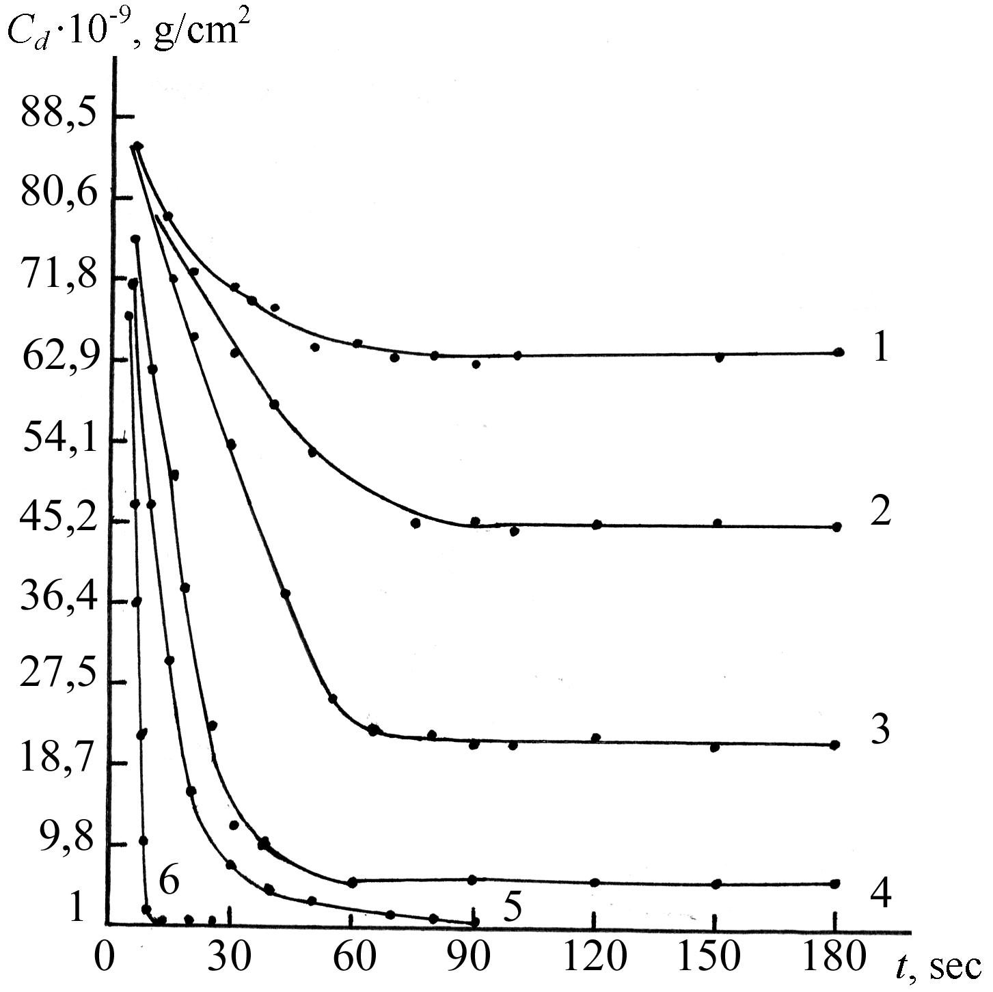
Figure 2. Dependence of the purity degree Figure 3. Dependence of the purity degree
of substrate surface on accelerating voltage: of substrate surface on exposure time:
1) 0,5 mA; 2) 1 mA; 3) 2 mA; 4) 3 mA; 1) 0,5 mA (t_{lim}=); 2) 1 mA (t_{lim}=); 3) 1,4
t=10 s. mA (t_{lim}=); 4) 1,5 mA (t_{lim}=); 5) 2,6 mA;
6) 3 mA; U= 3kV. Hatch line depicts the
dependency (14).
Analyzing dependencies C_{d} = f(I ) represented in Fig. 4 we find that at three different values of cleaning duration, the sharp drop of surface impurities concentration (for all the loops ) is observed within the range 1,4 ≤ I ≤ 1,6 mA. The sharp drop of C_{d} in this interval of discharge current values is caused by the intense filling of surface by the reactive radicals O*, generated due to ion and electron stimulation of neutral molecules of the working gas, and due to the ICE mechanism as well [3]. Removal of the RP deficiency on the surface, the latter being characteristic for lesser values of discharge current (I≤1,4 mA, see also Fig. 2), is now under process. The RP deficiency is fully removed by I ≥ 2,6 mA, and that is confirmed by the minimal value of C_{d} being reached. Thus, in the paper under consideration, to achieve the sensitive level of purity, we advice to clean the surface of dielectric substrates in plasma of an air of high-voltage gas discharge at the following conditions: U=2 or 3 kV, I = 3 mA, t= 10 s. For comparison, Fig. 3 also plots the design depedencies obtained using Eq. (14). Good agreement between the design loops and experimental data shows that the developed model adequately describes the physical process of surface cleaning of the dielectric substrates from organic impurities in plasma of high-voltage gas discharge.

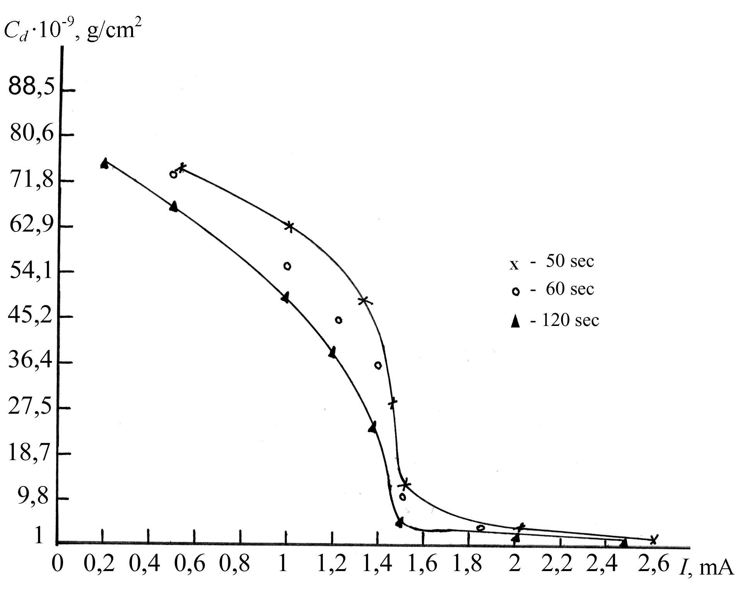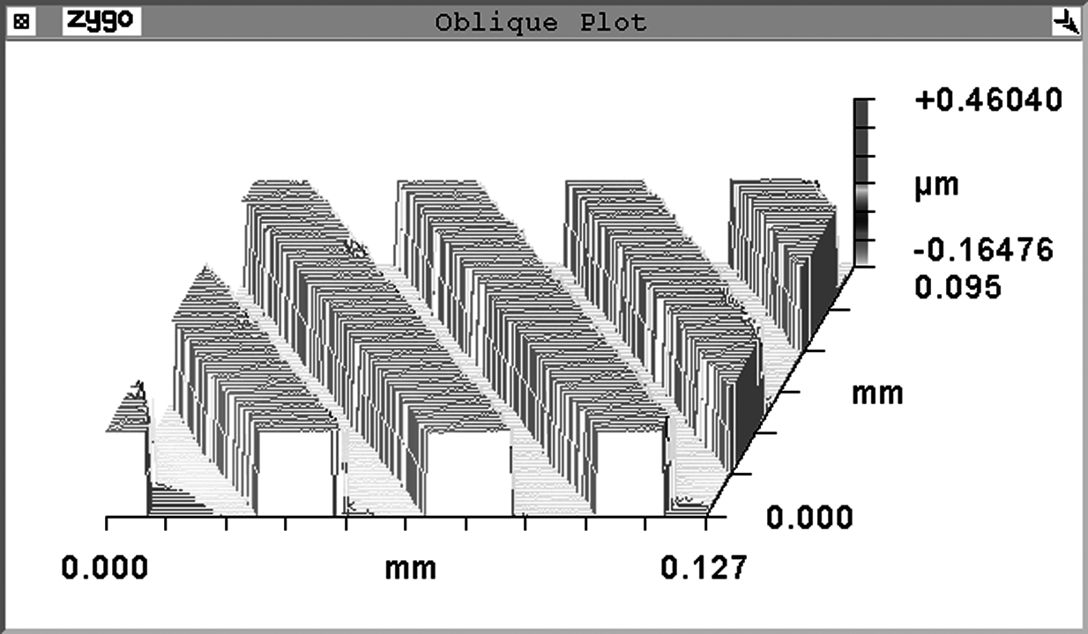
Figure 4: Dependence of purity degree Figure 5: View of the microrelief on
of substrate surface on the gas discharge silicon dioxide obtained using the
at U=3 kV. developed cleaning method;
etching mode parameters: I = 120 mA,
U = 2kV, etching time = 70 s.
An experimental ion-chemical etching of silicon dioxide in plasma CF₄/O₂ of high-voltage gas discharge showed the possibility of generating a microrelief represented in Fig. 5 in such plasma using methods of surface cleaning of dielectric substrates, developed in this paper. The microrelief is uniform and homogeneous all over the area of substrate surface without any sign of undercutting effect with the vertical profile of the walls. That is accomplished due to the sensitive level of surface purity ensured by the proposed method of cleaning.

5. CONCLUSIONS

The paper under consideration deals with theoretical and experimental research of cleaning mechanism of dielectric substrate surface in low-temperature plasma of the air of high-voltage gas discharge. The research made testifies to the impact of exposure time in plasma, discharge current, and accelerating voltage on surface purity of dielectric substrates. The sensitive values of surface purity are achieved at the exposure time amounting to 10 s, discharge current amounting to 3 mA, accelerating voltages equaling to 2 or 3 KV. The analytical relationship is obtained, connecting the value of surface impurities concentration with technological parameters (exposure time, discharge current, accelerating voltage) and adequate to physical process.

ACKNOWLEDGEMENTS
The work was financially supported by the RF Ministry of Education, Samara Region Administration, and the American Civilian Research and Development Foundation (CDRF Project SA-014-02) as part of the joint Russian-American program “Basic Research and Higher Education” (BRHE).

REFERENCES
[1] P. Duvalle, High-Vacuum Manufacture in Microelectronics Industry, Mir Publishers, Moscow, Russia, 1992, 262 P. (in Russian).
[2] A.I. Kolpakov, V.A. Kolpakov, and S.V. Krichevsky, Ion-plasma cleaning of low-power relay contacts, Electronics Industry 5, 41-44 (1996).
[3] V.A. Kolpakov, Modeling the process of etching the silicon dioxide in gas-discharge high-voltage plasma, Russian Microelectronics 6, 431-440 (2002).
[4] N.L. Kazanskiy, V.A. Kolpakov, and A.I. Kolpakov, Anisotropic etching of SiO₂ in high-voltage gas-discharge plasmas, Russian Microelectronics 33 (3), 209-224 (2004).
[5] M.N. Piganov, A.I. Kolpakov, and S.V. Krichevsky, Device for the express-control of substrate surface purity using tribometric method, Proceedings of International science-technical conference “Promising technologies for information transfer aids” , Vladimir, Russia, 155-157 (1995).
[6] V.A. Kolpakov, A.I. Kolpakov, and S.V. Krichevsky, Device for the express-control of surface purity of dielectric substrates, Devices and Techniques of Experiment, 5, 199-200 (1995).
[7] Yu.G. Poltavtsev, A.S. Knyasev, Technology of Surface Treatment in Microelectronics, Tekhnika Publishers, Kiev, Ukraine, 1986, 206 P. (in Russian).
[8] G.F. Ivanovsky, V.I. Petrov, Ion-PlasmaTreatment of Materials, Radio i Svyaz Publishers, Moscow, Russia, 1986, 496 P. (in Russian).
[9] I. Browdie, J. Muray, Physical Basics of Microtechnology, Mir Publishers, Moscow, 1985, translated from English, 496 P.
[10] Yu.N. Anisimov, V.I. Galibei, P.A. Ivanchenko et.al., Polymerization Processes and Physical-Chemical Investigation Methods, Vissha Shkola Publishers, Kiev, 1987, 159 P. (in Russian).
[11] V. A. Kolpakov, Generating an optical microrelief on the silicon dioxide in high-voltage gas discharge plasma, Thesis for Candidate Degree in Physics and Mathematics, Samara, Russia, 2004 (in Russian).
[12] V. Yu. Kireev, D.A. Nazarov, V.I. Kusnetsov, Ion-stimulated etching, Electronic treatment of materials 6, 40-43 (1986).
[13] V. Yu. Kireyev, M.A. Kremerov, Electron-stimulated etching, Electronic Engineering, Series 3: Microelectronics, 151, 3-12 (1985).

 vkolpakov@mail.ru; phone +7 846 335 42 13, +7 846 267 44 46

