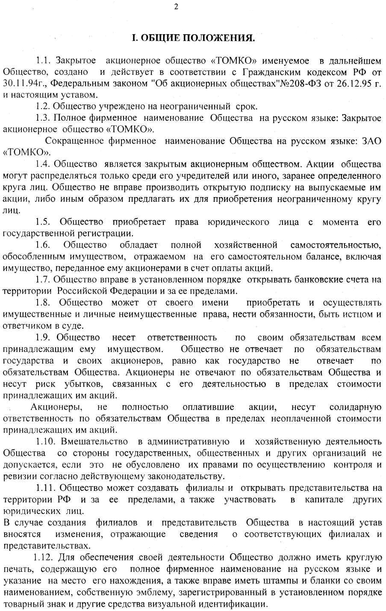
I. GENERAL TERMS

1.1. The closed joint-stock company TOMKO (further – the Society), was created and works according to the Civil code of the Russian Federation of the 30th of November 1994, the Federal law "Concerning joint-stock companies" No. 208-FL of the 26th of December 1995 and the present articles of association.
1.2. The Society can work for the unlimited period of time.
1.3. The full trade name of the Society in English: closed joint-stock company TOMKO. The abbreviated trade name of the Society in English: JSC TOMKO.
1.4. The Society is a closed joint-stock company. Its shares can be distributed only among its founders or another predefined group of people. The Society has no right to make an open subscription to its shares or, in any other way, offer them for acquisition to an unlimited quantity of people.
1.5. The Society is entitled with rights of a legal entity starting from the moment of its state registration.
1.6. The Society possesses absolute economic independence and individual property that is reflected in its independent balance, including property given by its shareholders as a form of payment for their shares.
1.7. The Society is entitled to set up bank accounts within and outside the Russian Federation in accordance with the established order.
1.8. The Society can have property and personal non-property rights on its own behalf, perform duties, act as a claimant and a respondent in court.
1.9. The Society is liable for the full extent of its assets. The Society isn’t liable for obligations of its shareholders and the state, as well as the state isn’t liable for obligations of the Society. The shareholders aren’t liable for obligations of the Society and bear risk of the losses corresponding to the cost of their shares.
The shareholders who haven't completely paid actions, bear a joint liability for obligations of the Society within the unpaid cost of their shares.
1.10. State, public or any other intervention in the administrative and economic activity of the Society isn't allowed except for the cases when this intervention is conditioned by their rights to carry out control and audit according to the current legislation.
1.11. The Society can create branches and open representative offices within and outside the Russian Federation, and also participate in the capital of other legal entities.
In case of creation of branches and representative offices of the Society, these articles of association will be changed in order to reflect the information about new branches and representative offices.
1.12. For carrying out its activity, the Society must have a round stamp with its full trade name in Russian and its address. It is also entitled to possess stamps and forms with its name, own emblem, trademark registered in accordance with the established order and other means of visual identification.

