Evgeniy Gribovskiy

Testing of game “Игры Разума” for social network (vk.com)

Enviroment:
OS: Windows 7 Maximum x64;
Browser: Google Chrome version: 45.0.2454.101 m.

Bug ID | MG1
Summary | Game sounds always turned in game
Severity | Major
Step to reproduce (STR) | - Launch application;  - Check application for Turn on/Turn off sounds button in game.
Actual result | Game doesn’t have possibility to turn off sounds.
Expected result | Game should have option to Turn on/Turn off game sounds.

Bug ID | MG2
Summary | Possibility open user profile in social network (VK) from game is absent
Severity | Major
STR | - Launch application;  - Open “Рейтинг”;  - Select any player;  - Try open his profile in VK from this page.
Actual result | There is no possibility to open user profile in VK from game.
Expected result | Game should give user opportunity to open user profile in VK from game. User should have possibility to deny access for different users or groups of people to get access to user profile in VK (reason: all multiplayer games give user opportunity choose between communicate or not with other users).

Bug ID | MG3
Summary | There is no transfer to game screen from invite messages in VK if user on “Достижения” page
Severity | Major
STR | - Launch application;  - Open “Достижения” screen;  - Get invite to game from friend;  - Select invite message in VK (see details in the screenshot from attachment).
Actual result | User doesn’t transfer to game screen and stay at current screen.
Expected result | User should transfer to game screen after selecting invite message in VK.
Attachment | 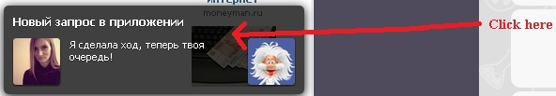

Bug ID | MG4
Summary | There is no possibility to share information in VK after getting new level, winning opponents or getting high results in game..
Severity | Minor
STR | - Launch application;  - Get new level in game;  - Try share information from congratulation screen.
Actual result | User can share information only about getting achivements from “Достижения” page.
Expected result | User should have possibility to share information about different kinds of success in game.

Bug ID | MG5
Summary | Player score marked red color on Result screen after game finished with Draw result
Severity | Minor
STR | - Launch application;  - Finish game with Draw result;  - Look at Result screen.
Actual result | Player score marked red color if game finished with Lose result. Draw result marked red color aswell (see details in the screenshot from attachment).
Expected result | Player score should be marked neutral color (like grey) if result of game was Draw.
Attachment | 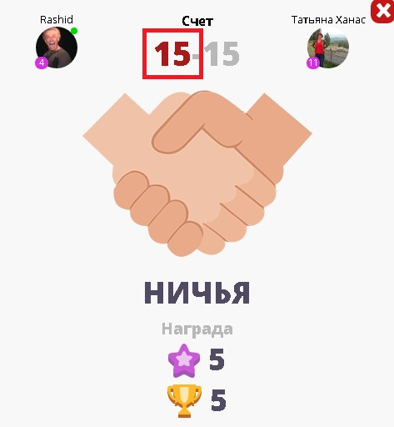

Bug ID | MG6
Summary | Name of tip “50/50” have regular view in achievements for using “50/50” tip in game on “Достижения” page
Severity | Minor
STR | - Launch application;  - Go to “Достижения” page;  - Open achievement for using “50/50” tip in game.
Actual result | Name of tip “50/50” not markered.
Expected result | Name of tip should be marked by quotes or different style of font (for example: bold font).
Attachment | 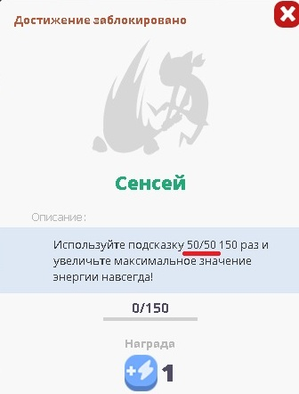

Bug ID | MG7
Summary | Name of tip “Изменить ответ” have regular view in achievements for using “Изменить ответ” tip in game on “Достижения” page
Severity | Minor
STR | - Launch application;  - Go to “Достижения” page;  - Open achievement for using “Изменить ответ” tip in game
Actual result | Name of tip “Изменить ответ” not markered.
Expected result | Name of tip should be marked by quotes or different style of font (for example: bold font).
Attachment | 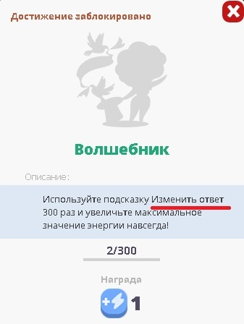

Bug ID | MG8
Summary | Picture with incorrect number of rounds displays in “Игровой процесс”point menu in Help
Severity | Minor
STR | - Launch application;  - Go to “Помощь!” page;  - Open “Игровой процесс” point menu;  - Look at picture.
Actual result | 6 rounds displays on picture (see details in the screenshot from attachment).
Expected result | Picture with 4 rounds should displays (like in game).
Attachment | 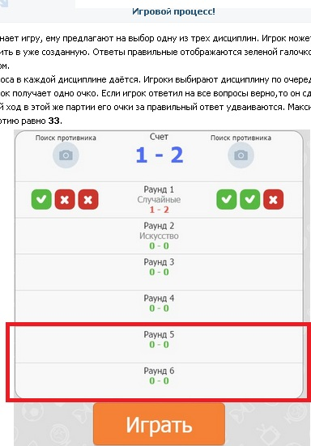

Bug ID | MG9
Summary | Excess link displays on “Share information” form and reposted record
Severity | Minor
STR | - Launch application;  - Get any achivement from “Достижения” page;  - Look at “Share information” form;  - Repost information;  - Look at reposted record.
Actual result | Excess link displays on “Share information” form and reposted note (see details in the “1” screenshot from attachment).
Expected result | Only one link should displays on “Share information” form and reposted record (see example in “2” screenshot from attachment).
Attachment | 1.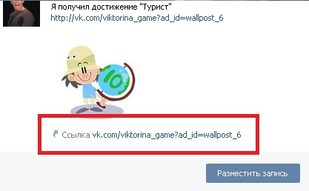  2.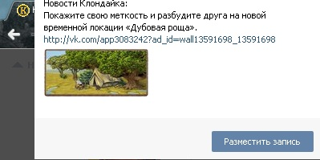

Bug ID | MG10
Summary | Text of answer in game doesn’t fit in button if contain 3 or more lines
Severity | Minor
STR | - Launch application;  - Start new game;  - Get question with 3 or more lines answer button;  - Look at button from step 3.
Actual result | Text of answer doesn’t fit in button (see details in the screenshot from attachment).
Expected result | Text should be scaled to the size of button.
Attachment | 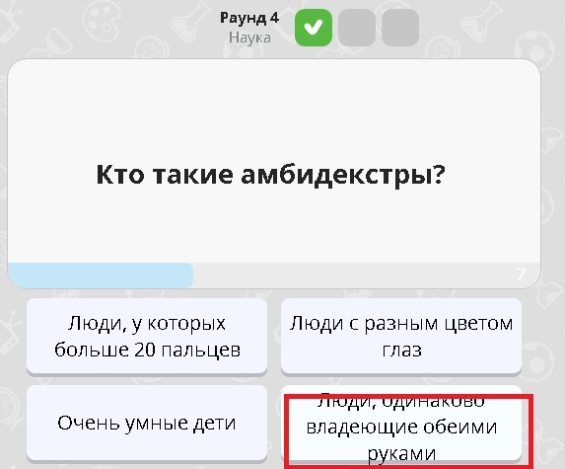

Bug ID | MG11
Summary | Settings apply without pressing confirmation button
Severity | Minor
STR | - Launch application;  - Open settings;  - Switch status of checboxes;  - Check result of action.
Actual result | Setting apply immediatly without necessity of press “Сохранить” button.
Expected result | Settings should apply after saving changes.
Attachment | 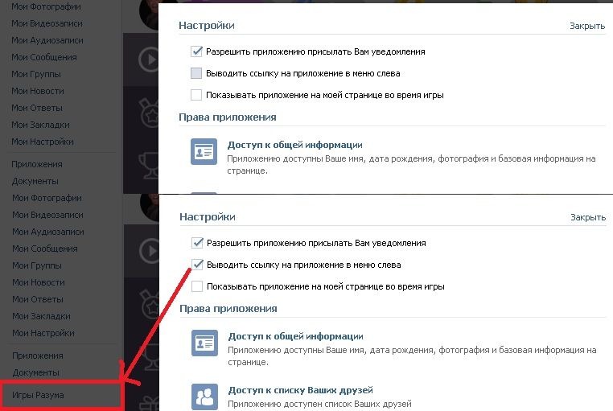

Bug ID | MG12
Summary | Prizes dont show in user statistics if was received when user finish and close game
Severity | Minor
STR | - Launch application;  - Start game when you second choose subject of question;  - Finish answering earlier than your opponent;  - Close game screen and wait until game session go to Game history;  - Open game session from Game history;  - Take prizes and look at number of cups and experince.
Actual result | Value of cups and experience don’t changes until player refresh page (see details in the screenshot from attachment).
Expected result | Value of cups and experience should be changed automaticly after finishing game sessions.
Attachment | 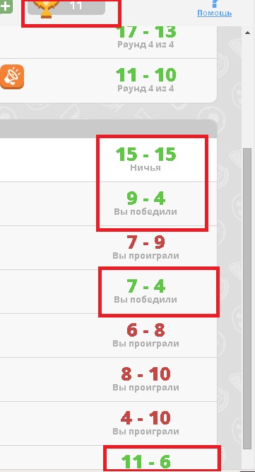

Bug ID | MG13
Summary | Infelicity in text about achievements for answering questions from category on “Достижения” page
Severity | Trivial
STR | - Launch application;  - Go to “Достижения” page;  - Open achievement for answering question from category Science;  - Read text.
Actual result | Phrase “...всегда будет меньше...”sounds not good in context (see details in the screenshot from attachment).
Expected result | Phrase “...навсегда будет уменьшено...” sounds better in that context.
Attachment | 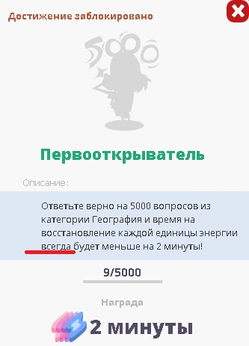

Bug ID | MG14
Summary | Incorrect spelling in text about achievements for win games from category on “Достижения” page
Severity | Minor
STR | - Launch application;  - Go to “Достижения” page;  - Open achievement for win games from category in History  - Read text.
Actual result | Word “со” using in context of win someone, not win with someone (see details in the screenshot from attachment).
Expected result | Word “над” should be used.
Attachment | 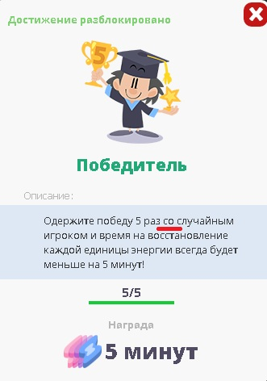

Bug ID | MG15
Summary | Feedback of answer overlap text of question if it contains more than 4 lines
Severity | Minor
STR | - Launch application;  - Start new game;  - Get question which contains 4 or more lines  - Select any answer;  - Look at feedback.
Actual result | Feedback overlap text of question (see details in the screenshot from attachment).
Expected result | Case 1: Feedback should displays not over question text;  Case 2: As designed.
Attachment | 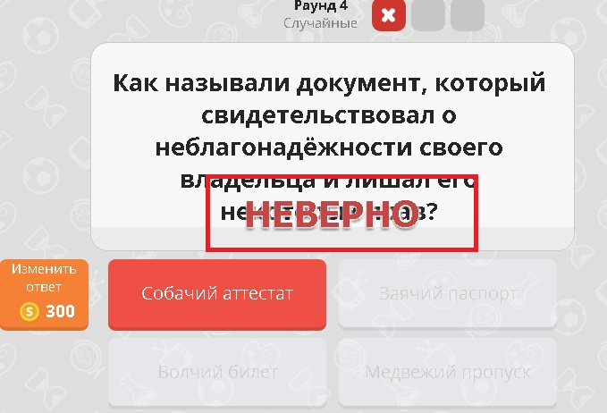

Bug ID | MG16
Summary | Text of question doesn’t fit in question field, if contain more than 5 lines
Severity | Major
STR | - Launch application;  - Start new game;  - Get question which contains more than 5 lines of text;  - Look question text.
Actual result | Question text displays under time counter bar (see details in the screenshot from attachment).
Expected result | Text in question field should scale to the size of that field.
Attachment | 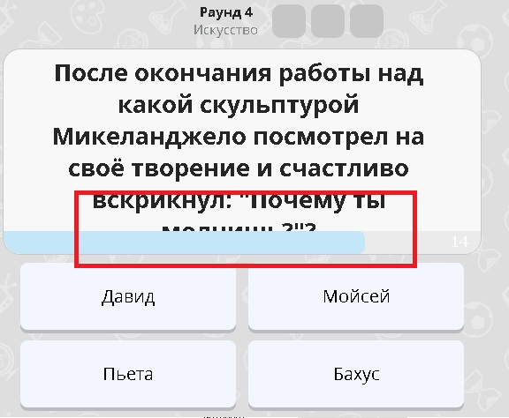

Bug ID | MG17
Summary | Capital letter and question mark absent in question about Science
Severity | Major
STR | - Launch application;  - Start new game;  - Get question “Самый распространненый газ в атмосфере?”  - Read text.
Actual result | Capital letter and question mark absent in question (see details in the screenshot from attachment).
Expected result | Text in question should starts with capital letter and ends with question mark (?).
Attachment | 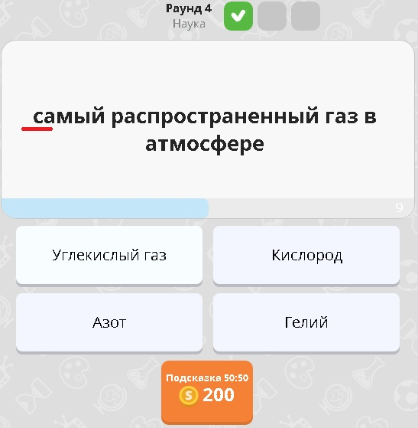

Bug ID | MG17
Summary | Mispelling in text of question about Science
Severity | Minor
STR | - Launch application;  - Start new game;  - Get question “Какой металл может расплавиться в Вашей руке?”  - Read text.
Actual result | Word “расплавится” writed with mistake (see details in the screenshot from attachment).
Expected result | Word “расплавиться”should be writed with letter “ь” in according to “тся/ться” rule of russian language.
Attachment | 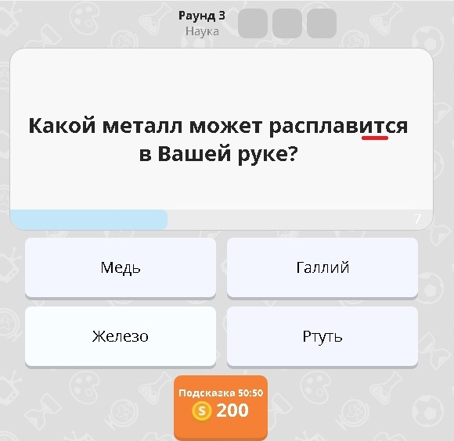

Bug ID | MG18
Summary | Mispelling in text of question about Science
Severity | Minor
STR | - Launch application;  - Start new game;  - Get question “Какая самая большая планета Солнечной системы?”  - Read text.
Actual result | Word “Солнечнной” writed with mistake (see details in the screenshot from attachment).
Expected result | Word “Солнечной”should be writed with one letter “н” becouse word contain suffix “ечн”.
Attachment | 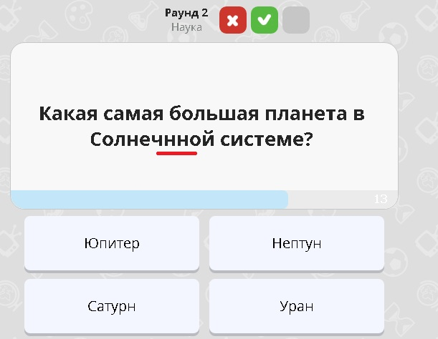

Bug ID | MG19
Summary | User receives same questions sometimes
Severity | Critical
STR | - Launch application;  - Play 10-30 games;
Actual result | User receives same questions sometimes.
Expected result | User should answer only on unical questions everytime.
Notes | I played something about 50 game sessions and get around 10 same questions during that time.

Bug ID | MG20
Summary | User achvievement not clickable if player try do this from achivement page another user
Severity | Trivial
STR | - Launch application;  - Open “Рейтинг” page;  - Select any user;  - Try click to your portrait for openning your achivement page.
Actual result | Portrait not clickable when you on page another user achivements
Expected result | Transition to “Достижения” page should be able from user achivements page of another player.

Bug ID | MG21
Summary | Gestures of Like and Dislike located on different sides of buttons
Severity | Trivial
STR | - Launch application;  - Star new game;  - Answer any questtion;  - Look at location of Like and Dislike on buttons.
Actual result | Gestures located on different on sides of buttons (see details in the screenshot from attachment).
Expected result | Case 1: Gestures of Like and Dislike should located before text on buttons.  Case 2: Gestures of Like and Dislike should located after text on buttons.  Case 3: As designed.
Attachment | 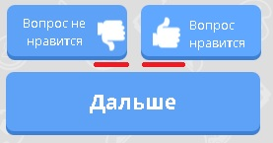

Bug ID | MG22
Summary | Animation of click absent for buttons “Вопрос нравится”, “Вопрос не нравится”, “Дальше” which displays after answering of question on game screen.
Severity | Trivial
STR | - Launch application;  - Star new game;  - Answer any questtion;  - Click on “Вопрос нравится”, “Вопрос не нравится”, “Дальше” in turn.  - Repeat steps 3-4 until all buttons were checked
Actual result | Animation of clicks for buttons for buttons “Вопрос нравится”, “Вопрос не нравится”, “Дальше”.
Expected result | Buttons should be play animation when player click on it like for other buttons in game.

Bug ID | MG23
Summary | Wrong name of rating section “по друзьям” in “Рейтинг” point in Help
Severity | Major
STR | - Launch application;  - Open Help;  - Select “Рейтинг” point;  - Read name of rating sections.
Actual result | Name of section “по друзьям” doesn’t match with actual name of section in game (see details in the screenshot from attachment).
Expected result | Name of section “Друзья” should be the same in game and help.
Attachment | 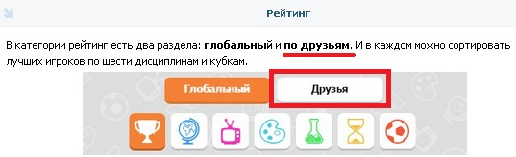

Bug ID | MG24
Summary | Mistakes in text of Help
Severity | Minor
STR | - Launch application;  - Open Help;  - Reveal text from all points of Help;  - Check text..
Actual result | Mistakes of Help (see details in the screenshot from attachment):  - Letter “и” absent in word “игроками”;  - Tautology in sentence;  - Wrong order of words in sentence;  - Dash is absent;  - Yoda order of words in sentence;  - Max number of points for 4 rounds are 21;  - Participle figure allocated commas;  - Participle figure allocated commas.
Expected result | Text in Help should be correct.
Attachment | 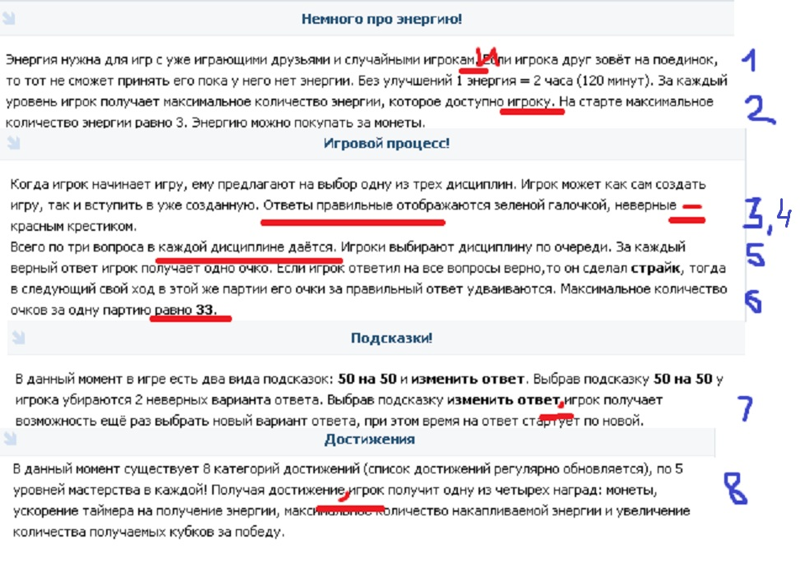

Bug ID | MG25
Summary | “Revenge” functionality is absent in game
Severity | Critical
STR | - Launch application;  - Start new game;  - Lose game;  - Click button “Revenge” on Result screen.
Actual result | Alert with information that user disable option “Revenge” displays. Game doesn’t have possibility able or disable this option.
Expected result | “Revenge” option should be implemented in game with possibility able or disable it.

Bug ID | MG26
Summary | Arrow buttons on “Рейтинг” page are active and clickable when rating table contain only one page
Severity | Major
STR | - Launch application;  - Go to “Рейтинг” page;  - Click arrow button.
Actual result | Arrow buttons can be clicked if rating table contain only 1 page (see details in the screenshot from attachment).
Expected result | Arrow buttons should be disabled if no reason to click on it.
Attachment | 