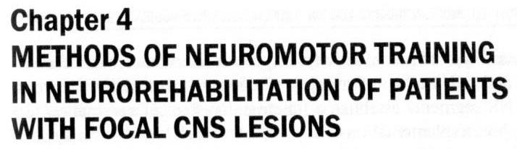

Shklovsky V. M.
Mamicheva E.D.
Fridman V. L.

Mechanisms of neuroplasticity are at the heart of recovery and compensation of impaired functions of the nervous system, memory, learning and acquisition of new skills [14, 31].
Anatomical basis of plasticity is cortical reorganizations, more effective functioning of survived structures and active use of alternate descending pathways. The actual realization of these changes on the cellular (neuronal) level consists of synaptic remodeling and neosynapto- genesis. There are cases when no less important is extrasynaptic neuronal transmission of excitation. Here, changes occur as to neurons (structural modifications of dendrites and axonal sprouting), so to glial elements [31]. Plasticity mechanisms involve the cortex and subcortex including thalamus, basal ganglions and brainstem structures. It is noteworthy that these processes are not uniquely positive for recovery and can be both adaptive and deadapative by character [31].
Kinesotherapy or remedial exercises (RE) have a special place in treatment of motor disorders. As one of the major methods of physical rehabilitation, kinesotherapy produces the therapeutic effect on patient's organism through physical training. Remedial exercises, an organized form of movements, act on biology, psychophysiology, and functional regulation of sick organism [17].
Implementation of exercises stimulates reorganizations of the majority of body functions, specificity and depth of which depend on intensity, duration and type of motor activity. The central nervous system increases liability and excitability of many projection and associative neurons. Different CNS segments establish a functional system of nervous centers that will support implementation of a given motor task based on analysis of external information. The established complex of nervous centers becomes a working dominant that has elevated excitability, maintained by different functionally capable afferent stimuli, and selectively inhibits reactions to irrelevant stimuli. The dominating nervous centers line up a chain of conditioned and unconditioned reflexes or a dynamic motor skill stereotype facilitating serial implementation of identical movements in cyclic exercises or a program of different motor acts in acyclic. In preparation for exercise, cortex of the hemispheres fulfills appropriate preprogramming and adjustments reflected in various modulations of the electrical activity. Intercentral relations of cortical potentials make a selective increase, muscle excitability and lability rise, and so does sensitivity of muscle proprioceptors [19].
Effectiveness of motor function recovery by stroke or CCI patients is high, provided the observance of the next basic principles of rehabilitation:
- Early start,
- Integrated administration of all available and necessary means,
- Rehabilitation program tailoring,
- Step-by-step approach,
- Continuum and succession on all the phases.
The most frequent outcomes of focal brain injury are palsies and pare- ses, typically with elevated spastic muscle tone, unnatural gait, desensiti- zation of various levels, and visual and oculomotor disorders. Bulbar and pseudobulbar disorders may be manifested by disphagy, dysarthria, and speech problems. Emotional-volitional disorders, neuropsychologic (cognitive) syndromes such as disturbed attention, perception, spatial disorders including spatial body awareness, ignoration of half of space, etc. are also not uncommon.
The most frequent motor dysfunction is central paralysis consequent to lesion of the central motor neuron in any region, which can be the motor cortex of the cerebral hemispheres, brainstem or spinal cord. Break or damage of the pyramidal tract abolishes the cerebral cortex effect on the segmental reflex apparatus of the spinal cord: its own apparatus unbreaks. For this reason, one way or another all main signs of central paralysis are engendered by growth of excitability of the peripheral segmental apparatus.
Rehabilitation for the stroke patient should be planned with account of the existing division of post-stroke period into 4 phases [12, 13, 14, 15, 20]:
- Acute stroke (first 3—4 weeks);
- Early recovery (6 post-stroke months) which is subdivided into two 3-month periods: first is the time of recovery of primarily the range of movements (ROM) and strength of paretic limbs and second is associated with the peak of resumption of complex motor skills that may be stable. This is the most suitable time for active use of special methods of neu- rorehabilitating the motor and cognitive functions, speech specifically;
- Advanced recovery (post-stroke months 6 to 12) in which further progress can be made in re-establishment of speech, static and labor skills;
- Residual period (in a year after stroke) when the patient with light residual phenomena may also continue working on rehabilitation of impaired functions provided he has access to intensive neurorehabilitation programme.
It should be noted that in the early and late rehabilitation periods the mechanisms of spontaneous functional recovery are particularly active and additional neurorehabilitation measures bring better and sooner results. In the residual period, extended regular neurorehabilitation is directed at training and teaching and addresses compensatory mechanisms rather than reserve.
Neurorehabilitation measures should start as soon as possible post stroke. These measures are applied to patients without contraindications from the first hours and days of stroke onset; choice of measures may vary significantly depending on the patient's condition.

ACUTE PERIOD
As a rule, stroke-induced disorders featuring central pareses (spasticity, contractures, pain syndrome) develop by week 3—4 of the disease which points to the necessity of early response in order to prevent augmentation. In other words, neurorehabilitation should be started before pathology stabilization, evolvement of severe muscular spasticity, and formation of pathologic motor stereotypes, postures and contractures. Numerous studies showed that the earlier rehabilitation was started the more effective it was which advocates for the importance of assimilation of the early rehabilitation system in practice [13, 14, 22, 29].
Goals of early rehabilitation are:
- Monitoring the processes of recovery;
- Maintenance of the coordinated functioning of all body systems and organs;
- Destabilization of pathologic systems;
- Reestablishment of normal trigger afferentation and reflex activity;
- Intensification of defect recovery and/or compensation by activation of the patient's own body reserve;
- Compensatory formation of new functional interfaces;
- Inhibition of nonphysiological movements and pathological postural sets;
- Prevention of complications.
In the acute period, a kinesithetapist is personally responsible for:
  - Early activation of the patient
  - Prevention of pathologic conditions including stable motor disorders, spastic contractures, arthropathies, muscular hypertonia, complications caused by induced hypodynamia
  - Restoration of voluntary movements.
Some methods of early rehabilitation should be used already in the intensive care or neuroresuscitation unit. To make the right choice of tactics of remedial treatment and early rehabilitation of impaired functions in a patient with acute stroke, the following indicators of unfavorable course of disease need to be assessed:
- Severe functional disorders at admission, e.g. total aphasia, serious general brain changes, sopor or coma, impaired functions of the pelvic organs, etc.;
- Stroke records in anamnesis;
- Motor problems prior to stroke;
- Advanced age;
- Visual-spatial disorders.
Factors that may delay recovery are:
- Inadequate perception of motor or vocal deficiency by the patient;
- Loss of sensitivity, proprioceptive specifically;
- Problems with perception;
- Pain reactions;
- Depressive mood;
- Lack of motivation to participate in rehabilitation actions;
- Low endurance of physical training.
The next neurorehabilitation methods are applied in the intensive care unit:
- Positioning treatment;
- Respiratory gymnastics (passive exercises);
- Integrated system of reflex exercises with inclusion of authors' technologies Balans-I, PNF, as well as of Feldenkrais and Vojta;
- Early verticalization.

Positioning treatment
Positioning treatment (corrective postures) means placing paralyzed limbs in the right position throughout the time while the patient is lying or sitting.
There are several positional patterns. G. Foerster was first to propose this treatment and substantiated effectiveness of positioning a supine patient in the posture opposite to the Vernike-Mann posture with stretching of hypertonic flexors, pronators and adductors of the arm and extensors and adductors of the leg. S.I. Uvarova-Yakobson detailed this position and G.R. Tkacheva elaborated it further into the procedure of periodic repositioning of limbs of the patient lying on his back or intact side.
Though simple, accurate implementation of the positioning treatment procedures is crucial for attaining:
- Weakening of muscular spasticity;
- Leveling of muscle tone asymmetry;
- Restoration of the body scheme;
- Increase of deep sensitivity;
- Suppression of pathologic activities of the tonic cervical and labyrinthine reflexes.
All these improvements put barrier to development of the pain syndrome and pathologic positions of limbs and torso and contractures in future. Moreover, the positioning treatment can be prescribed to all patients no matter the severity of their condition, and already after several hours from the stroke onset.
Positioning treatment consists of:
- Placing paralyzed limbs of the patient lying on intact side;
- Placing on paralyzed side;
- Placing in opposite to the Vernike-Mann posture; it should be mentioned that to achieve the prophylactic effect for the spastic tone awakening, no heavy item must be put in the palm and fingers and no rest must be provided to soles);
- Limited time in supine position.
Negative factors of placing the patient in supine position are:
- Insufficient respiratory function of the lung;
- Poor bronchi drainage;
- Reduction of pulmonary volume because of high diaphragm elevation;
- High risk of saliva aspiration;
- Intensification of pathologic reflex activity of the cervicotonic and labyrinthine reflexes increasing the tone of arm flexors and leg extensors;
- Spinal pain after staying long in one posture.
- It is necessary to observe several rules of turning the patient on the back:
- Head must be aligned with the median line;
- Paretic arm must be supported by the pillow (2—3 cm high);
- Paralyzed leg must have the normal physiological position with knee joint flexed with the help of pillows put under respective joints.
With the patient turned on the intact side care must be taken of:
- Paralyzed limbs be on same horizontal level to ensure equal gravitational loading;
- Damaged shoulder shifted forward (45—90 degrees) and the arm supported all the way long;
- Hand of the sick arm being in the functional position but not dropped from the pillow (shoulder joint abducted up to 45° and flexed up to 25—30°; elbow joint flexed at 90° in the mid-position between pronation and supination; wrist joint extended at 20°, proximal interpha- langeal joints flexed at 70—80° and distal interphalangeal joints, at 25—35°);
- No support to damaged foor.
The following rules exist for handling the patient lying on paralyzed side:
- Sick shoulder shifted forward with the shoulder joint flexed at 45—90°, elbow joint flexed together with the hand put into the typical position; all the arm rests on the bed surface which serves as an additional stimulation for extensors to assume the fixing position;
- Sick leg flexed in the hip joint at 30—45 degrees and slightly flexed in the knee joint;
- Vertical axis of the head is continuation of the torso vertical axis.
Respiratory gymnastics
Respiratory gymnastics is intended to normalize hemodynamics, to restore oxygenation, to eliminate the hypoxic hypoxia effects, and to stabilize the normal dynamic stereotype of breathing. Gymnastics contains both passive and active procedures.

Passive procedures:
- Contact breathing with monitoring and stimulation of breathing movements by touching the chest with a hand;
- Manual vibration during expiration;
- Shaking;
- Therapeutic body positioning (drainage, breathing assisting, aeration assisting, chest mobilizing positions);
- Intercostal stroking (skin and muscular variants).
Active procedures
The primary purpose of active respiratory gymnastics is elaboration of skills to control the balance of respiration cycle phases. Inspiration has the firing effect on the sympathoadrenal system while expiration, on the contrary, quells. To maintain eutonia during respiratory gymnastics, inspiration-expiration should be in the ratio 2:3; the ratio of pauses during respiration act, 1:2. To achieve the inhibitory effect, the expiration phase and the second pause of respiration act should be extended; on the opposite, to achieve activation of the sympathoadrenal system, the inspiration phase as well as the first pause should be extended. Breathing should not produce tension. After 5—6 deep breaths a 20—30 second should be taken.
The second purpose of respiratory gymnastics is teaching slow implementation of every breathing phase with gradual deepening. This type of respiration exercise leads to increase in oxygen uptake from inspired air and simultaneous maintenance of carbon dioxide level, which reduces blood pressure and HR noticeably. In addition, it is beneficial for establishment of the slow breathing pattern and destruction of the pathologic hyperventilation pattern of fast breathing.
Purposes of respiratory gymnastics are also attained through hypoxic training performed with the use of dedicated breathing devices. Design of these devices is based on the principle of pumping into the breathing mask of air with normal oxygen content and elevated concentration of carbon dioxide.
Passive respiratory gymnastics is executed by the exercise instructor to unconscious or insufficiently conscious patients. In this case, the main effort is placed on stimulation of expiration to ensure a more uniform ventilation during next inspiration. On the expiration phase, the instructor begins vibrating chest squeezes with a minimal force gradually making it stronger. During expiration, the instructor exerts resistance to the expanding chest which enhances reception of the respiration apparatus. In every 2—3 breathing movements the instructor moves hands onto another place of squeezing.
The satisfactory consciousness activity of the patient, i.e. the ability to understand and fulfill instructor's command allows combined active- passive breathing exercises as well. In addition to the passive exercise described above, the patient speeds up expiration by pulling in the stomach and makes full expiration with concurrent expansion of the chest and throwing out the abdominal muscles.
With progress in recovery of consciousness and other functions, the training course is complemented by passive-active and local exercises, and, finally dynamic breathing exercises. Care should be taken to exclude long breath holding during expiration and straining that can provoke rise of the intracranial pressure.
Kinesotherapy
Mechanisms of post-stroke spontaneous recovery resemble the development of child's motor movements in ontgenesis: functional recovery of the axial musculature and proximal segments of the limbs goes first and is followed by distal segments, walking and fine motor movements. That is organism uses paths laid in ontogenesis. This justifies the administration of ontogenetic kinesotherapy in early neurorehabilitation of stroke patients.
Kinesotherapy consists of stimulation of statokinetic reflex reactions implemented from deep receptors of ocular lateral muscles, axial and paraxial muscles of the neck and upper thoracic spine, and vestibular receptors. In this period, the most enabling method is the integrated system of reflex exercises. There is no point in doing usual exercises involving limb joints movements along the main axes (flexion, stretching, abduction and adduction) in this period, as they may result in consolidation or formation of pathologic motor stereotypes.
Organism fulfills this type of movements using the actually functioning, i.e. pathologic, programs.
In acute period the deglutition function is assessed and compensated, if necessary. Remedial training includes passive and active exercises.
Passive exercises are light massaging of the anterior neck and pharynx surface and moving the pharynx up and down as far as possible. Assisted active exercises are based on the direct and reflex associations between muscles of the neck, pharynx, tongue and chewing muscles the consensual actions of which constitute the deglutition act [14].
We should raise the issue of bedsores in acute period. Frequency of bedsore in hospitalized patients makes up approximately 3%. Bedsore causes pain and growth of spasticity, slows down recovery and predisposes to infection, inhibits intensity of rehabilitative measures, raises the price and prolongs time of treatment. Early activation and appropriate care are the best bedsore prophylaxis. Patients immobilized by stroke or CCI, affected by diabetes mellitus, hypoalbuminemia, anemia or a concurrent infection fall into the group of bedsore risk. Therefore, supervision by the therapist, regular inspection of integument and timely response to bedsore appearance is critical for success of acute rehabilitation. Adequate nutrition with sufficient supply of proteins and vitamins and treatment of concurrent pathology are beneficial for prevention and healing bedsores. In addition to antiseptic management and topical bedsore physiotherapy, problem areas are usually subject to regular airing. One or two times an hour the patient is repositioned carefully not to make folds on bedclothes and underwear; special mattresses and bolsters are provided (use of active and passive systems). Active systems are particularly effective; for instance, inflation and deflation of air holes to ease pressure in every spot prevents appearance of new sores and makes the existing sores less painful.
Rehabilitative treatment in acute period consists of differential massage during which mechanic energy of movements transforms into energy of nervous excitation with a positive effect on the neuromuscular apparatus. Massage stimulates inhibitory processes in CNS, relieves painful sensations, increases the size and working ability of atrophied muscles, and activates circulation in paretic limbs. Massage is prescribed from days 4—6 after acute brain events subsided. Sometimes massage and passive exercises are provided on the first day of training therapy to prevent contractures, deformation and pain in joints. The procedure takes 5—7 minutes initially extending gradually to 8—10 minutes. Muscle tone serves as a criterion of massage intensity and duration: the lower the tone, the more active and longer procedure.
Massage is combined with slow cautious implementation of passive movements. If the patient has not yet increased his muscle tone and is free of stiffness (contracture), passive and active movements should be started from distal parts of limbs necessary for progressive restoration of adequate prioprioceptive information in paretic limbs and ensuing recovery of active motor acts.
The following movements are particularly helpful to patients with spastic hypertonia: flexion and external rotation of the shoulder, forearm extension and supination, hand and fingers extension, thumb abduction and opposition, thigh flexion and rotation, shin flexion with unbent thigh, and dorsal flexion and pronation of foot. These exercises are performed with the patient in supine or prone position (shin flexion with fixed pelvis) or lying on the side (thigh extension, shoulder rotation, etc.).
In the event of severe paresis, training starts with isometric exercises in which muscles contract but not shorten. These exercises are performed to patients with absent or minimal voluntary muscle activity. Isokinetic exercises require a specific position of the training limb and special assistance of the instructor.
As soon as the patient regains the ability to produce isolated movements, he can be trained with simplified exercises designed to eliminate the undesirable effect of the force of gravity. The exercises are fulfilled using various suspenders, hammocks and blocks. Simplified exercises should not cause pain. They are done slowly and repeated as many times as the patient can endure.
Exercises with voluntary relaxation belong to the category of special. They are favorable to attenuation of muscle spasticity and used as a way of broadening the range of motor abilities and skills. These exercises have a distinct inhibitory effect on the central nervous system. Functioning of the motor apparatus is completely controlled by the central nervous system: excitation of motor centers leads to muscles contraction and tonic strain, whereas inhibition of the centers results in inhibition.
Completeness of muscular relaxation is in direct proportion with depth of the inhibitory process.
Next to passive exercises, active movements of healthy limb are added one by one and then, with instructor's assistance, the paretic limb begins doing resistive, static, yielding exercises with varying level of muscular strain. The greater part of active exercises prescribed on the initial phase of rehabilitation repeat passive exercises are performed with assistance or in a simplified form. It is recommended also to do exercises with impulse generated by the patient without active movements (ideomotor). Active exercises should not cause painful sensations. They are done slowly and smoothly within the available range of movements.
Transition to exercises that will increase strength of paretic muscles should be made in a gradual manner. Muscles may have simultaneous spasm and these exercises will not augment spasticity but, on the contrary, reduce it. Multiple repetitions of resistive exercises in different planes and directions with participation of two and more joints constitute the basic tactics of gaining muscular strength.
Appearance of signs of elevated tone in spastic groups of muscles reduces the number of repetitions and level of muscle strain. Exercises with manual expanders, tennis balls are not recommended in this period as they provoke hypertonia of hand and finger flexors.
Here are the methodical rules of strength rehabilitation:
- at the beginning, the exercises should be performed with a small amplitude gradually rising to full, physiological;
- strength exercises should be followed by stretching exercises aimed to increase the physiological length of paretic muscles;
- implementation of associated movements by two or more joints should not entail faulty associated movements;
- during these exercises, breathing should be even which is especially important at the time of maximal strain to exclude breath holding and a straining effort.
As the patient broadens the range of active movements, exercises with slight graded resistance can be added. For example, if the patient is capable to bend the shin, an attempt should be made to slightly impede the movement pressing the shin from the top not to let the knee joint straighten. Analogous exercises are performed for other muscle groups. Resistive exercises should be integrated into physical therapy only when the patient starts demonstrating and mastering different active isolated movements. These exercises are recommended only for muscles that do not elevate their tone. Resistive exercises alternate with passive relaxation exercises.
Spastic pareses are known for a large number of faulty associated movements, i.e. the triple flexion symptom (synchronous flexion of the hip, shin and foot), elbow flexion and shoulder abduction with hand and fingers flexing, mower's gait, etc. These faulty associated movements can be prevented by correct prophylactic positioning treatment, teaching the principles and skills of graded and differential straining of individual muscles or muscle groups beginning with synergy opposing minimal straining and training the patient how to preclude associated strain and movement in specific muscles.
Depending on paresis severity, pathologic synkinesis can be blocked by several methods including conscious synkinesis suppression in case of light paresis, orthopedic fixation with the help of splints, elastic bandage, special ortheses of one or several joints with particularly bad synkinesis; special anti-association passive and active-passive exercises performed with the instructor's assistance and aimed at destruction of a habitual synergy stereotype [11, 21, 28]. There is a set of exercises intended to overcome synkinesis in paretic arm combined with passive or active training of paretic leg.
Of interest are robotic devices for controlling pathologic synkinesis. One of them is a robotic orthese fixated on paretic arm and programmed to prevent the onset of flexion synergy in the arm attempting an active movement. Two months of training result in considerable attenuation of synergies [14].
Ortheses blocking arm bending can be used to overcome pathologic synkinesis of elbow flexion in the period of training motor skills [ 14].
Support reactions of bedridden patient's feet are modeled with sole mechanic load
imitator KORVIT originally designed for the needs of space medicine (fig. 4.1). The imitator stimulates the sole support zones agitating a strong flow of afferent pulses that has a regulatory effect on CNS motor control structures through stimulation of neuropasticity processes. The imitator is dedicated to modeling the sensory image of physiological gait imprinted in the evolution of walk cyclogram, potentiation of reflex mechanisms of the step, activation of the spinal locomotion generator, and higher level motor centers.
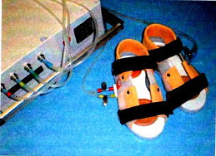
Contraindications to the imitator application are hazards of bleeding and thromboembolism, severe vegetotropic disorders in foot, and serious orthopedic pathology.
The procedure of sole stimulation takes up to 6 hours of the daytime. Every hour of the procedure includes two 20-minute sessions: slow walk at the speed of 70 steps/min. is followed by fast walk at 150 steps/min. During the procedure, the patient must be in supine position with straightened legs. Legs can press slightly against a support not to let feet rotate.

EARLY AND FOLLOW-UP VERTICALIZATION
Early verticalization of the patient is planned in several stages. Already on the first days in the intensive care unit Fig. 4.1.
everyday nursing is performed with the head-end of the bed raised and feeding, with the patient's body lifted. Several days later, legs will be moved down and the patient out into the sitting position. Provided that the patient's hemodynamics is stable and there is no contraindications, verticalization will proceed gradually, i.e. allowing a recumbent position, sitting in bed, sitting with legs down, and standing [22, 23].
Soon after, the patient is taught to sit, to stand by the bed on both legs and alternately on the paretic and unaffected leg, to walk in place, to move about the ward and corridor with the help of the instructor, and, as gait improves, using a three-point prop or a cane.
It is important for the patient to elaborate the right gait stereotype which implies the associated leg bending in the hip, knee and ankle joints. The early movements and procedures described above must be fulfilled under supervision of the instructor who, sitting on a small bench, holds the patient by the hip and stretches his shin, and accompanies him during walk, holding and lifting the shin with the use of special pullers. Footstep rug is used in walk training; to teach triple bending, small boards of 5—15 cm in height are placed between the steps to be made by the paretic leg. Rubber pullers, shin-fixating or orthopedic shoes as well as braces are used for dangle paretic foot. On the last stage, walk sessions are dedicated to going up and downstairs. Prior to going for a walk, the paretic arm must be fixated by cravat bandage.
Tilt-table ensures gradual verticalization of the patient with compulsory monitoring of heart rate, blood pressure and ECG.
For example, the table-verticalizor with integrated robotic orthopedic device Erigo (fig. 4.2) is used for intensive therapy at the very beginning of rehabilitation.
255
Verticalizor Erigo combines the capability of incremental verticalization at the tilt angle from 0 to 80 degrees and producing cyclic dynamic loading for the lower limbs. Erigo permits simultaneous dynamic movements by and physiological loading of the lower limbs of the patient tilted to the maximally vertical position.
Advantages of the Erigo-based therapy are concurrent patient's ver- ticalization, movements by and loading of the legs, activation of the cardiovascular and respiration systems, intensive afferent stimulation, repeating physical movements that decrease muscle spasticity in some patients, reduction of the risk of secondary complications caused by immobility; improvement of the patient's vegetative status.
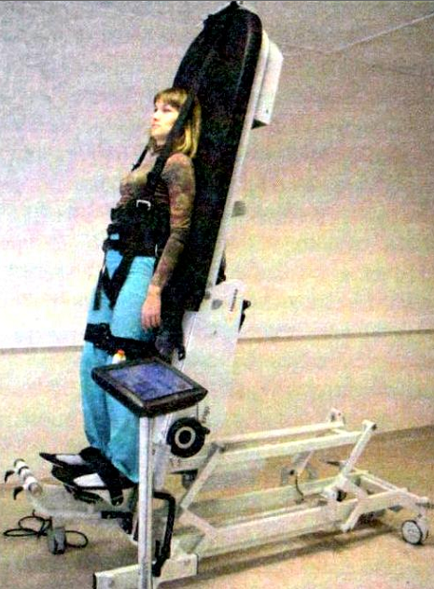
Physiological barriers to the Erigo-based therapy include leg contractures limiting mobility of the hip, knee and ankle joints, unconsolidated fracture, severe osteoporosis, pseudoarthrosis, and pronounced musculoskeletal displasia. Before developing the skills of moving about the patient should learn to stand on both legs with uniform weight distribution. The patient is taught to stand first on the unaffected and then the impaired leg with the instructor's assistance. Next exercise for the patient to master is of the walking in place type.
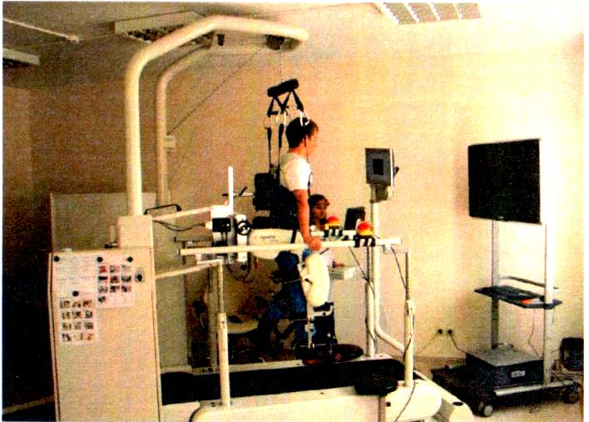
A At the present time, walking training of patients with hemipareses on the stage of acute and early stroke employs a variety of equipment like treadmills outfitted with systems for partial body weight support. Training equipment makes possible early beginning of walking skills development even in those patients who cannot stand vertically without aid. The systems are considered as the most effective technology of walk training of stroke patients with hemipareses. Comparative studies showed that treadmills with prop system ensure much better results than the traditional training when the patient masters walking skills in a step-by-step manner. Training on the treadmill with bodyweight props can be prescribed to the patient who still cannot stand because of weakness of the torso and paretic leg muscles. With redistribution of up to 70% of bodyweight on the prop system, he starts treadmill training at a very low speed. With time the percent of Fig.4.2. redistributed bodyweight decreases down to 0%. As a result, walk speed increases significantly, step biomechanics improves and step asymmetry grows small 114|. In recent years, treadmills have been complemented withcomputerized robotics — ortheses that were initially used to induce passive leg movements on the step pattern (Lokomat Basic); as movement recovery Fig.4.3. progresses, the share
of active participation of the patient in locomotion increases. Lokomat Basic (fig. 4.3) consists of
robotized ortheses and a bodyweight prop system integrated with the treadmill. The computer-driven Lokomat motors are precision-synchronized with the treadmill belt setting the movement path that will form a close to physiological gait pattern. The instructor adjusts walking parameters using a convenient computer interface.
The dynamic [suspension] prop system was designed for equal body- weight relief in order to facilitate a close to physiological gait and to ensure optimal sensory stimulation. Prop parameters are also adjustable to the patent's need to guarantee comfortable training. Lokomat aids to the patient with disturbed gait to perform movements on the treadmill; equipment combines functional locomotion therapy with assessment of the patient's condition. The availability of visualized feedback raises motivation of the patient. The integrated feedback system monitors and displays the patient's gait in real time. All rehabilitation efforts should be performed in such a way as to achieve the best possible rehabilitative effect and to exclude injury of paralyzed limbs. In parallel to activation and gradual ver- ticalization of the patient, one by one active movements are added first for the unaffected leg and then paretic (with assistance) in different exercises (resistance, static, relaxed) with varying level of muscular straining. Active exercises for the most part repeat passive and are done in an easy form.
Training includes exercises aimed at drilling the important motor skills in strength-challenging tasks of precise grasping, holding and manipulation with an item. To this end, fine hand motor functions are trained with small items, e.g. bricks, pyramids, big puzzles, plasticine, etc.; for these exercises, the patient either sits in bed or, if he can, goes to the desk (fig. 4.4, 4.5).
Further on, training continues with employment of different devices as, for example, EMG-based biofeedback, robotized Armeo system with a package of rehabilitation games (fig. 4.6).
Armeo helps hemiparetic patients to mobilize functionality of the upper limb for developing and enhancing the locomotor and grasping skills. Armeo involves the patient in three-D simulation of everyday situations favorable to arm weight compensation.
The real-time display of the results of impaired arm performance raises motivation significantly. Armeo exercises simulating everyday activities make the arm stronger and more functional, and prevent the negative effects of induced long-term akinesia. The package contains a broad variety of effective and captivating exercises in the form of video games with several levels of complexity to be selected with consideration of the patient's capability;
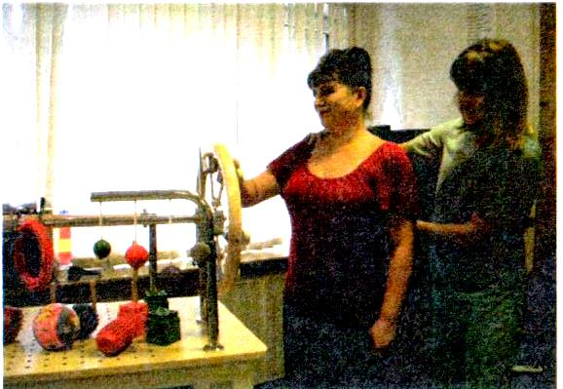
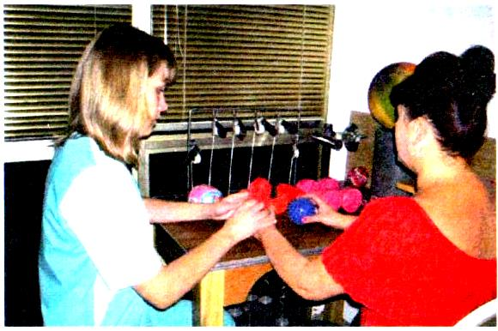
Fig.4.4. Fig.4.5.
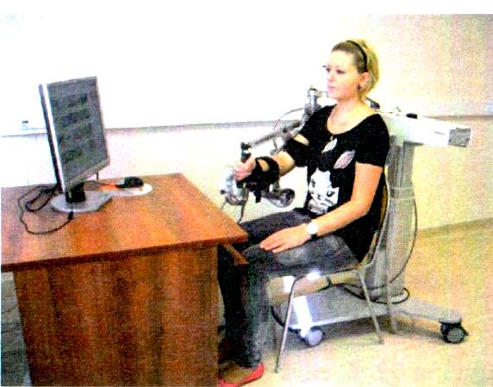

a pressure sensitive joystick picks up even a weak hand grip, which facilitates implementation of grab exercises at the onset of rehabilitation therapy. Exercises combining pronation and supination are helpful in broadening the range of available movements.
Armeo software performs accurate registration of hand movements necessary for assessment by the therapist of the progress in patient's coordination, and therapy. Armeo can be easily adapted to the needs of any patient so that he will be able to train by oneself. Armeo expedites rehabilitation due to the combination of arm support with the highly Fig.4.6. sensitive handgrip sensor and motivation of thepatient by involvement in the usual living activities.
Further rehabilitation program envisages expansion of the range of movements through application of numerous methods and forms of kinezotherapy. Instability of hemiparetic patients' standing and walking is rooted in vertical posture asymmetry as an outcome of pressure center displacement toward the healthy leg [22]. Hemiparesis distorts locomotion which creates a greater, compensatory by nature, loading on the system of static and dynamic postural regulation. According to the data of computerized stabilography, stroke patients with hemipareses show vertical balance instability manifested by increases in area and amplitude of the pressure center displacement and vertical posture instability (pressure center shifting toward the healthy leg) [24, 25]. Stability can be equally a compensatory reaction of the musculoskeletal system to instability, and an outcome of a more serious damage to the postural regulation system [24, 25]. Assessment of postural stability and therapy effectiveness is made with the use of computerized stabilography, i.e. registration of the projection of total body mass center (TMC) on the bodyweight-bearing plane, and its fluctuations while the patient stands or implements diagnostic tests. The major parameters are pressure center (PC) position in frontal and sagittal planes, statokinesiogram area, PC frequency spectrum, PC velocity of travel, and statokinesiogram density. The advantages of the method are that the test system enables integral functional evaluation of many body systems (musculoskeletal, nervous, vestibular, visual, proprioceptive and others), the investigation takes relatively short time (several seconds to a minute), and, except for special studies, does not require attachment of sensors, and that registered data are very sensitive and possess the diagnostic and predictive value.
CSPN investigators use the Romberg test for studies on computerized system MBN-Biomekhanika (research and production firm MBN, Russia) (fig. 4.7, 4.8). The studies are scheduled before, during and after a course of therapy. The following changes in stabilometric markers are considered positive: shifting of the PC frontal and sagittal projections toward the normal position, decrease of PC travel velocity, diminution of statokinesiogram area, reduction of the high-frequency spectrum. Computerized stabilometry is also needed to specify duration of the course of wearing the therapeutic suit (TS), to revise exercise therapy prescriptions, and to select orthopedic means.
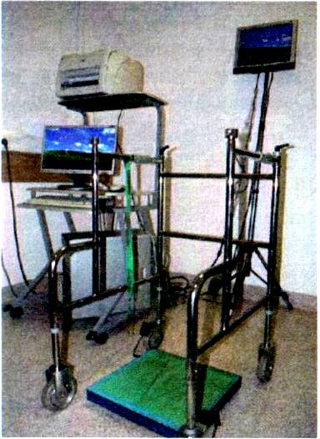
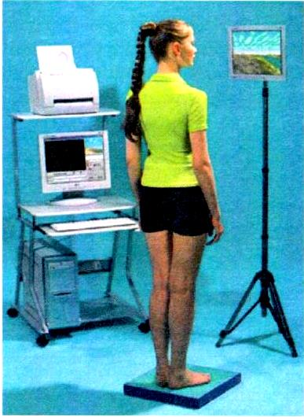
That explains the importance of exercises mastering the equilibrium function and vertical posture stability by trying different types of walk (along a footstep rug, rough surface, with closed eyes, etc.) and balance- therapy, such as step-training and dedicated remedial aerobics. Balance therapy employs BF-stability training facilities with packages of rehabilitation games. The patient is asked to step on the platform and assume a comfortable vertical posture. Then he gets the instruction that the cursor on the screen will indicate coordinates of his body pressure center on the platform surface. In the course of the training game the patient has to shift his pressure center in different directions. Investigations showed that integration of this method in the physical rehabilitation program ameliorates the stability function. In addition, it is favorable to reduction ofleg paresis, improvement of deep sensitivity, spatial awareness and psychic
Fig.4.7. Fig4.8.
functions, i.e. attention and mental ability, and normalization of emotional and volitional sphere of patients. Training with the statokinesiogram-based biofeedback lessens steps asymmetry and makes gait faster and more natural [12, 28]. Examples of the stabilometric investigation are shown on fig. 4.9 and 4.10.
One of the factors obstructing recovery of movements and self-service skills is trophic disorders infrequent in the initial months of stroke; they are arthropathy of paretic limb joints and the painful shoulder syndrome typically consequent to the shoulder joint subluxation. Arthropathies may terminate in appearance of contractures which, because of joint pang, constrain passive and active movements significantly. The painful shoulder syndrome is the most common development after 4—5 weeks of the catastrophe. Genesis of the syndrome can be associated with either trophic disorders (arthropathy) or humoral head prolapse from the articular bursa that occurs under the pressure of paretic arm weight and in consequence of muscle paralysis. Pain in the shoulder may start already on the initial days of stroke; it is particularly bad during rotation and abduction of the injured arm. X-ray pictures and clinical investigations of these patients usually make it possible to discover head prolapse from the joint space even after months and years post stroke [12, 14].
Some of the stroke patients complaining of painful shoulder have other clinical phenomena related to the syndrome of reflex sympathetic dystrophy or the shoulder-arm syndrome. Treatment of arthropathies is often a poor success and, therefore, measures should be taken to prevent their development. First and foremost, this is correct positioning of limbs during acute stroke and, with any sign of trophic changes, implementation of analgetic electrical procedures, reflexotherapy, electrophoresis of drugs, use of methods favorable to joint trophism, e.g. paraffin- or ozokeritotherapy, vacuum massage, etc. Treatment is combined with remedial exercises and massage. Same arm exercises are continued on the advanced stage of rehabilitation when contracture and elevated muscular tone (Vernike-Mann posture) are infrequent. In this case, arm is smoothly moved from the torso to the level position; the instructor fulfills prescribed exercises with fixation of the shoulder head in the artucular cavity. Different types of orthesotherapy are used on every stage of functional rehabilitation to facilitate movements recovery and gain stability. Cravat and other bandages and shoulder tutors are used in the event of humoral head subluxation; hand and wrist splints are applied to ease spasticity; different kinds of footrest to restrain feet and ankle joint, and functional ortheses to restrain elbow and knee joints.
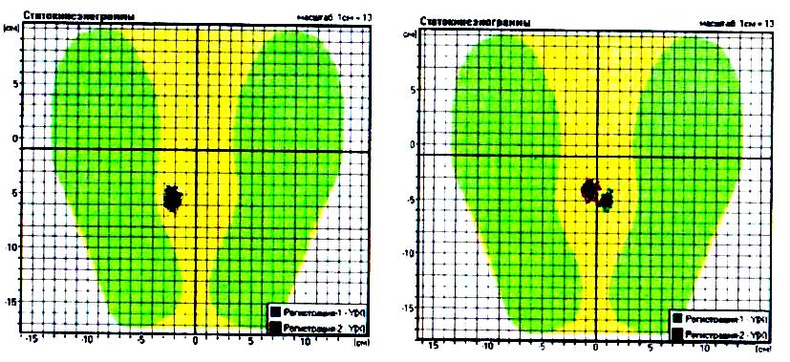
Neuromuscular electrostimulation is applied in order to facilitate voluntary muscular contraction, to increase and maintain the range of joint movements and to reduce spasticity. Typically, stimulation is provided to antagonists of spastic muscles. The training effect of electrostimulation comes from the direct activation of large motoneurons and also from the facilita- tory effect of cutaneous afferents on these motoneurons. The training effect of electrostimulation can be compared only to the effect of voluntary contractions of very high intensity. However, in contrast to active exercises acting directly on the cardiovascular and respiration systems, neuromuscular electrostimulation has a minimal activation effect on these systems, if only local. In addition to the neuromuscular effect, electrostimulation benefits blood
Fig.4.9. Fig.4.10.
supply to contracting muscles ensued by enhancement of metabolic and plastic processes. Electrostimulation electrodes are attached to muscles with account of location of the so-called motor points which are areas of the lowest excitation threshold. Electrodes for electrostimulation should be placed perpendicular to the muscular fiber's direction at the sites of motor endings that lack thick fascia. As a rule, stimulation is given to antagonists of spastic muscles, i.e. arm extensors and leg flexors. As part of rehabilitation, electromyostimulation heightens voluntary activity in stimulated muscles, increases their strength and depresses tone in spastic antagonists.
Recent decades have witnessed the intensive work on space research programs. Adoption by medicine of conversion technologies opened new opportunities for rehabilitation. The term "impaired support afferentation" coiled by space medicine implies a broad range of physiological effects of the micro-g environment (microgravity) [8].
The experiments performed by the Institute of Biomedical Problems (IBMP) over several years demonstrated that the major stimulus for the multitude of adverse effects of microgravity, including the muscular decon- ditoning, disorders in the functioning of central coordination mechanisms, orthostatic insufficiency and changes in cardiorespiration parameters, is removal or sharp reduction of support afferentation that automatically leads to deprivation or a dramatic decline of tonic activity and subsequent secondary physiological and structural changes in various body systems (Grigoriev A.I. et al., 2004). In view of this concept, IBMP investigators carried out comprehensive experimental studies aimed at verifying the possibility of preventing the microgravity-induced disorders by a direct influence on tonic mechanisms (Popov D.V., Sayenko I.V., 2003, Miller Т., Sayenko I.V., 2005, Kozlovskaya I.B., Sayenko I.V., 2007). To this end, the following technologies and equipment were developed, tested and integrated into the space program: an axial loading suit and low-frequency muscular tone costume-type stimulator for continuous wear. Testing of the suits in ground-based model experiments and space missions attested their high effectiveness as countermeasures against muscular structural and functional disorders and changes in the systems responsible for movements' control in microgravity. Considering the similarity of sensorimotor functional disorders in consequence of exposure in microgravity and pathologic processes, IBMP investigators in collaboration with a number of clinical institutions embarked on an ambitious program of promoting the methods and means developed for the purpose of counteracting the hypokinetic syndrome in space crews into practice of rehabilitation of patients with severe motor outcomes of perinatal encephalopathy, ICP, ischemic stroke, craniocerebral injury and spinal pathology, cardiovascular and other diseases.
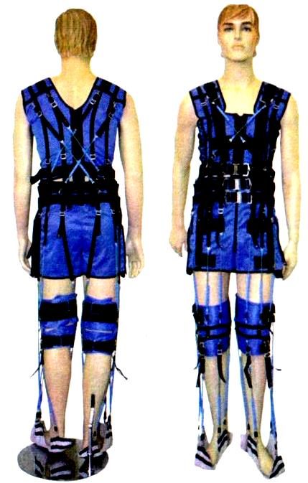
Adapted for the clinical environment, space medicine technologies proved high effectiveness in amelioration of muscular and sensory disorders, more rapid rehabilitation of health and motor activity, providing additional methods of improving social and self-care abilities and quality of life of chronic patients who have so far been considered hopeless (Cherniko- va L.A., Saenko I.V., 2010, Suslina Z.A., Saenko I.V., 2010).
The idea of loading the cosmonaut's musculoskeletal apparatus was embodied in the training loading suit (TNK) producing permanent loading on the skeleton, leg muscles and torso, and a method of dynamic proprioceptive compensation using a THK therapeutic modification (TS) [2,3,4] (fig. 4.11).
The basic TS component is elastic tension elements (ETE) that create axial "compression" and reproduce topography of large muscles of the tor- no and lower limbs. The physical instructor adjusts ETE tension for optimal loading of the patient's musculoskeletal apparatus.
ETE tension ensures correct positioning of the legs responding to applied force by muscular resistance or Fig 4.11. stimulates passive recruitment into (he TS-triggered
physiological synergy contributory to normalization of step movements.
The instructor identifies the loading value that will lead to normalization of the posture-tone balance in paretic and unaffected leg. ETE elements on the vest maintain shoulders and torso in the right position. There- lore, the suit decreases posture asymmetry substantially.
The initial 1—2 sessions are devoted to ETE tension adjustment optimal for an individual patient.
Choice of ETE depends on patient's characteristics (height, volume, diagnosis) and a method of shock-absorbers attachment to the props structures .
The number of TS sessions in the period of inpatient treatment may vary from 10 to 15. Session duration increases gradually from 20 minutes to 1.5 hours with 2 or 3 breaks for 5—7 minutes of rest. The patient moves about all the time while wearing the suit: moves about independently or, if required, with assistance, does exercises with the usual gait changed by added step, crisscross step, half squatting, etc., goes down an inclined plane, up and down stairs. The instructor watches the patient's bearing, head position, step structure and whether the patient makes the walk-associated reciprocal hand movements, and corrects feet positioning.
The procedures must be scheduled for the patients in generally satisfactory condition and strongly motivated to take the course of TS treatment; therapy program is tailored for an individual with account of actual functional mobility. Blood pressure and pulse rate are measured before, during and after the procedure. Training in TS increases considerably effectiveness of rehabilitation of patients with motor disorders, conduces to a more complete recovery of lost functions and improvement of life quality. Besides, wearing the therapeutic suit by stroke patients normalizes complex locomotor acts through normalization of the proprioceptive input [5, 6, 7, 9, 16, 18, 30].
To sum up, the concept of anti-g or axial loading suit application consists in massive artificial stimulation of afferent proprioceptive systems of posture and movement maintenance, while weight-bearing afferentation triggers posture-tonic reactions, makes postural and phase muscles more active participants in locomotion and stipulates elaboration of new stereotype movements.
In addition to remedial exercises, physical training facilities are used to strengthen patient's endurance of physical work and to condition the cardiovascular and respiration systems. Work intensity, number of repetitions and duration of training sessions vary with patients.
Mechanotherapy on special devices, mostly on the pendulum pattern, reduces arthropathy severity and increases the range of movements by joints. Contraindications to training therapy in acute stroke period are:
- hyperthermia;
- ischemic ECG;
- circulation insufficiency,
- significant aorta stenosis;
- acute system disease;
- uncontrollable ventricular or atrial arrhythmia, uncontrollable sinus tachycardia above 120 beats/min.;
- class-3 atrioventricular block without pacemaker;
- thromboembolism syndrome;
- acute trombophlebitis;
- noncompensated diabetes mellitus;
- musculoskeletal defects complicating physical training.
Risk factors associated with prescription of remedial exercises to patients in acute stroke phase are as follows:
- hypertonic or hypotonic reaction to rehabilitation procedures that may affect cerebral or cardiac circulation;
- dyspnea;
- exaggerated psychomotor excitation;
- inhibited activity;
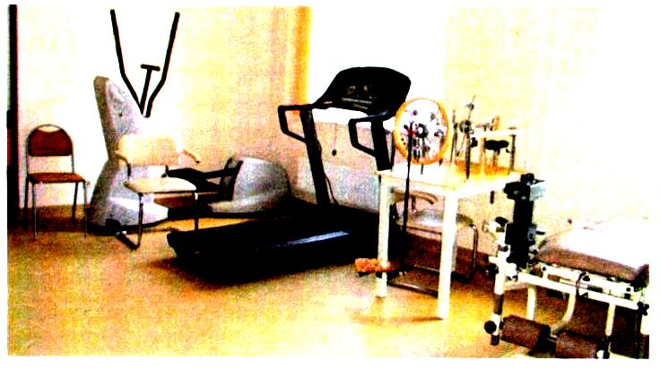

Fig.4.12.

- increase of painful sensations in the spinal column and joints of senior patients on the background of age-related changes in the musculoskeletal apparatus.
Some elements of the training rehabilitation program must be used no less than twice a day to accelerate stabilization of patient's motor reactions.
After treatment of acute stroke in the rehabilitation unit, early rehabilitation wards and neurological unit, patients with impaired motor and vocal functions are referred to rehabilitation unit in a hospital, outpatient clinic or specialized rehabilitation centers for further treatment. Goals of this stage are psychological, motor and social rehabilitation of the patient, and objectives specified in the rehabilitation program with consideration of the existing deviations and disorders. By this time (3 months post stroke) the patient has essentially spent the reserve mechanisms of spontaneous movement recovery; however, a bit more than nothing of potential may still be present.

EARLY AND ADVANCED PERIODS (APPROXIMATELY A YEAR AFTER STROKE OR CCI)
The neurorehabilitation program is aimed at wakening up the adaptive and compensatory mechanisms and increment of patient's volitional activity.
In this period, essentially same procedures as on the early stage of rehabilitation are applied to perfect the regained skills and abilities.
It is maintained that by this phase part of the patients have already formed a stable neurologic defect and. therefore, efforts of neurorehabilia- tion professionals are concentrated on the patient's adjustment to circumstances.
This is not true. Our experience shows that fulfillment of exercises with intensive physical loading and application of a variety of forms and methods of kinesotherapy enhance motor abilities on rehabilitation stages II and III and that physical neurorehabilitation still occupies a significant place.
CSPN makes use of the scale proposed by V.Ya. Porokhova [10, 11] that distributes the major motor disorders over the next five levels:
Level-5 — paralysis; passive condition, inability to get up and move about without assistance; disobedient impaired arm, prevailing spastic muscular contractures (except immediately after catastrophe), possible joint stiffness.
Level-4 — deep paresis, moving about the room though with difficulty and support, abducted arm flexed and pronated; extended elongated leg makes circumscribes during ambulation (typical hemiplegic gait); hardly obedient arm, attempted voluntary movements give rise and amplify associated movements and contractures.
Level-3 — paresis, spastic partly hemiplegic gait; ambulation leaning on prop with half-bent and slightly abducted arm and leg circumscribing a small semicircle, no support during ambulation, no typical hemiplegic posture in bed and not really noticeable in the standing position though becomes more apparent during walk and agitation; single mild spastic muscular contractures; hand manipulations are crude, jerky using the whole hand; attempted voluntary movements give rise to pathologic synkineses, particularly evident in the hand and fingers.
Level-2 — residual paresis: spastic hemiparetic gait, unaided walk, frequent drags, no hemiplegic posture, the arm can be held down during walk, leg is slightly abducted due to slow and incomplete knee joint flexure; successful voluntary control of separate pathologic synkineses; hand manipulations are performed partly with participation of fingers though with difficulty and not always successfully.
Level-1— light residual paresis: no marked gait defects, during follow- up and examination residual paresis is evidenced by slowness and awkwardness of some movements, a little bit slow normal associated hand movements, slightly forced postures and involuntary movements with hands, feet and fingers, a little bit delayed foot dorsal and plantar flexion, and difficulties with implementation of fine and precise hand, particularly finger, movements, irregularity of the general motor coordination, clumsiness during fast walk, turn, jump, dance, etc.
The proposed scale of the typically observed motor disorders facilitates substantially their assessment and detection, as well as consideration of improvements that may result from long-term administration of various methods of physical rehabilitation, remedial training specifically.
There exist several international muscle tone and strength scale:
)

Six-point muscular strength scale (L. McPeak, 19%; M. Veiss, 1986

S Score | Muscle strength | % of  strength | PaParesis severity
5 | Full range of movement (ROM) against the natural force of gravity and maximal external resistance | 100 | No
4 | ROM against the natural force of gravity and slight resistance | 75 | Light
3 | ROM against the natural force of gravity | 50 | Moderate
2 | ROM during physical exercise | 25 | Distinct
1 | Sensation of strain when attempting active movement | 10 | Acute
0 | No sign of strain when attempting active movement | 0 | Paralysis
Modified Ashworth spasticity scale (from R. Bohannon, V.Smith, 1987; D.Wade, 1992)
S Score | Muscular tone
0 | No increase in tone
1 Slight increase in muscle tone, manifested by a catch and release or minimal resistance at the end of the ROM when the affected part(s) is moved in flexion or extension
2 | Slight increase in muscle tone, manifested by a catch, followed by minimal resistance throughout the remainder (less than half) of the ROM (75% of passive movements)
3 | More marked increase in muscle tone through most of the ROM, but affected part(s) easily moved (50% of passive movements)
4 | Considerable increase in muscle tone, passive movement difficult (less than 50% of passive movements)
5 | Affected part(s) rigid in flexion or extension (no passive movements)

BARTHEL INDEX scoring (from Barthel D., Mahoney F., 1965; Granger C. et al„ 1979)
Instruction: Entries in the form can be made by the patient or carer. The maximal score of 100 corresponds to full independence in everyday living.
Activity | Dependence level | Score
 |  | before | After
Feeding | - Does not need helping, can use table covers | 10 | 10
 | - Needs some helping | 5 | 5
 | - Unable, fully dependent | 0 | 0
Bathing | - Does not need helping | 5 | 5
 | - Needs some helping | 0 | 0
Grooming | - Independent face/hair/teeth/shaving | 5 | 5
 | - Needs to help with personal care | 0 | 0
Dressing | - Independent | 10 | 10
 | - Needs help but can do about half unaided | 5 | 5
 | - Dependent | 0 | 0
Bowels | - Continent | 10 | 10
 | - Occasional accident | 5 | 5
 | - Incontinent (or needs to be given enemas) | 0 | 0
Bladder | - Continent | 10 | 10
 | - Occasional accident | 5 | 5
 | - Incontinent, or catheterized and unable to manage alone | 0 | 0
Toilet use | - Independent | 10 | 10
 | - Needs some help, but can do something alone | 5 | 5
 | (retaining equilibrium, on and off, etc.)
 | - Dependent | 0 | 0
Transfers | - Independent | 15 | 15
(bed to chair | - Minor help (verbal and physical) | 10 | 10
and back) | - Major help (one or two people, physical), can sit | 5 | 5
 | - Unable, no sitting balance | 0 | 0
Mobility | - Independent, >45 meters | 15 | 15
(on level | - Walk with help of one person, >45 meters | 10 | 10
surfaces) | - Wheelchair independent, > 45 meters | 5 | 5
 | - Immobile, or <45 meters | 0 | 0
Stairs | - Independent | 10 | 10
 | - Needs help (verbal, physical, carrying aid) | 5 | 5
 | - Unable | 0 | 0
Total score

The overall goals of remedial exercise are to train the cardiovascular and respiration system, to stimulate the digestive and other functions, to bring the emotional activation, and positive effect on the neuropsyhologic status of the patient.
Particular objectives are defined from the pattern of cerebral vascular recovery, clinical syndrome, and character of functional defect.
The core of physical therapy is again remedial training consisting of several special exercises of varying type and purpose.
The exercises can be arbitrarily divided into two groups. One group constitute exercises increasing muscle strength and reducing (normalizing) muscle tone, improving joint mobility and readiness for strictly graded muscle strain and relaxation, anti-atactic and aimed to recover coordination of movements, anti-association, synkinesis suppressing exercises. The other group consists of exercises directed to restore the everyday motor skills such as walking, dressing, eating, phoning and others, as well as exercises activating afferentation and enabling passive movements.
The division is very arbitrary, as in the course of treatment exercises are executed in various combinations and proportions. Remedial exercises intertwine with general health-improving, general developing and breathing exercises.
The following methods of physical training therapy are used to achieve these goals:
- remedial gymnastics, morning exercises and
- exercises performed by the patient independently in the day time according to an individual plan.
The program of physical training therapy includes methods of positioning treatment, active movements with healthy limbs; passive, assisted, and active movements with paretic limbs, breathing exercises, relaxation, special exercises to restore coordination of movements, teaching to walk and skills necessary in everyday living.
Positioning treatment is scheduled for 45 minutes 2—3 times a day immediately after remedial exercises. Special splints, soft bolsters and sand packets are used to fixate the upper and lower limbs. Affected anatomical relation of the shoulder head and glenoid cavity of the shoulder requires the use of scarf bandage during ambulation and sitting. Disturbance of ankle movements by unequal muscle straining is compensated by wearing of orthopedic footwear, i.e. a shoe with high counter and stiffened internal and external arches.
Remedial exercises are performed every day in 1—2 sessions that take 40—45 minutes. On the initial 7—10 days in hospital, lying, sitting or standing exercises are arranged individually, but can be done in group. Afterwards, on weeks 2 and 3 individual exercises are combined with group training. Patients are taught the best use of acquired movements and practice compensatory movements, recover fine hand movements, master walking and self-help skills. The resulting reduction of pathologic muscle tone makes possible to raise amplitude and speed of movements. Absence of the need for relaxing passive movements decreases their portion significantly. The goals of social and psychological adaptation are also integrated into the program of physical training.
Rhythmic music during group sessions is destined to give start to mutual induction of patients.
Frequently observed associated pyramidal and extrapyramidal disorders (foci in the deep brain sections, e.g. internal capsule, subcortex masses with underlying white substance) as well as pyramidal and cerebellum disorders (stem foci) are dependent on severity of cerebral damage and concern of adjacent brain masses. This fact is taken into consideration in physical exercises planning.
Vestibulocerebellar syndrome is the major one. The training program is focused predominantly on resumption of vestibular and coordination functions. Ballistic exercises such as throwing and pushing different items, and imitation of these actions train precision and accuracy and add to joints freedom and muscle strength. There are also buffing, afferent deficient, step-guide rug and oculomotor exercises, practicing to cross threshold, go up and down stairs and be independent of props.
On this stage of rehabilitation of neurological patients the best result is achieved by combining remedial exercises with massage.
Part of the body to massage is selected in view of the type of neurological syndrome.
Classic massage of paretic limb is prescribed to patients with spastic hemipareses. Because of hypertonia that tends to increase unequally in different muscles of the affected side, massage of spastically contracted muscles must be smooth and differential. Soft and tender hand movements are surface on the pattern of continuous plane and embracing stroking; antagonistic muscles are massaged with greater energy. If tolerance is good, light transverse prickling petrissage is added first for stretched hypotrophied muscles and then spastically contracted. Passive movements during massage are compulsory. Absence of muscle tone elevation and synkenisis serves as the criterion of correct massage procedure.
Massage of lumber (S1-L2) and thoracocervical (С1-Тн12) segments is applied to stimulate leg and arm trophism, respectively.
Duration of paretic limb massage procedure is 7—10 minutes at the beginning and 25—30 minutes further into the course of 20—25 procedures.
Atonic hemiparesis is also treated by massaging paretic limbs and segmental zones. The purpose is to improve skin trophism through activation of regional and general lymph and blood flow, normalization of muscle tone and increase of contractile function and atrophy prevention. Continuous and intermittent embracing strokes, rubbing, light longitudinal and transverse petrissage, and additional techniques of intermittent petrissage such as prickling and pressing. Continuous vibration has a stimulating effect on muscle tone agitating a massive proprioceptive flow into the CNS. One procedure takes 12—15 minutes; the course consists of 20—25 procedures.
Extrapyramidal rigidity can also be treated by massaging limbs and the collar zone; massage of the collar zone, arms and scalp is administered to patients with the syndrome of verterbrobasilar vessels damage. One procedure takes 12—15 minutes; the course consists of 15 procedures.
The remedial exercises interchange with robotic and mechanotherapy on Lokomat and Armeo facilities, treadmill training, electromyostimulation, dynamic propriocorrection (TS), weight-bearing stimulation (Korvit) and other methods described above.
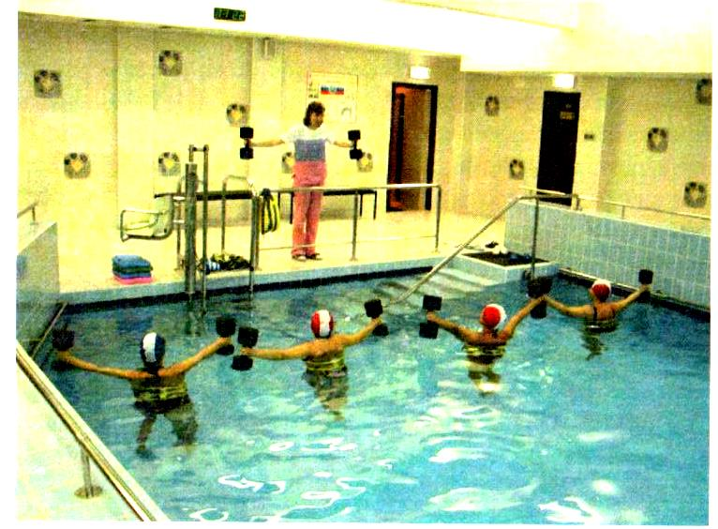
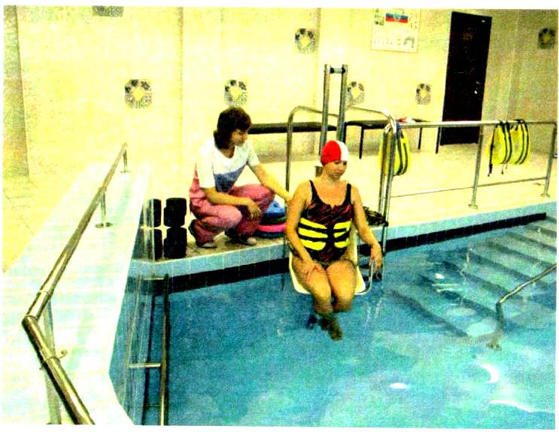
Post-stroke patients benefit from in-water exercises and swimming, as water resistance does not let sharp movements. All movements become smooth, controllable and graceful; the couch watches deviations in exercise implementation and intervene, if necessary. Besides, warm water (35—37 °C) is favorable to organism reducing muscle tone and contracture strength, improving tissue trophism and enhancing circulation. Water procedures are arranged for a small group or a single patient (fig. 4.13, 4.14). Exercises are done at different depths, i.e. waist and shoulder deep. Active and passive exercises are performed with easy and additional burden (aquatic dumbbells and gloves, etc.), manipulation with items and aids (stick, different balls, flippers and others), and exercises for muscle relaxation and with the use of aquatic mechanic training facilities.
Fig. 4.13. Fig. 4.14.

RESIDUAL PERIOD
Clinical practice shows that though slow ly, recovery of complex motor activities (living and work skills) continues in the residual period, as do vertical stability and speech.
The main objectives on this stage of rehabilitation are perfecting of positive motor shifts achieved in hospital and rehabilitation center in the course of the brain vascular disease treatment, overcoming stroke outcomes (paresis, paralysis), and recurrence prevention: further psychic and physical rehabilitation and environmental adjustment including the development of liv ing, vocational and social skills.
On this stage, physical training therapy pursues the goals of:
- Elevation of the general tone;
- Prevention of muscle shortening and maintenance of normal joint mobility;
- Restoration of ROM, strength and quality;
- Decrease of muscle rigidity and associated movements:
- Recovery of correct associated activity of weak and intact muscles;
- Regain of correct carriage and normal motor stereotype;
- Elaboration of vital living and vocational skills.
Very often remedial physical training combines the general tonic exercises with the next dedicated exercises [10]:
- passive movements by joints of impaired limb with assistance of the instructor and helping oneself with the healthy hand;
- active movements by joints of impaired limb with assistance of the instructor and helping oneself with the healthy hand;
- active facilitated exercises on a level surface with exclusion of limb mass and friction (slippery surface, roller hand cart, water pool, etc.);
- elementary active exercises for impaired and healthy limbs and torso:
- training of differential movements by separate joints of impaired limb;
- enhancement of associated and anti-associated movements; further gait improvement;
- exercises with gymnastic items and those used for elaboration of important living and vocational skills.
Each session should alternate dedicated exercises for impaired limbs and general tonic. This is necessary to perfect coordination and to level muscular tone. Besides, physical training has a repercussive effect; regular engagement of unaffected limbs and torso in training can accelerate "reeducation" of the whole neuromuscular apparatus. The session should start with exercising the healthy muscle groups.
Growth of loading should be incremental. Admissible level of loading is defined by heart rate (HR) and blood pressure (BP) values:
HR, = HR + 0.5 X (HR , h-HR ,).
training rest ^{v} threshold rcsl'
Exercises can be selected and composed for the purposes of tonic, trophic, function compensation and normalization training.
One of the stroke outcomes is derangement of carriage, a motor habit formed on the basis of reflexes and body posture and maintaining body, torso, pelvis and limb in a person-customary position.
Stroke disturbs biomechanics of the musculoskeletal apparatus, i.e. weight bearing predominantly by the right or left leg (unaffected) reduces the projected body length and deviates the pelvic axis toward the less loaded impaired leg. The heavier loaded leg acquires an extending position with foot stepping on the whole sole. On the contrary, the underloaded leg becomes a little bit flexed and touches the floor with the frontal part of the sole. The lateral pelvis inclination leads to side curvatures of the back column, i.e. lumber spine curvature toward the impaired limb and compensatory thoracic spine curvature toward the opposite side. Center of gravity makes a sideway shift and, instead of projecting between the feet, approaches contour of the heavily loaded foot or oversteps its edge.
In view of the above, physical training should include exercises for bearing correction through building tone and strength of the neck, back, stomach and limbs muscles, consolidating awareness of spatial arrangement of properly postured body and forming the habit of keeping the correct bearing as well as right posture when performing different types of muscular activity.
Along with the remedial exercises, methods of robotic mechanotherapy (Lokomat, Armeo), electrostimulation, treadmill training, dynamic pro- priocorrection (JIK), therapeutic swimming and others are administered.

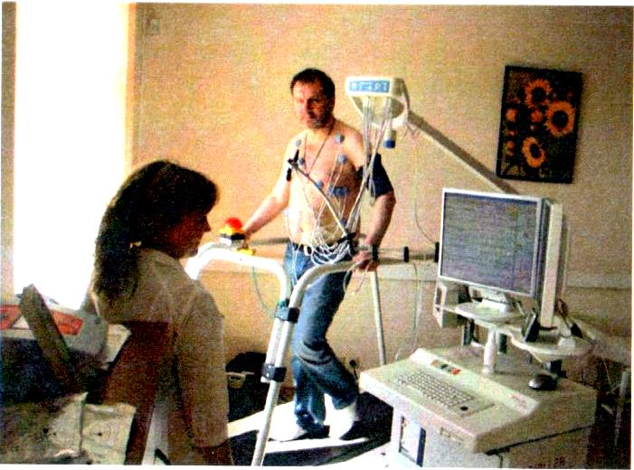

Fig.4.15.

In recent 6 years, the Physical Therapy and Massage Unit provided treatment to 4720 patients; 4545 (96.3%) patients were afflicted with musculoskeletal dysfunction of varying severity. For instance, deep and significant hemiparesis was observed in 1754 (38.6%) patients, moderate paresis in 464 (10.2%) patients and minor motor disorders in 2327 (51.2%) patients.
To assess the results of motor function recovery, T.D. Demidenko proposed a table of clinical and social outcomes [10].

Table 4.1. Clinical and social outcomes [10].
Outcome
Essential recovery  (full functional recovery or full restoration of social and living activities;  minor residual paresis) | 4.2%
Substantial improvement  (transfer up to a less affected group; full restoration of self-care skills) | 56.9%
Improvement  (paresis and social and everyday living activities score +1) | 29.6%
Modest improvement  (positive dynamics in some of the motor functions) | 6.9%
No progress  (w/o dynamics) | 2.4%

Below are our results of using the preventive loading suit in rehabilitation of patients with stroke and craniocerebral injury.
The considerable progress of space programs and assimilation of conversion technologies by health services in the past decades opened up new opportunities for medical rehabilitation.
The term "weight-bearing afferentation disorder" was coined by space medicine; it encompasses a host of the bodily effects of microgravity environment. The idea to stress cosmonaut's musculoskeletal apparatus with the help of a suit producing permanent loads on the skeleton, leg muscles and torso (prophylactic loading suit, PNK.) developed into the method of
dynamic proprioceptive correction for rehabilitation clinic application (therapeutic suit, TS).
The therapeutic suit increases significantly effectiveness of rehabilitation of motor disorders, restoration of lost functions and enhancement of stroke patient's life quality. In addition, TS contributes to normalization of complex locomotion acts owing to normalization of the proprioception input.
The concept of anti-g or axial loading suits application relies on massive artificial stimulation of afferent proprioceptive systems responsible for posture and movement maintenance, while weight-bearing afferentation triggers posture-tonic reactions, makes postural and phase muscles more active participants in locomotion and stipulates elaboration of new stereotype movements. TS-training is performed in parallel to the standard neurorehabilitation procedures. Ten to 15 TS sessions are scheduled for the course of treatment. Session duration extends from initial 20 minutes to 1.5 hours with 2—3 breaks of 10—15 minutes. The patient moves about all the time while wearing the suit: walk independently or, if required, with assistance, does exercises with the usual gait changed for added step, crisscross step, half squatting, etc., goes down inclined plane, up and down stairs. The instructor watches the patient's bearing, head position, step structure and whether the patient makes the walk-associated reciprocal hand movements, and corrects his feet positioning.The procedures must be scheduled for the patients in generally satisfactory condition and strongly motivated to take the TS course of treatment.
In the Center of Speech Pathology and Neurorehabilitation, the dynamic proprioception method using TS Adeli and Gravistat has been employed since 1995. We provided treatment to 589 patients including 384 acute stroke and 179 CCI patients. The stable positive clinical effect was achieved in 94% patients with acute stroke outcomes and all CCI patients.
Purpose of this study was to evaluate the effects of Regent, a new TS modification (IBMP development), on the basis of clinical, neurophysiology and neuropsychological data analysis.
The selection-in criteria were first ischemic stroke or left hemisphere CCI in anamnesis, hemiparesis above the lung (according to the score proposed by L.G. Stolyarova, 1978), or hemiparesis and ataxia. The selection-out criteria were serious cardiovascular disease above class 1) and severe arrhythmia.
Neurologic symptomatology in these patients included coarse focal symptoms such as pyramidal syndrome, sensitivity, coordination and vegetative disorders. Pyramidal hemiparesis of varying intensity was one of the main invalidization factors.
Main group
The group of those who donned the suit consisted of 36 patients between 18 to 66 years of age. Number of stroke patients made up 27 (75%) and CCI, 9 (25%). They were 26 male and 10 female patients. Period of disease varied from 5 months to 6 years. In 24 patients (89%), left-hemisphere stroke was an outcome of idiopathic hypertension combined with lesion of the cerebral great vessels. In one patient, stroke was provoked by extracranial occlusion of the left common carotid artery. Nonspecific aortoarthritis with complete obliteration of the left internal carotid artery was the factor in 2 patients.
CCI was presented by severe brain contusion in 2 patients (22%) and operated traumatic subdural hemorrhage in 7 patients (78%).
Serious vocal and motor disorders, coarse paresis, were characteristic of 21 patients. Ten patients (28%) suffered gross paresis and 5 patients (14%), moderate (according to the L.G. Stolyarova scale, 1978), three of these patients exhibited moderate ataxia.
Nine patients (25%; 6 points by the Functional Ambulation Categories) could move about independently without props and assistance. The rest 27 (75%) patients needed some way of support, i.e. 17 people used props equally in and outdoors and 10 took them only when going out (3 and 4 points, respectively).
The primary selection criterion was failure of previous treatment to revive the speech and locomovement functions.
Suit therapy was integrated into the standard neurorehabilitation program. The number of suited sessions during the inhouse treatment ranged from 10 to 15. Session duration extended gradually from initial 20 minutes to 1.5 hours at the end with 2—3 breaks for 10—15 minutes of rest. The patient moved about all the time while wearing the suit: walked independently or, if required, with assistance, did exercises with the usual gait changed for added step, crisscross step, half squatting, etc., descended an inclined board, and went up and down stairs. The instructor watched the patient's bearing, head position, step structure and whether the patient made the reciprocal on-the-way hand movements, and corrected their feet positioning.
The procedure was administered with the patient in general satisfactory condition and motivated to receive this therapy. Suited training program was tailored with consideration for patient's mobility. Blood pressure and pulse rate were measured before, in and after each session.
Control group
The control group consisted of 32 patients between 24 to 68 years of age. Number of stroke patients made up 24 (75%) and CCI, 8 (35%) The patients were also distributed among the subgroups with coarse paresis (n = 18, 56%), gross paresis (n = 8, 25%) and moderate paresis (n = 6, 19%); 4 CCI patients had ataxia.
Unlike the main group, the control patients were treated by the standard course of neurorehabilitation composed of drug therapy, neuropsycho- logically programmed individual and group speech lessons, individual and group exercise therapy, massage, ergotherapy, and physiotherapy
All patients went through the 45-day course of neurorehabilitation in the CSPN hospital.
Assessment methods:
- Clinical effect was estimated quantitatively using:
- Functional Ambulation Categories, Holden M. et al., 1984, 1986;
- Barthel ADL Index;
- Up & Go, Podsidlo and Richardson, 1991
  - Computerized stabilometry (CS) according to the Romberg test with the use of hard- and software MBN-Biomekhanika (Research and Production Firm MBN, Russia) concurrently measuring the standard CS parameters, i.e. mean position and sagittal and frontal deviation of the general pressure center (GPC), statokinesiogram length and area, GPC travel velocity, and Romberg coefficient.
  - Neuropsychological testing for qualitative and quantitative assessment of the higher psychic functions.
All tests and measurements were performed before and after the suit therapy course in the main group and on the admission day and after three weeks of the standard neurorehabilitation treatment in the control group.

RESULTS
The clinical effect is commonly understood as improvement of patient's condition in the form of reduction of neurological syndrome and neuropsychological symptomatology confirmed by scores of increases in the range, diversity, strength and precision of movements, leveling of disturbed posture-tonic relations, increment in activity, speech, general condition and mood improvements. However, the primary goal of rehabilitation is communication and self-care adaptation of the patient, and improving life quality, elaboration of the purpose-oriented motor act, specifically. This was the reason for our focusing on assessment of patient's ability to self-service, recovery and consolidation of lost skills, particularly independent walking (without props and assistance), gait refinement in order to make it faster, with long pace and better maneuverability), facilitation of communication with the surrounding, considering that paresis has faded away little after one year of the stroke history.
The integrated treatment was shown to make the patient's general state and feeling better, to stabilize the hemodynamic parameters, and to improve endurance of exercises which gives ground to conclude that the therapeutic suit has a training effect on patient's organism.
The Functional Ambulation Categories test determines the need of aid outdoors (maximal score of 6 attests full independence).
Comparative analysis of averaged test data before and after suit therapy is presented in table 4.2.

Table 4.2. The Functional Ambulation Categories test results.
 | Main group, | n = 36 | Control group, n = 32
Categories | Before  suited  therapy | After suited therapy | Baseline  data | After 3 wks. of neurorehabilitation
Patient can walk independently anywhere — score of 5—6 | n=9 (25%) | n = 17(47%) | n=5 (16%) | n-8 (25%)
Patient requires prop and/or help outdoors — score of 4 | n=10(28%) | n = 8 (23%) | n=8 (25%) | n=10(31%)
Patient requires prop and/or help in  and outdoors - score of 3 | n= 17 (47%) | n = 11 (30%) | n=19 (59%) | n=14 (44%)

Clearly, that percent of the patients who do not require props and help anywhere including stairs and uneven surface is much higher in the main group as compared with the control. For instance, gain in the number of independent patients in the main group amounted to 22% vs. 9% in control.
The Barthel ADL Index (maximal score attesting full independence in everyday living = 100) assesses the following types of activity: walking, stair climbing, transfer from chair to bed, toilet use, bowels, grooming, feeding and bathing.
Comparative analysis of averaged Barthel ADL Index data before and after the course of suit therapy is presented in fig. 4.16.
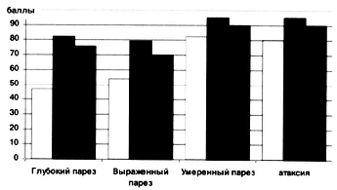

Fig.4.16. Barthel ADL Index dynamics.

The diagram demonstrates clearly that no matter what hemiparesis subgroup, all patients in the main group are characterized by significant positive dynamics.

Go & Up test (Podsidlo and Richardson, 1991)
The test possesses high reliability and specificity for quantification of functional mobility. The test includes a number of tasks such as standing from a sitting position, walking (6 m), turning at 180°, stopping, and going back to chair. The test has been adopted as an objective method of treatment effectiveness evaluation.
Mean time of test completion decreased from 38.11 to 27.6 s in the main group (Д = 10.51); the control group decreased time of test completion from 42.6s to 35.72s (Д = 6.91) which confirms the positive effect of suit therapy on functional mobility.
Stabilometric studies
Stabilometry is gaining footing in many fields of medicine [23, 30] owing to the fact that the battery of tests enables integral estimation of various body systems including musculoskeletal, vestibular, visual, proprioceptive and others.
We applied the method of static stabilometry comprising the balance test on stationary platform with eyes open and close before and after the suit therapy.
Patients for the comparison subgroups were selected from both the main and control groups by the criteria of displaying stabilometric deviations typical of hemiparesis, i.e. GPC shifting onto the unaffected side, increases in statokinesiogram travel velocity and area. Patients with these symptoms made the majority — 25 among 36 in the main group and 22 among 32 controls. This was done because along with the typical stabilometric symptoms of postural instability there are also paradoxic versions featuring hyperstabil- ity, GPC shifting onto the injured side or central positioning.
Most of the patients with deep hemiparesis showed prevalence of frontal instability over sagittal accompanied by GPC acceleration, and reduction in statokinesiogram density.
Studies of 36 hemiparetic patients evidenced positive stabilometry dynamics in 31 cases manifested by noticeable GPC shifting toward the sagittal isoline and area diminution after 6 sessions, and stabilization till session 11. Following session 12 dynamics was indistinct.
Studies of the atactic group demonstrated positive stabilometry dynamics in all group members. Reduction in predominantly the area and length parameters of statokinesiogram was observed after 6 suited sessions, remained stable till session 10 and then showed a slight increase. It is noteworthy that patients did not complain of growing coordination difficulties. Data of the study are summarized in table 4.3.
Data analysis shows convincingly that the main group improves statokinesiogram much faster despite similarity of the trend in the groups. For instance, as compared with baseline measurements, the sizeable GPC shifting toward the sagittal isoline and reduction of the statokinesiogram area with open and closed eyes were registered after 6 suited sessions and persisted till session 11. No further dynamics was noted after session 12. As for the group of ataxic patients, positive stabilometric dynamics in each member was due to, chiefly, reductions in statokinesiogram area and length by session 7 which persisted till session 10 and tended to grow slightly further afterwards. It is noteworthy that the patients did not feel augmentation of coordination disorders. Therefore, change in proprioception initiated by wearing suit Regent increases materially the level of posture-tonic relations stability in organism of the stroke patient.
The therapeutic suit influenced not only the locomotion patterns of the patient but had a parallel positive effect on the higher psychic functions. For instance, the dynamic neuropsychological testing revealed quantitative and qualitative improvements. Patients with motor aphasia progressed in articulation, grammatical system and the nominative function of speech, and enriched active vocabulary. Patients with sensorimotor aphasia could understand better situational and situation unrelated words, which was favorable to their emotional balance; also, they decreased the incidence of visual agnosia.
Of principle importance was the fact that all patients enhanced motor activity of the speech act. In comparison with patients who had not received suit therapy, they demonstrated more rapid and natural recovery from oral and articulation praxis. It can be assumed that here we have the phenomenon of transfer of the motor rehabilitation effect on the articulation system in general.
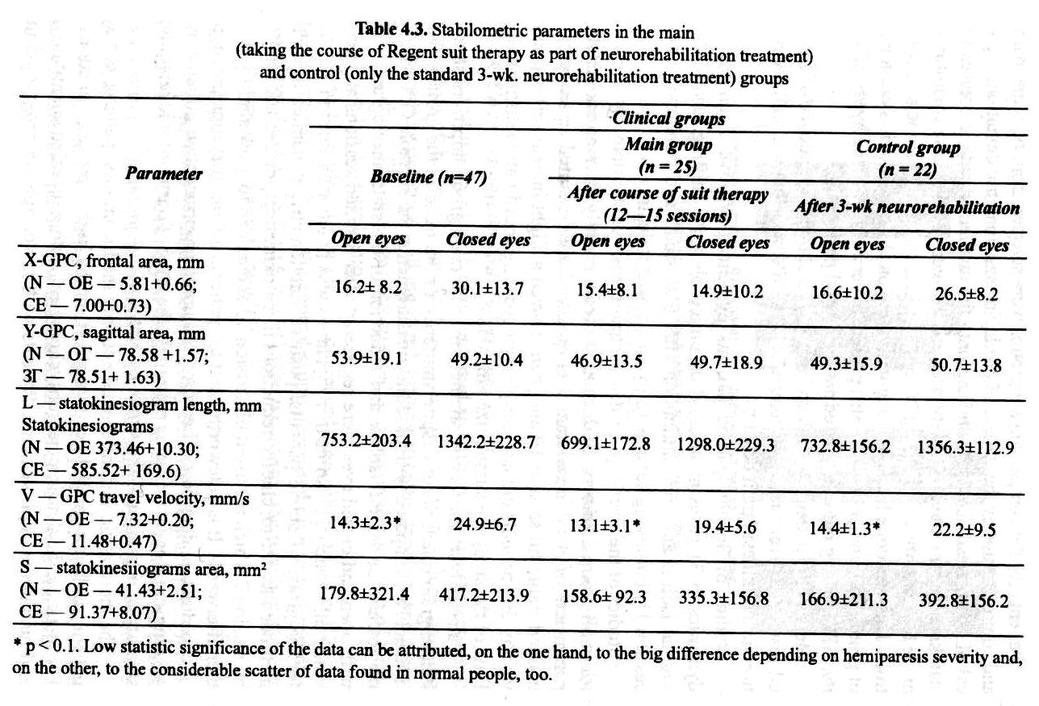

In conclusion we can say that integration of the proposed method of dynamic propriocorrection into the program of medical rehabilitation of stroke and CCI patients provides gradual normalization and optimization of the efferent component of the motor-kinesthetic analyzer, stabilizes afferent input in stem structures of the brain responsible for psychomotor integration. In the end, stabilization of the cortex-subcortex relations leads to improvement of the motor and speech activity, and emotional status of the patient.
Administration of the original integrated method of neurorehabilitation enlarges substantially the potentiality of rehabilitation and achievement of clinical effect in the category of previously hopeless patients under continuous and unsuccessful care.

