RETURN OF THE FINNISH LEGEND
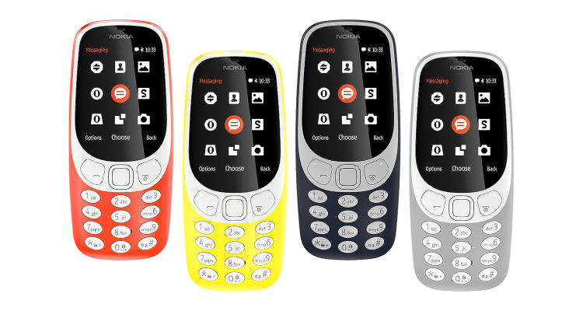
Miss me?

“No comments needed to adore Nokia”.
-The New York times-
We know you might have had this phone in your bouncy childhood.
Or your parents. At least, your grandparents…
Well, to remind you how cool Nokia is, we compiled a little bit of information just in case to remind you evident things you could forget
- Nokia was one of the most popular and best-saled phone in 2000-s (126 mln of phones was sold out).
- This “tiny tot” is well-known for it’s durability and resistance – take it whenever you want without any precautions and use it instead of hummer/tool.
- Reintroduced Nokia 3310 have a multicolour display, month-long battery, bigger screen and, imagine how lucky you are, LEGENDARY SNAKE GAME.
- The new Nokia 3310 is sleeker comes in different bright colours. The phone is expected to come with Bluetooth, Internet access and an app store.
- This Nokia miracle costs only 60 euros. Be the first to experience reintroduced Nokia 3310 and get a fashionable accessory!

For more information subscirbe online at http://www.nokia.com/nl_int

Kidding, but anyway - if it breakes, we will turn your money back.
If you book a preorder, Nokia will cost you 10 euros cheaper.

