Arbitrage Crypto Trader is a trading terminal making profit of price differences on the exchanges

We do what traders can only dream about!
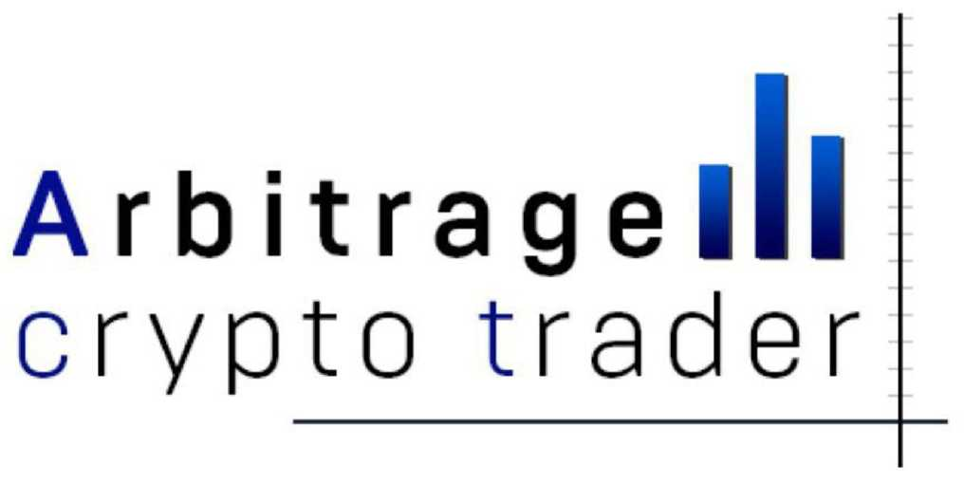
www.arbitragect.com

White paper
version 1.0

CONTENT

1. Introduction
2. Why arbitrage does not work today
3. How Arbitrage Crypto Trader solves these problems
4. How it works
5. ACT Token
6. Our Mission
7. Action Plan
8. ICO
9. Our Team

1. Introduction
Arbitrage is one of the oldest trading strategies. Among traders and investors the arbitrage strategies are famous for low risk level. The key target is simultaneously to buy and sell identical or sufficiently alike classes of assets.
Prior to Internet era the arbitrage process took place like the following. Two trade experts held constant telephone line between exchanges in Chicago and New York. When on one of the stock exchanges the price for example, sugar surged for whatever reason, but on the second exchange still not, then sugar was sold where it was more expensive and bought cheaper at the second exchange. In a few seconds when the information about price changes came to all market participants, prices again equalized. And the traders just locked in profits.

Huge capital rose from this simple trading algorithm. But it ended up with the Internet era and now exchanges globally move towards electronic trading. Eventually, robots replaced people. Today robots are happy to use price fluctuations of 0.01% and even 0.001% while people made a profit up to 10% of one transaction.
Traders of classic stock and commodity markets remain to feel nostalgic for never-return times.
However the arbitrage did not die. Thanks to the creation of crypto currencies it is well-liked again. All of us can see that right now the bitcoin quotations on different exchanges differ by 1-5%. And for some altcoins the difference sometimes rises to 50%.

2. Why arbitrage does not work today

The simplest question may occur to every person even that one who is far from trading: "Why all those who deal with crypto currencies are still not dollar millionaires?" After all everything seems to be easy: sell crypto currency or tokens in one market, buy them in another, then wait for price-cutting and lock in profits.

1. Lack of liquidity in markets
It is impossible to quickly buy an asset in one of the crypto exchanges and to sell it in a larger volume on another. Because of that there are nearly no market majors and much less funds that would spur prices in the stock market.
If a major player who see 10% price difference between exchanges try to sell a $10 Mio asset on one of them and to buy for the same amount in another, the player will get a tremendous slippage and in most cases will not make even 10% but on the contrary will lose 10 - 50%.

2. Problems with entering /withdrawing large amounts on exchanges
In connection with the tightening of money laundering control the entering of large amounts in markets becomes a problem for a client, a bank and an exchange itself. It often takes weeks and months. And when it comes to withdrawing money things get even harder and longer.
As a whole, majors cannot find liquidity (paragraph 1) and cannot quickly enter and withdraw their funds in various exchanges for arbitrage transactions.
3. Lack of understanding of how to technically conduct arbitrage
As a result of problems described in paragraphs 1 and 2 there are nearly no institutional investors on the market. But there are a lot of people with insufficient financial education. For most of them it is a problem to conduct arbitrage strategies themselves as well as to create a robot able to monitor price divergence and conduct transactions.

4. Insufficient infrastructure
Most crypto-exchange terminals are still rooted in the stone age in comparison with the technical progress. For example the charts of each trading pair can be loaded as long as for a few seconds. And when you click on the "buy" or "sell" button the transaction may goes down for another few seconds. Prices, constantly getting changed on several exchanges, make you instantly figure out by guess and cause mistakes.
So it is extremely difficult for a trader to obtain a precise result which would be equal to the price spread between the two exchanges.

3. How Arbitrage Crypto Trader solve those problems

1. Illiquidity in markets
The terminal is created for dealing with any volume of trading deposit. It can be used by both small traders and large institutional hedge funds. Strategies of the majority of the latter include risks hedging, in other words, arbitrage.

At the moment, due to the low liquidity of the crypto-currency markets, small and medium players can earn money using the platform, the smaller volume of orders the better results Arbitrage Crypto Trader demonstrates.
During the next one or two years there will be a liquidity "explosion" in the market when the aggregator companies will solve the problems on the model of today's ECNs which link liquidity from hundreds of different suppliers. After that large speculators and funds will be able to come in the market using Arbitrage Crypto Trader in their trading strategies.

2. Problems with entering / withdrawing of large amounts on exchanges
Since for the time being the terminal is tooled for small traders it waives the problem of the arbitrage strategy such as connected with entering/withdrawing of funds.
For small deposits such transactions took a few hours and even minutes.

3. Lack of understanding of how to technically conduct arbitrage

Arbitrage Crypto Trader does not require any deep technical or even financial knowledge. It monitors markets 24/7, searches for suitable transaction entering formations and expects the trader to do just one thing - to press the "enter the transaction" button. At the same time a coin is bought in one market and is sold in another.
It is enough to watch an educational video to understand how the terminal works. We intentionally do not include a large number of functions to the base version in order to avoid confusion. But for premium accounts which will be used by professional traders Arbitrage Crypto Trader gives a wide field for using various types of orders and strategies.

4. Insufficient infrastructure
Arbitrage Crypto Trader does not require charts, much less does not make participants wait them to download. The platform receives quotations via WebSockets of exchanges in approximately the following format (depends on exchanges):
Time - quotation ticker - price - volume of transaction. For example:
14.05.37 BTC 4560.34 1.3 bitcoin
Unlike the long charts loading process in the terminal of exchanges the data mentioned above are getting received almost without delay. And the transaction time risk is solved by setting a time lag with the possibility to cancel the transaction if the lag value in seconds is exceeded at this time.

4. How it works

Our product is the trading terminal Arbitrage Crypto Trader. How does it work? We receive quotations from several crypto-exchanges. An user selects two of them where he or she has a trade deposit. Then the pair of interest is selected. For example Bitcoin / Dollar or Ethereum / Dollar.
On the basis of the quotations received from each stock exchange, the terminal automatically calculates the average price difference in percent between the two exchanges. It's not a secret that in some exchanges crypto currency is a bit more expensive and in others it is a bit cheaper. The main reason is different rules of entering / withdrawing funds plus exchange brokerage.

Suppose the average difference between the two selected exchanges is 1.5%. It means that the situation when in one exchange 1 bitcoin costs $ 4,000 and in another it costs $ 4,060 is standard, with a standard difference of 1.5%.
The task of Arbitrage Crypto Trader is to monitor this price difference between two crypto-exchanges every second. The ratio will constantly change amounting to 1.6%, 1.2%, 2.4%, etc. The client sees this discrepancy in the terminal as a line in the chart as well as a variable index in percent.

Further, depending on whether the trade is conducted by a player or in automatic mode there are some differences:
-- Manual transactions
The client looks after changes in the percentage or obtains alerts. When he or she considers the difference sufficient the client conduct arbitrage by buying Bitcoin / Dollar pair in one exchange and selling in another. In a while the price returns to its standard deviation of 1.5% and the client's deposit increases.

-- Automatic trading
The client does not need to constantly spend time at the display. He or she does his/her own things, for example works, studies, plays with children. The client only needs to set the price difference in percent between the exchanges and the algorithm automatically enters the transaction.
For example during the day Arbitrage Crypto Trader can conduct several such transactions and the user will review the report on them and the earnings report in the evening.

What risks does a client bear?

The main advantage of arbitrage is the extremely small risk level. Since there is a simultaneous purchase and sale of identical assets. The user just waits for the price dispersion between the two crypto-exchanges and enters the transaction. When this difference returns to its historical average values the client locks in profits.

The main risk of arbitrage is that at some moment the price difference might not return to its historical rates ​​(for any reason). For example, on one of the exchanges, the rules for entering / withdrawing would get changed and the standard difference would increase from 1.5% to 3.0%.
In this case if the user is already in the transaction he or she will take a loss. Since the entry into the transaction has occurred when the value was larger than average the volume of loss volume will be less than 1.5%.
Further, a new average divergence of 3% is established and the user again takes profit from new transactions.

How does Arbitrage Crypto Trader make money?

The standard version of the platform for all users will be free. In this case monetization is performed by using a small window with the ads displayed.
In case the customer wants to use the trading functions with one click or automatic trading he or she can use Premium packages. In this case payment for Arbitrage Crypto Trader services is set as a percentage of the volume traded. In fact that is the same commission that the client pays for any transaction on the stock exchange.

The main difference is that the customer pays the Arbitrage Crypto Trader commission by conducting almost solely profitable transactions. The actual volume of the commission will be approximately 2-5% of the profit depending on the volume traded.

5. ACT Token

Arbitrage Crypto Trader ACT token will be used in all calculations between the platform's users. This will form a constant demand growth for it. If 1000 new users buying Premium packages come to the platform they will have to preliminary purchase ACT tokens on the exchange increasing the demand for them.
30% of the profit taken by the Arbitrage Crypto Trader platform will be distributed among the tokens holder every 3 months.
The ACT tokens are to be placed in 2 stages: Pre-ICO and ICO. Their total stock is fixed. All tokens which will not be bought at both stages of placement are subject to annulment. Their additional emissions will never be issued again. The ACT token is placed on the basis of the Eterium smart contract.

The fixed number of issued ACT tokens guarantees the buyers rise in the cost as the demand for Arbitrage Crypto Trader services increases.

6. Our Mission
Arbitrage Crypto Trader solve the huge market inefficiency historically present on crypto exchanges. The task of the platform is to reassign funds, to the benefit of the clients, that platforms owners take from customers as large commissions and fees for entering / withdrawing funds.
We believe that the advantages from the blockchain technology and the opportunities offered by crypto-currency trading are to be received by all participants and not by a small group of people who own exchanges.

7. Action Plan

2017

March-May
Development of arbitrage strategy and testing it in manual mode

June-August
Creation of a test prototype which checked six crypto-currency exchanges on a transaction history of 400 coins
September
Preparation for pre-ICO

Start of the advertising campaign October Start pre-ICO

November.
Preparation for the ICO, start of the advertising campaign
November-December

Start ICO

2018

January
Adding ACT tokens to the crypto-exchanges
Launching a site with exchanges statistics
Running the desktop terminal
February
Adding the option of buying of Premium packages and ACT tokens among users
Designing a mobile application
May June
Adding functionalities within the exchange arbitrage trading
Adding automatic trading on several exchanges and pairs simultaneously
8. ICO

Arbitrage Crypto Trader ACT token is the only means of payment for the terminal Premium packages.
1,000,000,000 (1 billion) tokens will be issued in total. All coins not distributed during ICO are subject to annulled. The profit from the number of remaining tokens will be allocated in proportion to the ownership ratio.

The cost of tokens as per Pre ICO: 1ETH = 125.000 AST
The cost of tokens as per ICO: 1ETH = 75.000 AST
The minimum amount of levies 1200 eth
The planned amount of levies 2200 eth
The maximum amount of levies 10400 eth
If the minimum amount is not reached during the ICO all money will be returned to the owners.
The team's share is to be tied up for 6 months without power of sale.

Distribution of tokens:

Pre ICO | 70%
ICO | 10%
Team | 10%
Mentors | 4%
Bounty | 4%
Private sale 2%

9. Our Team
1. Kirill Korzhenkov - CEO
Competencies:
Entrepreneur, Trader, Programmer, Founder of "ArbitrageCryptoTrader".
Responsibilities:
Strategic planning, Finance, Improvement and Featuring of the terminal.
About me:
I was born in a provincial town of the Moscow region. Since my childhood I have been devoted to IT field. Like most of you, I started my way from computer games but soon, after I graduated from an institute, cyber sports and information technologies became my way of earning and developing both myself and people around me. I started to work with online projects in 2014 as a technical specialist. Along with that I studied programming that helped me to create "Arbitrage Crypto Trader" - our new and breakthrough project. You may ask "why is it exactly the market of crypto currencies", and the answer is obvious - great potential and tremendous opportunities to implement information technologies in a trader's work. I never stop and always keep up to date, my numerous participations in IT forums confirm that:
"TB Forum 2014-2017"; "InfosecurityRussia 2013-2017" and many others.

2. Andrey Demyanov -Director for marketing and PR
Competencies:
Marketing expert, Information security specialist, currently Leader of the technical support team at Fujitsu Technology Solutions.
Responsibilities:
Marketing, PR
About me:
I started my professional activity in the IT field as Information Security Specialist at a classified Russian organization and my work completely and for life won over me. Now I am the Head of the technical support team at the international corporation "Fujitsu Technology Solutions". This work requires constant communication with subordinates and customers and that is my motto. During my work in IT I have launched many projects such as "Data unidirectional transmission", "Software Fund" and many others. These words might say nothing to you but believe me all those projects required a lot of efforts and patience for a successful launch and continuous working, the latter is still on. I like to attend forums and various events related to IT both as a guest and as a speaker. At one of such events I met Kirill K. After many discussions and a number of joint projects we decided to run the "Arbitrage Crypto Trader" project on initiative of Kirill. I strongly believe in the development of this project in the crypto currency market and I am positive about its future.

3. Pavel Matveyev - CTO
Competencies:
Programmer, Trader
Responsibilities:
Terminal development and maintenance

