To date, Czech Republic and Russia are positioned as potential economic and strategic partners. This is largely due to strong disagreement from Czech Republic with EU policies, and also president Zeman treat kindly to Russia. Russia in its turn has always been ready to achieve productive collaboration with EU member countries. Therefore, I think It is important to clarify directly Czech's cietezens attitude to Russia, understand public perception to this state. Although Czech Republic and Russia are not immediate neighbors, strengthening people-to-people contacts and intensifying relations can be seen between them during the last two centuries. Their intensification would occur mainly in the twentieth century. Interaction dynamic increases reflect web of interests that related to a number of factors. Among the most significant of them is people's strategic position in Central Europe and the interconnection of its interests with the interests of other states, on the one hand, and the promotion of Russia's strategic interests in Europe, on the other.
As being of more importance Czech and Russian relationship can be assessed by the Czech side because of Russia's power politics and possible impact on the living space and development of the Czech Republic. For Russia, Cezh Republic is only one of many partners although cultural and economic level and strategic position of the Czech Republic is as a partner if not important then at least is interesting. Although the humankind’s memory based more on forgetting than on event fixation and people remember a more pleasant experience, it cannot be said that in the memory of both countries there are only positive events that promote rapprochement and mutual enrichment. There is no doubt that history is somekind of teacher for people but historical events ultimately, are perceived from the perspective of current experience. Historical memory is the base of relationship’s perception but because of changing of previous experiences that, eventually, is blocked by the actual events and the potential benefits of mutual friendly behavior.
Friendliness is attributable not only by interests of individual segments of society but also by particular expierencs, tradition , prejudice individual segments of society which can support or contribute to the overcoming of existing stereotypes and behavior patterns.
An important role in the cultivation of relations in the modern information society has the mass media. In theory, the media should provide balanced and objective information in a liberal-oriented society, but their products often depend on the interests and values of the financial groups that subsidize them or on the opinion of editors who mostly belong to the middle classes and their activities can reproduce their prejudices and moods.

Watershed in relation to Russia Certainly was the beginning of the 1990s, when the collapse of socialism and the disintegration of the Soviet Union and Czechoslovakia occurred, that both countries cut off past mistakes, because they were related with the existence of the communist regime. However, certain degree of mistrust, fear and prejudice sometimes remain on the Czech side, despite the growing economic and cultural links, with Russia.
Opinion polls over the past 20 years, focused on the relations of the Czech population to other states and nations, show a peculiar perception of Russia and its Czech citizens public. Despite the gradual improvement of Russia's image in comparison with other European countries, Russia is still perceived as a problematic partner.

Table №1. Sympathy (+) for individual countries and their civilians

(1991-2011) positive (+) negative (-) The ranking of relationships of Czech Republic with another countries, (2008-2011 гг.)

 |  |  | Sympathy for individual
 |  |  |  |  |  |  |  |  |  |  |  |  |  |  |  |  |  |  |  |  |  | The ranking of relationships of Czech Republic with another countries
 |  |  |  |  |  | Countries and their civilians
 | Year |  | 1991 | 1993 |  | 1995 |  | 1997 |  | 1999 |  |  | 2001 |  | 2010 |  |  |  |  | 2008 |  |  |  |  | 2009 |  |  | 2010 |  |  | 2011
 | Attitude |  | + | + |  | + |  | + |  | + |  |  | + |  | + |  |  |  |  | + |  |  | - |  | + | - |  | + | - |  | + | -
 | China |  |  |  |  |  |  | 13 |  | 15 |  |  | 23 |  | 16 |  |  |  | 37 |  |  | 40 |  |  | 42 | 31 |  | 44 | 37 |  | 48 | 28
 | France |  |  | 80 |  | 86 |  | 73 |  | 75 |  |  | 81 |  | 72 |  |  |  | 83 |  |  | 8 |  |  | 78 | 14 |  | 82 | 10 |  | 85 | 6
 | Germany | 49 |  | 45 |  | 48 |  | 41 |  | 45 |  |  | 53 |  | 52 |  |  |  | 87 |  |  | 11 |  |  | 80 | 15 |  | 89 | 7 |  | 88 | 9
 | Polish | 18 |  | 23 |  | 44 |  | 43 |  | 50 |  |  | 67 |  | 57 |  |  |  | 89 |  |  | 6 |  |  | 90 | 6 |  | 92 | 4 |  | 91 | 5
 | Russia |  | 22 | 18 |  | 24 |  | 15 |  | 16 |  |  | 26 |  | 23 |  |  |  |  | 39 |  |  | 52 |  | 52 | 37 |  | 56 | 33 |  | 63 | 27
 | Great Britain |  |  | 66 |  | 80 |  | 67 |  | 65 |  |  | 69 |  | 68 |  |  |  | 83 |  |  | 6 |  |  | 82 | 8 |  | 84 | 8 |  | 85 | 5
 | Slovakia |  |  | 50 |  | 64 |  | 60 |  | 67 |  |  | 83 |  |  | 84 |  |  | 94 |  |  | 4 |  |  | 92 | 5 |  | 94 | 3 |  | 93 | 5
 | USA | 67 |  | 68 |  | 75 |  | 58 |  | 54 |  |  | 54 |  | 56 |  |  |  | 87 |  |  | 9 |  |  | 86 | 9 |  | 83 | 12 |  | 88 | 6

Сzech public sympathy. for Russia and their citizens relatively low for the past 20 years. compared to sympathy for another countries. Although numbers shows a slight increase in sympathy , this trend has cyclical nature and sympathy for another countries is bigger than sympathy for Russia. It seems that political developments that have an impact on emotions of the people has a key role to play in this situation. To what extent is the result of an independent assessment of the situation by individual citizens or its result of media's negative image thought-provoking question. Directly the cyclical nature of the assessment allows us to assume the possible emotional nature of the perception of the significance of events. Individual events or anniversaries of events that evoke negative assessments intensify negative emotions.
It's Significantly that modest increasing sympathy for Russia decreases sympathy for Western countries (USA, France, Great Britain). The most significant was the decline in relation to the US, even if the sympathy for the United States was still 2 times higher than the sympathy for Russia. The only country in respect of which sympathy in the Czech Republic is almost constantly increasing, is Slovakia. The assessments of the Czech Republic's relations with other states seem to be clearly positive. They might be less burdened with individual experience, they are less emotional, and other factors, such as, for example, distance from the country, can also have an impact, which reduces the risk of negative impact of these countries' policies on the Czech Republic. Also, Czech citizens evaluate relations between the Czech Republic and Russia much more positively than in the case of personal sympathy for Russia, as shown by public opinion polls conducted by the Czech agency for opinion polls of the Central Committee of the Central Election Commission (Table 1) [3]. Based on the published data, the year 2009 is groundbreaking. In 2009, compared to 2008, there was a significant turn in relation to Russia from negative assessments to positive estimates. In terms of overall trends, despite a noticeable increase in positive estimates, they are still lower than similar estimates of relations with Western countries.
The main issue of the Czech-Russian relations, or the perception of Russia by Czech citizens, is concern or fear before a powerful eastern neighbor. Although since 2000, the proportion of people who are feared Russia, according to a survey conducted by the Czech opinion polling agency, STEM is declining, it still reaches about 50% [11].

Table №2. Public opinion to the Russian dangers for Czech Republic in the period from 1998 to 2009.
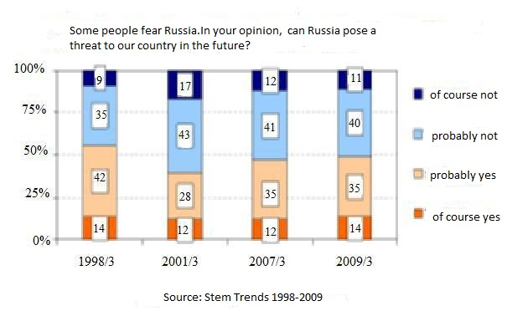
Since 2001 STEM Agency’s research shows strengthening of fears caused by individual countries. Russia was viewed as Risky subject from the point of view of two parameters - military danger and organized crime.

Table №3. Public opinion to the dangers of Russia for CR depending on the political orientation in 2009.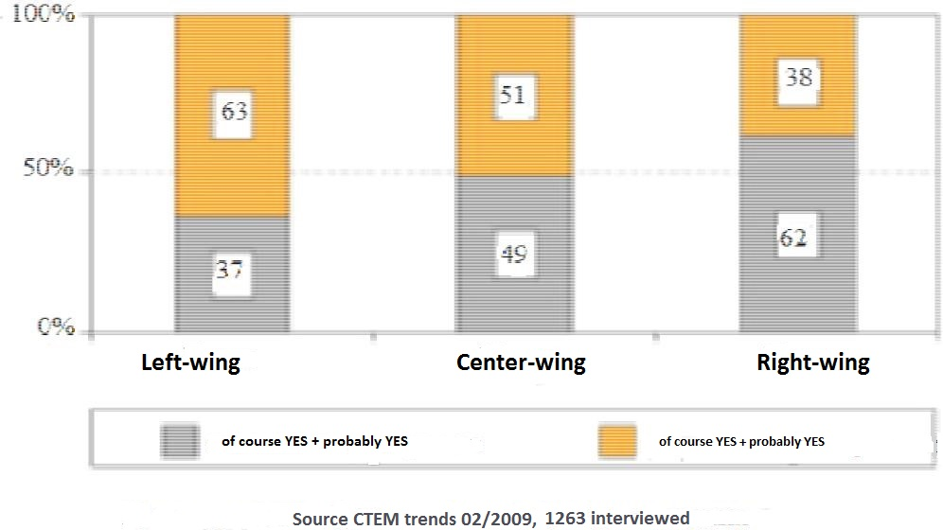

The risk of economic or political supremacy was rated as low, concerns of Czech citizens here were mostly caused by Germany and the United States. It is noteworthy that from the point of view of the military threat and organized crime, more people of the right orientation (61%, 45%) and young people under 29 (54%, 43%) perceived Russia as a risk factor who do not have practical experience with the Czech-Russian relations. It can therefore be assumed that their opinion can be influenced by the media, right-wing politicians or the education system. However, concerns towards Russia in the economic and political spheres in almost all categories of citizens create conditions for the development of mutually beneficial economic and cultural cooperation between the two countries.

Table №4. Citizens' opinions about CR relationship to other countries – “In your opinion, which country presents a danger to CR?”

 |  | Military threat |  |  |  |  |  |  |  |  | Economic slavery
 | opinion | average | left-wing parties | Right-wing parties |  | above 60 |  | below 29 |  |  | opinion | average | left-wing parties | Right- wing | above 60 |  | below 29
 | Russia | 49% | 28 | 61 |  | 38 |  | 54 |  |  | Germany | 68% | 75 | 65 | 75 |  | 63
 | Germany | 9% | 19 | 3 |  | 16 |  | 5 |  |  | USA | 15% | 17 | 13 | 13 |  | 16
 | China | 7% |  |  |  |  |  |  |  |  | Russia | 7% | 2 | 10 | 5 |  | 9
 | USA | 4% | 10 | 1 |  | 8 |  | 4 |  |  | Austria | 2%
 | Organized crime |  |  |  |  |  |  |  |  |  | Political enslavement
 | opinion | average | Left-wing | Right-wing |  | above 60 |  | below 29 |  |  | opinion | average | eft-wing | Right- wing | above 60 |  | below 29
 | Russia | 41% | 32 | 45 |  | 36 |  | 43 |  |  | Germany | 38% | 46 | 30 | 45 |  | 34
 | Ukraine | 32% |  |  |  |  |  |  |  |  | USA | 31% | 39 | 27 | 31 |  | 31
 | USA | 4% | 7 | 2 |  | 7 |  | 4 |  |  | Russia | 18% | 7 | 26 | 16 |  | 20
 | Germany | 2% | 4 | 1 |  | 5 |  | 2 |  |  | Austria | 3%

In modern society, the media have a significant influence on the formation of public opinion, as was repeatedly noted. The mass media take the form of the general consciousness of the population or its active layers and also can exert an active influence on it through the choice of information or the way it is presented. television, radio and newspapers. Have a significant impact. Television and radio influence the population regardless of the ideological and political preferences of individual layers, the newspaper acts selectively. As a target group are regular readers. Russia and its politics in particular are the topic that can be found in the Czech media often choose Russia and its policies as a topic for their news releases. The reason is that Russia has the status of a great power, and has the potential and real opportunities to influence the Czech Republic and its security or stability. Historically, Russia is a powerful country, and it has real levers of governance in the Czech Republic. Russia can influence its security and stability. The frequency with which references to Russia and its policies in the past five years are found in the Czech media are also mentioned. For comparison, we give an analogous information about the United States . The table presents data on links to Russia, as well as its political activities over the past 5 years. The USA in this table is given as a comparison.

Table №5. Frequency of reference «Russia and its politics» in the selected CR’s media during 2008-2011.

Year |  | 2008 |  |  |  |  | 2009 |  |  |  |  | 2010 |  |  |  |  | 2011
Country |  | Russia |  | USA |  |  | Russia |  | USA |  |  | Russia |  | USA |  |  | Russia |  | USA
Media | 1325 |  |  | 3501 |  | 1033 |  |  | 2811 |  | 782 |  |  | 2319 |  | 663 |  |  | 2314
TV and radio | 793 |  |  | 676 |  | 705 |  |  | 558 |  | 449 |  |  | 465 |  | 407 |  |  | 455

National newspapers mentioned Russia and its policy, three times less than USA between 2008 and 2011 with regard to Czech Radio and Television in 2008's , mentioning of Russia by them were more often then of USA. Interest in Russian issues in the media has gradually declined. To assess the information in the media, from the point of view of its objectivity, generally, it is rather difficult to evaluate their positive, neutral or negative orientation against a specific object, especially in the case of television or radio, is not unambiguous. The objectivity of information is attributable to ability of media workers to perceive facts in terms of their real meaning and influence on future development. Values and interests of the editor who provides information, and the dynamics of the situation itself should be included in the assessment. The focus of information and its impact on the public are stunt by both the anchor and his questions. Which in some cases can be either suggestive or vice versa to the invited guests, and the composition of the participants in the debate and their ability to convince the public of the greater value of their evaluations in relation to other participants.
For four years (in the period from 2008 to 2011) there have been changes in topics about Russia, the view of Russia has completely changed. Data on these changes are indicated in Table 1, which indicates a decrease in fear of Russia among the Czech public. The most discussed topics of 2008 were: the Russian-Georgian confrontation and the creation of an American radar in the Czech Republic, after which Russia threatened the deployment of its missiles in Kaliningrad. These two events deepened the fears of conservatively and liberally oriented layers of Czech society over "Russian expansionism."
However, with the onset of the economic crisis, the importance of economic issues also increased. Since the world has formed a troubled situation in the fight against terrorism, there was a need for closer cooperation with Russia.
In view of the change in US policy, once President Obama was elected at the end of 2008, he began a reassessment of relations between Russia and the United States in the direction of closer cooperation. Because of the reassessment (restart) of the relationship between Russia and the United States, the deployment of missiles and radar bases in Poland and the Czech Republic (2009) had been canceled, and in 2010, the Treaty was signed about strategic offensive arms, limiting the number of strategic nuclear warheads and carriers. These events are reflected in the opinions of the Czech media, when the media heard more followers of cooperation with Russia, and former opponents of Russia, instead of refusing to cooperate, began to emphasize caution towards Russia.

The turning point for changing Russia's rating and its politics in the media was just 2009. In 2008, positive or neutral assessments of Russia prevailed in the general public newspapers in the left-wing press - Halo Novina and Pravo. In the right-wing press (Dnes, Gospodarzhske noviny, Lidove noviny), the share of neutral and negative assessments was about 50 to 50. Especially strongly in the media, the Czech sots was criticized democracy for their contacts with Russia (July 2009) and President Claus - for his refusal to unilaterally condemn Russia for the Russo-Georgian conflict. Beginning in 2009, the trend towards a more objective and balanced, albeit critical evaluation of Russia and its policies, began to grow in the media.
Russia's ratings in Czech television and radio were always more balanced, with the exception of radio in 2008, where about a third of the programs were hinted in the context of Russia's harsh reaction to the deployment of US bases in the Czech Republic and Poland. Also because the Russian-Georgian conflict - on the risks associated with Russia, for Czech and European security. Often there were also words about Russian aggressiveness and traditional Russian imperial expansionism. In the years that followed, we began to talk about the assertiveness and naturalness of Russia's core interests with the fact that our membership in the EU and NATO does not threaten us.

The above noted negative shift in the perception of Russia by Czech youth, thus, can be either an incorrect perception of information, when even with its balance, a greater value due to less experience gives the youth negative information, or it can be the result of the formation of historical consciousness through the education system.

It should be noted that during the whole period, in essence, a "neutral" assessment could be found in the media from businessmen. This was caused, on the one hand, by their interest in cooperation, which can hardly be based on a negative attitude towards the business partner, and, on the other hand, in their interests - to objectively perceive Russian reality as conditions for their own success in their business. Neutral assessment does not carry the right to uncritically perceive Russian reality.
In the conditions of an economic recession, will become the basis for an objective assessment of the situation in Russia and will help overcome the traditional Czech negative stereotypes, which in many respects not only do not correspond to the real situation, but also hinder the formation of normal relations.

According to the research - "Russia as a strategic market for Czech exporters and investors" prepared by the Center for European Studies of the Economic University in Prague, which deals with Russian-Czech economic relations, Czech companies understand that the Russian market is a promising market and is at the same time, and the market is solvent. Nevertheless, it has many features, problems and difficulties, therefore, for successful work in this market, it is necessary to know its requirements, properties and know how to act correctly [10].

One of the most important sources of information concerning business with Russia is DHL research conducted by the Czech Trade campaign, which monitors the opinions of Czech exporters and analyzes their assessments of the latest developments in the Czech Republic and abroad. The aim of the study is to identify trends, expectations and opinions of ex-porters in the field of export development and key markets for Czech exporters, assess current events with the potential for impact on exports, as well as the factors and conditions of exports from the Czech Republic. According to DHL studies of exports in 2011, the key market remained Russia's market along with the EU markets [5]. Studies confirm a long-term trend. According to 2010 polls, the states of the European Union from the point of view of the geographical factor remain the most important area for Czech exporters, followed by Russia and the countries of the former Soviet Union. In a survey conducted in 2009, 27% of Czech ex-porters expressed the hope that in Russia and the countries of the former Soviet Union they will find new customers (Russia ranks second after the EU - 53%), far behind are China and South-East Asia (15%). The majority of respondents in Germany (27%) and Russia (22%) sees the largest export opportunities in the future.

Russia is also one of the most important territories for Czech export promotion organizations. For example, for the Export Guarantee and Insurance Corporation (EGSK - EGAP), the Russian Federation is the country that absorbs the largest amount of insurance capacity and its volume in monetary terms is still growing. In 2010, 55.4 billion kroons was sent to Russia, that is, 35.5% of the total capacity of the EHCS insurance, in 2011 this was 57.7 billion kroons, which is 33.6% of the insurance potential [8]. While before 2006, EGAP insured Czech exports to Russia in the amount of 21 billion korunas, over the past five years the amount was more than 100 billion kroons. And the Czech Export Bank in the Russian Federation as of 31.12.2011. placed 46% of its loan portfolio.

The Russian Federation continues to strengthen its position as a key trading partner of the Czech Republic. In terms of turnover, the Czech Republic ranks sixth among trade partners with a share of 4.2%. In exports, Russia ranks 9th with a share of 3.2%, in imports it is 5th with a share of 5.4%. Foreign trade of the Czech Republic and Russia has been marked in recent years by a significant upsurge. In 2011 compared to 2010, its volume increased by 28.6% (from 10.4 billion to 13.3 billion US dollars). Czech imports from Russia increased by 18.7% (from 6.8 to 8 billion US dollars) and significantly, by 47.6% also increased exports (from 3.5 billion dollars in 2010 to 5 , 2 billion USD in 2011). Along with the growth of mutual trade, the long-term balance of the Czech trade deficit with Russia has decreased. The trade deficit in 2011 reached almost $ 2.9 billion per year, but this is 12.4% less compared to 2010, when it reached 3.3 billion. This trend has not changed even in the face of rising prices on energy carriers (oil and gas), which account for 77.7% of Czech imports from Russia. Supplies of crude oil rose in price by 15.3% in physical volume, however, decreased by 17.8%. Gas supplies increased in price by 8.8%, but its physical volumes decreased by 15.8% [12]. The development of trade between the Czech Republic and Russia in recent years is described in the table below.

Table №6. Volume of trade between Russia and the Czech Republic (mill. of US dollars)

 |  |  |  |  |  | 2011/
Год | 2007 | 2008 | 2009 | 2010 | 2011 | 2010
 |  |  |  |  |  | (+/-)
Czech Republic’s export | 2 870,4 | 3 988,2 | 2 621, 2 | 3 535,4 | 5 220,1 | 47,6%
Czech Republic’s import | 5 629,1 | 9 140,9 | 5 399,9 | 6 822,0 | 8 100,9 | 18,7%
Turnover | 8 499,5 | 13 129,1 | 8 021,2 | 10 357,4 | 13 321,0 | 28,6%
Balance of trade | -2 758,7 | -5 152,7 | -2 778,7 | -3286,6 | -2 880,7 | 87,6%

The close relations of Russian and Czech business circles are also illustrate the signing of the Cooperation Agreement between the Chamber of Commerce of the Czech Republic and the Chamber of Commerce and Industry of Russia of 8.12.2011 in the Prague Castle.
Among the decisions of synergy can be found the creation of the necessary conditions for the active participation of enterprises, organizations, companies and entrepreneurs of both countries in exhibitions, fairs and other advertising and information events held in the Czech Republic and Russia, as well as development of cooperation in support of education and business education, in particular, for the training of Russian entrepreneurs wishing to cooperate with EU countries (using educational programs available for the Czech side) and ra the cooperation in the field of science and technology, direct contacts and the exchange of specialists between scientific research centers and educational institutions of the two countries. Both Chambers will also support each other in their presence in another country [7].

An important aspect of the destruction of stereotypes is culture and sport. Area of sport is important for overcoming stereotypes of young people. Activities in these areas are often supported by the company considering that the financial support of cultural and sports events, in particular, is related to their advertising, and the possible side effect is precisely connected with overcoming negative stereotypes that prevent them from making a profit.
Older generation who studied Russian language as mandatory rule, aware a lot of Russian classical culture. Knowledge of Russian culture today due to the dominance of Hollywood in the Czech market is lower among young people. The obstacle is the lack of knowledge of the Russian language, although today Russian at secondary schools already takes 3rd place (after English and German) in terms of the number of students who study it.
The world we live in , intrinsically related with globalization. Globalization creates qualitatively new conditions for interpersonal relations, social time proceeds faster, social space becomes smaller and mutual dependences deepen. To use these conditions for general benefit is a challenge and a task that should be addressed. Regarding Russian-Czech relations, it is necessary to regularly monitor the opinion of the public of these countries, since it can be an additional incentive for rapprochement or rupture of diplomatic relations between our two states.

